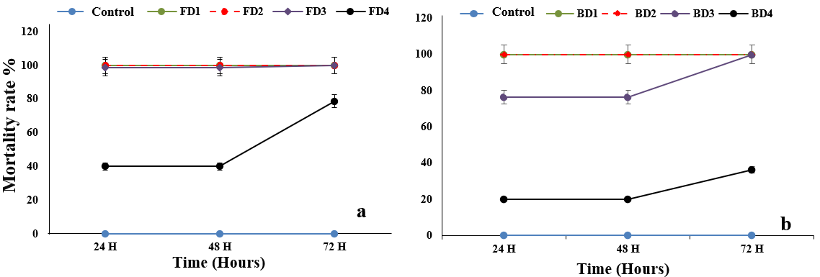
Fig. 1. Time course of mortality rate of Meloidogyne spp. under the effect of applied aqueous extracts (a: Leaves; b: Bulb).

