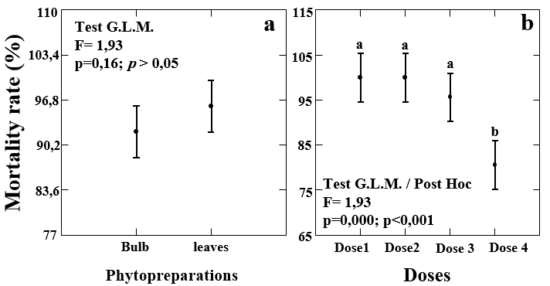
Fig. 2. Comparative study of the effect of aqueous extracts on the mortality rate of L2 larvae of Meloidogyne spp.

