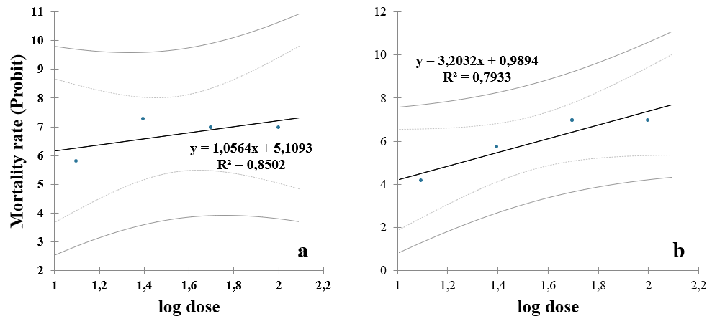
Fig. 3. Larval mortality rate of L2 larvae as a function of the logarithm of doses of aqueous extracts from Urginea maritima. (a: Leaves; b: Bulbs).

