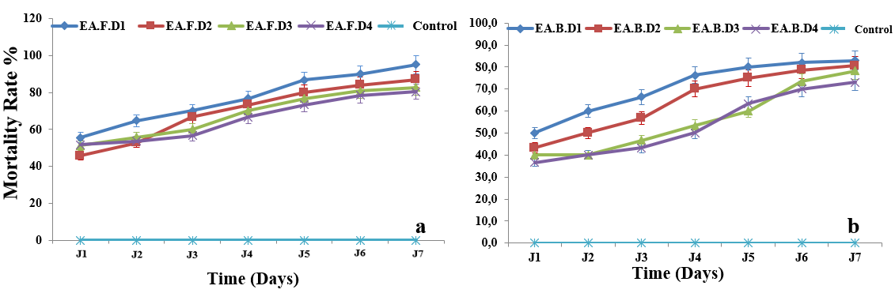
Fig. 5. Temporal fluctuation of the mortality rate of Sitophilus oryzae under the effect of applied aqueous extracts. (a: Leaves; b: Bulbs).

