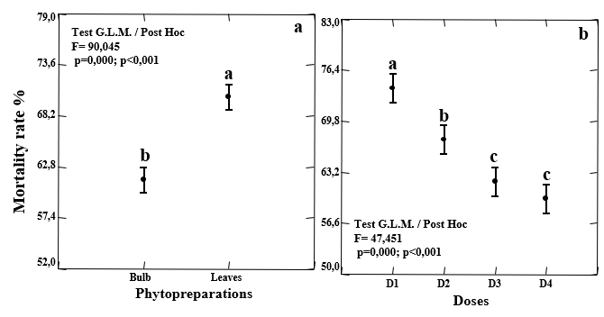
Fig. 6. Comparative study of the effect of aqueous extracts on the mortality rate of Sitophilus oryzae.

