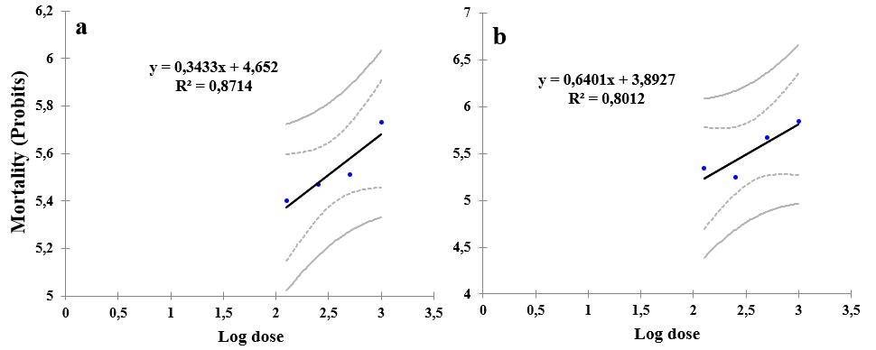
Fig. 7. Mortality rate of Sitophilus oryzae as a function of the logarithm of doses of aqueous extracts from Urginea maritima. (a: Leaves; b: Bulbs).

