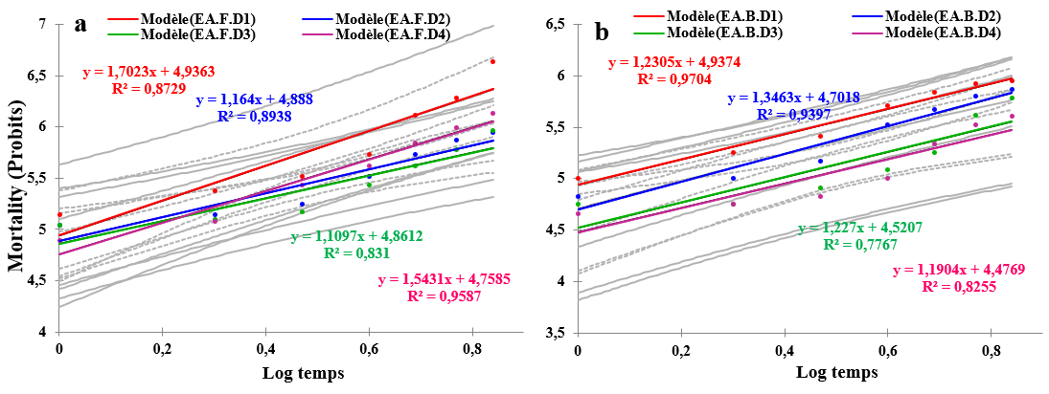
Fig. 8. Mortality rate of Sitophilus oryzae as a function of the logarithm of treatment times applied. (a: Leaves; b: Bulbs).

