Analysis of soil and micronutrients in citrus cultivars Co-infected with Candidatus liberibacter asiaticus and Xanthomonas axonopodis

Khadija Gilani^{1*}, Rehana Badar², Iqra Aslam¹, Iqra Sohail¹, Tehniat Fatima², Taimoor Aalian²
¹Institute of Molecular Biology and Biotechnology (IMBB), The University of Lahore, Lahore Pakistan.
²Department of Biological Sciences Superior University Lahore, Lahore Pakistan.
Corresponding Author: khadija.gilani@imbb.uol.edu.pk

Abstract
The citrus industry, a cornerstone of global agriculture, faces significant threats from bacterial diseases, particularly Huanglongbing (HLB) and Citrus Canker (CBC). This study explores the impact of co-infection by two bacterial pathogens—Xanthomonas axonopodius, responsible for citrus canker, and Candidatus liberibacter L., the greening pathogen—on citrus plants. The co-infection adversely affects citrus health by reducing nutrient uptake from roots to shoots, which compromises fruit quality. The research aims to clarify the interaction between HLB and CBC, assess their combined effects on nutrient absorption, and suggest effective management strategies for affected orchards. The study hypothesize that co-infection may reduce the uptake of micronutrients. Citrus samples were collected and tested for co-infection using qPCR. Nutrient levels, including Zn, K, P, N, Fe, and Mn, were analyzed in soil and leaves using atomic absorption spectroscopy. Results showed a significant reduction in nutrient uptake in co-infected citrus samples compared to healthy ones, with decreased levels of essential minerals in both soil and plant tissues. Soil pH shifted from alkaline to acidic, further affecting citrus growth. These findings highlight the detrimental impact of HLB and CBC co-infection on nutrient absorption and citrus crop yield, underscoring the importance of comprehensive management approaches. Foliar sprays for micronutrient supplementation emerged as a promising strategy to address these deficiencies. This research provides practical insights for managing citrus orchards facing the challenges of HLB and CBC co-infection, offering a pathway to mitigate their effects on citrus production.
Keywords: Huanglongbing (HLB), Citrus Canker (CBC), Co-infection, Micronutrient dynamics
Introduction
Citrus fruits are the widely cultivated crop in the world. The important commercial and industrial citrus fruits are oranges, mandarin, lime, lemon, and grapefruit. Citrus wastes are the good source of contents, like flavonoids, dietary cellulose, and hemicellulose fibers (Barbulova et al., 2014). Citrus fruits are drawing attention for their health benefits, primarily due to their high vitamin C content. Citrus fruit consumption is associated with a lower risk of chronic diseases, which is why these fruits are a sought-after part of a balanced diet. In addition, citrus by-products, including essential oils and flavonoids, are used in the pharmaceutical and cosmetic industries (Carr and Maggini, 2017). Forty percent of different citrus cultivars were produced in all over Pakistan. It was grown about 199,400 ha with 2.29 million tons of annual production. In Punjab province, 95% of citrus was produced, and 70% was Kinnow only (Niaz et al., 2004). Pakistan citrus industry commercially cultivated a large amount of Kinnow (Anwar and Ibrahim, 2004). Among several other plant, micronutrient utilization is important in raising citrus fruit production (Iglesias et al., 2007). However, the citrus industry faces a relentless and multifaceted threat in the form of two devastating pathogens: Candidatus liberibacter L. (CLas) and Xanthomonas axonopodis (commonly known as Xanthomonas citri subsp. citri, Xac). CLas, the elusive pathogen responsible for citrus greening disease (Huanglongbing), and Xac, responsible for citrus canker, together pose a formidable challenge to citrus growers around the world. Their co-infection of citrus added to the complexity and uncertainty related to disease management and crop sustainability (Bruening et al., 2010).
Huanglongbing (HLB) is a citrus bacterial disease known as citrus greening. In Asian countries, HLB has destroyed about 60 million citrus crops. Visual symptomology of HLB disease on citrus trees showed yellowish pattern leaves and shoots with asymmetrical chlorosis. The trees’ height is shortened with stimulated growth with lop-sided and small-sized fruits fail to give proper yellow color and are green from the lower side. The HLB disease is difficult to observe because some infections in trees are confused with Zn deficiency (Tatineni et al., 2008). It is mainly a disturbing disease due to the unculturable bacterium Candidatus liberibacter L. A gram-negative, phloem-limited fastidious nature bacterium spread by the vector’s psyllids, named, Diaphorina citri and Trioza erytreae (Bove, 2006). The bacterial pathogen, commonly known as citrus canker, causes visible, unsightly lesions on citrus leaves, fruits, and stems, affecting both the aesthetic and economic value of citrus fruits (Shahbaz et al., 2022). The pathogenic bacterium of CBC is Xanthomonas axonopodis pv. citri (Xac) (Gottwald et al., 2002). It occurs mainly in tropical and subtropical environmental conditions where significant rainfall follows hot temperatures. Citrus canker became a seriously threatened citrus world industry when marshy weather occurred during the shoot appearance (Schubert et al., 2001). The presence of CLas and Xac in citrus fruits can lead to complex negative effects on tree health and yield. Coinfected trees often exhibit more severe symptoms, including significant yellowing of leaves, fruit deformation, increased fruit drop, and reduced fruit quality (Barbieri et al., 2023). This can result in significant economic losses for citrus producers as the affected fruit may become unsaleable. Additionally, deterioration in tree health caused by co-infection can impact the overall viability of citrus groves, potentially leading to long-term yield and productivity declines (Zhang et al., 2019).
The macronutrients and micronutrients, i.e., N, P, K, Cl, Mn, Zn and Fe, are essential nutrients for citrus fruit quality (Khan et al., 2015). More than 95% soils of Punjab are nutrient deficient, having problems with the insufficiency of Nitrogen (N), Phosphorous (P), Potassium (K), Chloride (Cl), Zinc (Zn), and Iron (Fe), (Rashid, 2004). In the province of Punjab (Pakistan), the variety of citrus production covers more than 80% of the citrus cultivated. Citrus fruit is comparatively low in Pakistan in contrast with other countries. Citrus yields are extremely depleted with a deficiency of micronutrients present in the soil, carbonate soil, deep soil, where the water table level is high, and soil that has not been cultured earlier (Khan et al., 2015). The citrus canker and huanglongbing pose significant challenges to the growth of citrus crops, as discussed previously. These diseases go beyond the observable symptoms and affect the delicate equilibrium of micronutrients in citrus plants (Etxeberria et al., 2012). This study mainly focus on the uptake of different macro and micronutrient profile in healthy and co-infected citrus cultivars with the relationship of macro and micronutrients present in soil.
Materials and methods
Source of explant
The sample of citrus will be collected and confirmed by Government Citrus Research Institute (CRI), Sargodha, and Bhalwal. The healthy leave samples of citrus trees infected from citrus canker and huanglongbing were collected from Government Citrus Research Institute (CRI), Tehsil Bhalwal, Sargodha district, Pakistan. The samples were taken from the time period in August 2023 at room temperature. Healthy and infected samples were taken from different trees. The healthy and infected citrus trees were collected from fields in a zip lock bag.
Sample size
This study will use the varieties of sweet oranges (Citrus sinensis L.) var. Valencia Late, Succari, Salistiana and sour oranges (Citrus aurantium L. var. Kinnow). The leaf sample size was 100 (n=100) (50=H, 50=I). The decision to choose sweet oranges (Citrus sinensis L.) and sour oranges (Citrus aurantium L.) as the main plant varieties for this research is based on their significant role in the citrus industry and their known vulnerability to diseases such as citrus canker (CBC) and huanglongbing (HLB) (USDA National Agricultural Statistics Service). The total samples of 100 leaves per 10 trees were obtained, consisting of an equal number of 50 healthy and 50 co-infected trees. Having an equal number of healthy and co-infected trees in the sample size enables valuable comparisons, revealing the degree of changes in micronutrient uptake when these diseases are present. This methodical approach adheres to well-known principles in sampling methods and helps in gaining valuable understanding of the connections between CBC, HLB, and micronutrient levels in citrus trees (Cochran, 1977).
DNA Extraction
To achieve this, leaf tissue weighing approximately 200 mg was collected from both healthy as well as diseased citrus samples. The leaf, the first sample subjected to essential process of degrading plant material by liquid nitrogen cracking was well maintained as we found out after performing "Wageningen QIA analysis" assaying quality and quantity in subsequent post processing techniques. The lyophilized powdered plant material was then put in sterilized 2 ml screw cap vials containing two steel grinding balls of 2.3 mm for homogenation (Doyle and Doyle, 1987). The DNA extraction was done using a Qiagen Inc. kit, which is well-established and commonly used convert View (Valencia, CA). The performance and reliability of Qiagen DNA extraction kits to produce high-quality genomic DNA is well-recognized Milligan BG (Gilani et al., 2019). The DNA from the disrupted leaf material was then extracted using the Qiagen protocol. The extracted DNA was then purified with a RNA removing method in 100 ul of TE buffer (pH 8.0). To do so, the researchers used RNase A (Gilani et al., 2019). This rigorous DNA extraction process not only ensures that the material is pure, but also whole for downstream testing. Here we describe a methodology to isolate flanked regions for Physical Mapping and Enrichment of Arrayed DNA libraries (Pmega-WISE) that has facilitated positional cloning and the transient analysis of gene expression encoding disease susceptibility/resistance in addition to nutrient utilization by citrus infected with many economic pathogens including CBC or HLB.
qPCR protocol for detection of HLB
The first stage, and an important one, was the isolation of DNA from citrus leaves. Following DNA extraction, for HLB detection which was based on the development of a calibration curve that correlates Ct value with Candidatus liberibacter L. gene copies levels and to generate this curve, a serial dilution was performed with the amplicon purified from gel by obtaining known DNA concentration values (Li et al., 2006). Finally, the calibration curve was made by plotting Ct values obtained from qPCR reactions against DNA concentrations of each dilution. This calibration curve serves as an important method for quantitating the amount of Candidatus liberibacter L. DNA (specifically a phage) in samples with high accuracy. Detection of double-stranded DNA by SYBRTM Green, a widely used sensitive fluorophore in qPCR reactions. It was considered as the advanced molecular technology which has been developed to a detection method that is useful for clinically diagnosing Huanglongbing, includes detecting an amount of Candidatus liberibacter L. DNA in citrus plant tissues and correlating such information with surgical yield data from agroforestry trees carrying huanglongbing infection (Gilani et al., 2019).
qPCR protocol for detection of CBC
One important approach to PCR detection of the fungus pathogen, Citrus Black Spot in citrus plants. This process entailed DNA extraction from citrus leaf lesions and pure bacterial suspensions, as well as an extensive sample history for PCR accuracy. DNA was extracted following recommended protocols from Qiagen Inc. using their methodology and kits. (Valencia, CA) for consistent and reliable performance (Viljoen and Mahomed, 2019). Extraction buffer (500 μl) was added to the DNA samples. To ensure the complete removal of RNA, RNase A was used. But there was a highly adapted protocol to extract bacterial suspensions on lesions and get DNA. A 1000 μl aliquot of a bacterial suspension was centrifuged at 800 g for five minutes and the pellet was resuspended in 500 μl extraction buffer. Following incubation at room temperature for 60 minutes, liquid above the sediment was collected and mixed with a further 450 μl isopropanol. The pellet obtained after centrifugation at 1000 g for few minutes was resuspended in saline and, sometimes, just a further round of centrifugation is needed (the lysed cells), where the liquid should be practically no longer. That last step was actually done with supernatant from other sample to fill up one plastic tube full of it so that final preps could grow in vivo. The pellet was air-dried and resuspended in 100 μl of sterile water before being re-dissolved (Damn et al., 2018). The citrus DNA from lesions and leaves will be used for the qPCR analysis. A small fraction of 2.5 µl was used as a template for real-time PCR using SYBR Green dye as the fluorophore. Use of the SYBR green aid in identification and measurement of PCR products thus allowing accurate estimation CBC. Golmohammadi et al. described the methodology follows this approach in 2007, the urgent need to develop an efficient detection method for this CBC pathogen arose in order of obtaining successful citrus plants management and control against this fungal disease.
Atomic Absorption Spectroscopy analysis of leaf
Due to this study, the importance of leaf mineral analysis by Atomic Absorption Spectroscopy (AAS) was evidenced in terms of evaluating the mineral profiles of citrus trees with CBC and HLB co-infections. For the study of mineral estimation, both healthy and infected citrus leaves were dried thoroughly in an oven with set at 70 ºC for two days. The leaf samples were assimilated and dried during firing that prevents the moisture as well, then prepared in a way for further mineral studies on them. This was followed by digestion of 1g (oven-dried) leaf sample with a mixture of sulphuric acid and hydrogen peroxide in the proportion of 4 ml: 8ml respectively. When the colourless solution resulting from digestion, meaning all organic material in the sample were digested fully. The mixture of solution was then filtered and digested substance was finally diluted with distilled water to its final volume (~50 ml) (Alloway 2008). All the carefully prepared leaf samples were analyzed for various minerals such as Cl, K, Mn, P, N, Zn and Fe from an AAS instrument. The accuracy and precision of AAS makes it possible to quantify very small amounts (in the ppm level) of elements, which is a unique advantage for this technique. The nutrient concentrations of citrus leaves, usually expressed as percentages (%), provided important information on the contents. A reliable assessment of the mineral content in healthy and infected citrus leaves was determined allowing us to gain further insight into how CBC + HLB co-infections affected micronutrient homeostasis as a whole within this population (Khan et al., 2015).
Soil sampling
The soil sampling method involved the collection of 90 (30 x3) taken within root zone in the dripline area for about15to20 citrus trees, infected and healthy ones from all corners as spread throughout entire block. Samples were taken at a 6" depth. This procedure gave useful information of soil conditions that in turn affected the health and nutrient uptake by trees which were evaluated from samples collected at dripline (between canopy edges to top spread) where major percentage activity is focused. Individual soil samples from each core were, then combined within a bag. The term compositing applies to blending the individual samples in such a manner as they represent sufficiently closely all different soil properties existing within any given designated research area. After mixing, the samples were allowed to dry by leaving them open in air so that any remaining moisture was removed ensuring suitable analysis of these. These were the measures that they adopted to ensure faithful representation of soil conditions in study area by proper collection and analysis of soils samples which was conducive for describing nutrient composition (Alva et al., 1997).
Analysis of soil sampling
At the start, soil samples gathered from the study site were brought to biotechnology lab for detailed analysis. The first step was to dry the samples, removing any excess moisture so that they were in perfect condition for further testing. The screened dried soil samples for other contaminants or non-soil particulate matter, including rocks and roots. This assures that the soil samples to be used for further studies were free from any noticeable impurities which could equivocate the authenticity of results. Following some initial preparation steps, a chemical extraction solution was employed (Alva et al. 1997). This technique included softly trembling a details quantity of the dehydrated dirt for just 60. The purpose of this method was the proper extraction/availability, and uptake by the plant roots of all necessary nutrients from soil nutrient composition viz. phosphorus (P), potassium (K), chloride (Cl), zinc (Zn), iron (Fe), nitrogen (N) and Manganese (Mn). Afterward, the extracted nutrients of the solution were measured precisely. Consequently, the results reported by degree e.g. (%) are expressed as nutrient content in soil samples (Tucker et al., 1995).
pH determination of soil
The pH of the soil was determined using established protocols. Soil samples were carefully prepared. The first step of processing was drying the samples and removing any excess moisture, followed by sieving to remove physical impurities such as stones and roots. Finally, a sample-wise mixing of this was executed to mix everything properly The soil PH was measured with a pH meter to determine the authentic value through employing this procedure. A pre-determined amount of the soil sample was added with a known specific mass of distilled water during preparation, to obtain a suspension that included both solid components (soil) and aqueous phase. For measurement to be sure and accurate, pH buffer solutions are adapted prior to using the pH meter. pH meter is used for pH measurement of soil-water suspension by dipping the electrode into it and recording the reading when the electrode stabilizes. The measurement used to record the soil pH level was calibrated on a scale of 0-14. Acidic soil has a pH below 7, neutral soils have a pH of around 7 and alkaline soils will return results above 7. The pH level of the soil directly impacted on nutrient availability. The uptake of essential micronutrients in the citrus trees were limited when grown soils with pH outside your ideal range. In this study the evaluation of soil characteristics within the research area is completed with addition pH measurement on top of further analysis (Alva et al., 1997; Rumiani et al., 2023).
Soil electrical conductivity
Soil electrical conductivity (EC) by established methods confirmed precision and a degree of reliability. Soil samples were collected from the field in Sargodha region under citrus cultivation, up to 120-150cm depth for EC measurement. An important step in obtaining uniform samples was to dry the oven dried wood outdoors so that there would be no moisture left on it. The difference in the electrical conductivity of soil (EC) was measured using a combined meter. An EC meter, which measures the soil's ability to conduct electric changes in conducting electricity and as a result how much ions were present in your soils. The increase in soil salinity caused by a higher EC value can have adverse effects on plant growth and nutrition as well (Chaudhry, 2003).
Atomic Absorption Spectroscopy analysis of soil
The atomic absorption spectroscopy was also be applied to mineral analysis. Samples for determination of soil minerals were collected from 0-15 cm depth and stored into small containers. The soil samples were initially dried at 40ºC to remove any excess moisture. AAS analysis of the mineral composition of soil The analysis was performed using this method because the lamp cathode mono-element was empty. The lamp was aligned to increase the sensitivity of the equipment and then wavelength adjusted prior to analysis. This is because AAS offered the ability to perform exact, quantified sensing for major soil mineral factors including K, Mn, Zn, Cl, P, N and Fe (Alva et al., 2014).
Statistical analysis
The mean ± SEM were used to report the results. Statistical analysis was conducted using SPSS analytical software, and significance will be determined by one-way ANOVA, with a P value of < 0.05 considered significant (Steel et al., 1997).
Results
Analysis of citrus leaf sampling
There were 100 leaves samples/ 10 treea of Citrus aurantium var. Kinnow (Bitter orange) and Citrus sinensis (Sour orange) var. Valencia Late, Succari, Salistiana in a row were chosen with vulnerability to diseases such as citrus canker (CBC) and huanglongbing (HLB) for the study were selected from the Citrus Research Institute Sargodha, Pakistan.
qPCR analysis
For PCR analysis, DNA was extract as described in above methodology and uniformly generated DNA extracts from citrus cultivars were employed for its analysis. Typical standardization bend that links the reproduction amount of Candidatus Liberibacter asiaticus' DNA by means of Ct value is shown in Fig. 1a. A calibration curve was created utilizing successive dilution of gel purified amplicon to estimate the copy number of CLas DNA (prophage). (Fig. 1a). For healthy samples, Ct values varied from 15.5 to 36.3. These numbers range from 0-139 for the reproduction amount of CLas amplicon (prophage-specific). Based on prior studies, any Ct or Ct Value larger than thirty was declared undesirable and lower dependable recognition competence, reproduction amount of 139, or fewer were judged undesirable (Sieburth et al., 2009; Paula et al., 2018). Majority of number values in the indicative sections (CLas-Infected) with highest being 4.5 106 (Ct= 16.50) were in millions. Three exceptions were found, with copy numbers ranging from 1.39 103 (Ct=28.2) to 1.87 105 (Ct=21.1). It’s worth noting that the lowest contaminated cultivar, Kinnow, had reproduction amount that was ten times greater than the Ct 30- derived the Ct 30-consequent negative threshold worth of 139. A typical amplification plot is shown in Fig. 1b, with three technical replicates for each sample. The curve depicting the production of a double-stranded DNA product (amplicon) was observed when the reaction kinetics were examined using SYBRTM. During an RT-PCR reaction, double- stranded DNA is detected in green.
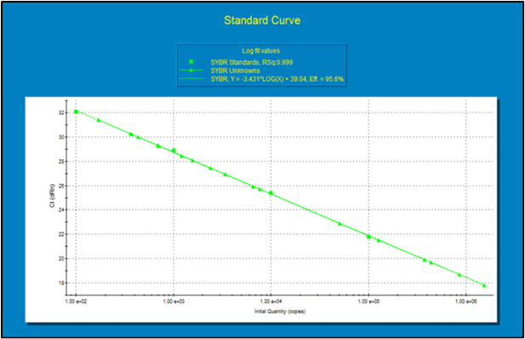
b
a
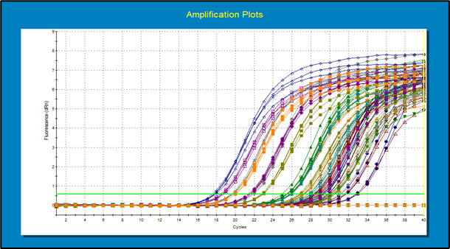
Figure 1 (a-b): Huanglongbing-infection status in fifteen citrus cultivars through qPCR
Standard curve obtained for real-time PCR. A gel-purified amplicon was quantified by optical density and serially diluted to represent from 1 to 1x106 copies in PCR reactions to construct the standard curve. Legend: Squares: calibration values, triangles: unknown samples, SYBR =SYBR® Green (Bennett and Wallsgrove), linear regression formula: Y=-3.3261 x LOG(X)+36.40, Rsq: 0.995, efficiency of the amplification=102%; b) Typical amplification plot of 3 replicates per sample from HLB positive and healthy plant samples obtained from real-time PCR.
qPCR-CBC
Xanthomonas axonopodius, which is the main agent in citrus canker, Molecular approaches was used to validate in citrus canker infection diagnosis depending on visual symptoms in the leaves, peel, and pulp. (RT) PCR was used to see the infection status as shown in the figure 2 a and b.
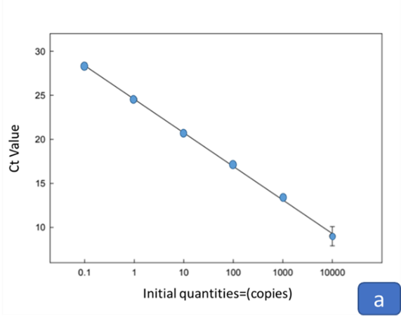
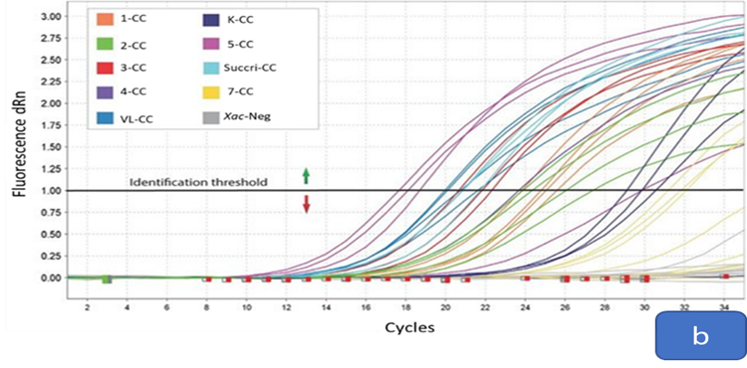
Figure 2 (a-b): Xac-infection status in 8 citrus cultivars through qPCR
Legend: Squares: calibration values, triangles: unknown samples, SYBR =SYBR® Green (Bennett and Wallsgrove), linear regression formula: Y=-3.3261 x LOG(X)+36.40, Rsq: 0.995, efficiency of the amplification=102%; b) Typical amplification plot of 3 replicates per sample from Xac positive and Xac negative plant samples obtained from real-time PCR. Standard curve obtained for real-time PCR. A gel-purified amplicon was quantified by optical density and serially diluted to represent from 1 to 1x106 copies in PCR reactions to construct the standard curve.
Analysis of leaf minerals through atomic absorption spectroscopy
This study conducted the atomic absorption spectrophotometric analysis of leaf minerals samples of Citrus aurantium and Citrus sinensis. Seven type of minerals included potassium (K), nitrogen (N), phosphorous (P), chloride (Cl), zinc (Zn), iron (Fe) and manganese (Mn) were analyzed from both healthy citrus leaf and citrus leaf infected with CBC and HLB. Different concentrations in % of N, P, K, Cl, Zn, Fe and Mn (0.88, 159.84, 781.89,0.37, 0.000125, 0.000315 and 0) respectively of co- infected leaf samples and N, P, K, Cl, Zn, Fe and Mn (2.10, 1.12, 0.08, 0.11, 0.001124, 0.0113 and 0. 00345) respectively of healthy leaf samples were obtained after spectrophotometry as shown in Table 1 & Figure 3.
Table 1: Atomic Absorption Spectrophotometry: shows concentrations along with mean and standard deviation of different minerals in healthy and co -infected Citrus sinensis and Citrus aurantium leaf samples.
Atomic Absorption Spectrophotometry
 | Leaf Samples Concentrations (%)
Micronutrients | Healthy samples | Co- infected samples
Nitrogen (N) | 2.10 | 0.88
Phosphorous (P) | 1.12 | 159.84
Potassium (K) | 0.08 | 781.89
Chloride (Cl) | 0.11 | 0.37
Zinc (Zn) | 0.001124 | 0.000125
Iron (Fe) | 0.0113 | 0.000315
Manganese (Mn) | 0.00345 | 0.00
Mean ± S.D | 0.49 ±  0.82 | 134.71 ±  291.51
t- test | 0.27
ANOVA | 0.25
Legend: p≥0.05
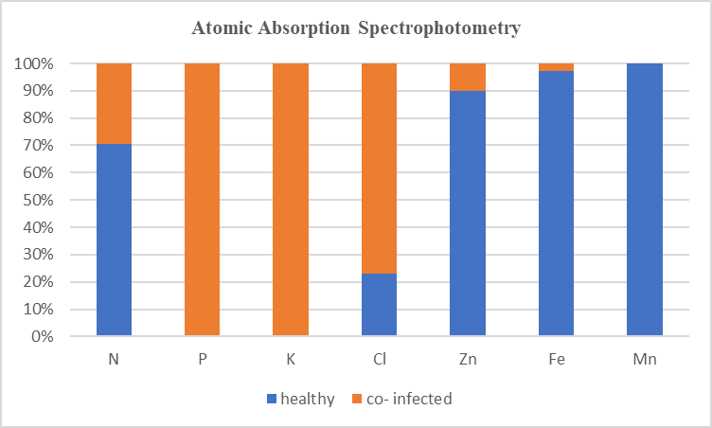
Figure 3: Atomic Absorption Spectrophotometry: Micronutrient’s concentrations in healthy and co -infected Citrus sinensis and Citrus aurantium leaf samples.
The bar graph and table 4.2 illustrated that the minerals uptake by citrus trees varied slightly in co -infected samples as compared to the healthy citrus samples. Results indicated the significant p value i.e., 0.25 surpassed common significance levels taken as 0.05. This suggests that there is insufficient evidence to support the rejection of the null hypothesis by One-way ANOVA between the healthy and co- infected leaf samples of Citrus sinensis and Citrus aurantium.
Analysis of soil sampling
Soil samples were carefully and systematically gathered, with a deliberate separation into two groups: one consisting of healthy soil, and the other consisting of soil affected by both citrus canker (CBC) and Huanglongbing (HLB) infections. Further the study concentrated on crucial soil factors, such as pH and electrical conductivity, and evaluated the mineral absorption patterns in relation to these citrus infections.
Electrical conductivity of soil
The measurement of electrical conductivity was conducted on citrus samples with both healthy and soil co-infected with HLB and CBC. Co -infected citrus soil has altered the soil conductivity. The electrical conductivity of co -infected soil decreased which indicated the reduced nutrients and minerals in the soil. The table 2 and figure 4 presented an electrical conductivity measurement of seven different soil samples resulting in electrical conductivity of 2.28 of healthy soil, indicating a greater presence of ions in the soil solution. This suggested a higher level of dissolved salts or minerals, ultimately leading to improved nutrient absorption by citrus plants. However, the soil conductivity in co-infected soil was 1.05, indicating a lower concentration of ions in the soil solution compared to healthy soil. This suggested reduced levels of dissolved salts or minerals, leading to decreased nutrient assimilation in citrus plants.

Table 2: Electrical conductivity of healthy soil and the soil co -infected with CBC and HLB.
Electrical Conductivity (dSm -ˡ)
Sample size | Healthy soil | Co -infected soil
S1 | 2.31 | 1.08
S2 | 2.27 | 1.05
S3 | 2.30 | 1.02
S4 | 2.29 | 1.04
S5 | 2.26 | 1.01
S6 | 2.33 | 1.07
S7 | 2.24 | 1.03
Average | 2.28 | 1.05

Figure 4: Electrical conductivity of healthy soil and the soil co -infected with CBC and HLB.
pH of soil
The pH level was determined for seven different citrus samples, which included both healthy specimens and those affected by co-infection of HLB and CBC in the soil. The co -infected species have altered the pH of soil from alkaline to acidic. In comparison to acidic soil, citrus species have a greater ability to flourish in alkaline soil. The pH measurement of 8.77 in Table 3 and graph 5confirmed that the soil in the healthy citrus samples is highly alkaline. The pH level of the co-infected citrus samples was recorded at approximately 7.94. The acidity level of this soil ranges from slightly acidic to neutral. This indicated that healthy citrus species absorb more mineral or micronutrients compared to citrus species that have been infected with both citrus canker (CBC) and huanglongbing (HLB).

Table 3: pH of healthy soil and the soil co -infected with CBC and HLB.
pH
Sample size | Healthy soil  (alkaline) | Co -infected soil  (acidic)
S1 | 8.75 | 7.98
S2 | 8.78 | 7.92
S3 | 8.80 | 7.95
S4 | 8.85 | 7.97
S5 | 8.73 | 7.91
S6 | 8.71 | 7.93
S7 | 8.79 | 7.99
Average | 8.77 | 7.94

Figure 5: pH of healthy soil and the soil co -infected with CBC and HLB.
Analysis of citrus soil through atomic absorption spectroscopy
This study showed the atomic absorption spectrophotometric analysis of soil samples of Citrus aurantium and Citrus sinensis. Seven type of minerals included potassium (K), nitrogen (N), phosphorous (P), chloride (Cl), zinc (Zn), iron (Fe) and manganese (Mn) were analyzed from both healthy soil and soil samples infected with CBC and HLB. Different concentrations % of N, P, K, Cl, Zn, Fe and Mn (2.04, 0.029702, 0.099221,0.16, 0.000305, 0.07453 and 0.002675) respectively of co- infected leaf samples and N, P, K, Cl, Zn, Fe and Mn (0.037, 0.00434, 0.0118, 0.284, 0.000163. 0.000604 and 0.00048) respectively of healthy soil samples were obtained after spectrophotometry as shown in Table 4 and Figure 6.
Table 4: Atomic Absorption Spectrophotometry: shows the concentrations along with mean and standard deviation of different minerals in healthy and co -infected Citrus sinensis and Citrus aurantium soil samples.
Atomic Absorption Spectrophotometry
 | Soil Samples Concentrations (%)
Micronutrients | Healthy samples | Co- infected samples
Nitrogen (N) | 0.037 | 2.04
Phosphorous (P) | 0.00434 | 0.029072
Potassium (K) | 0.0118 | 0.099221
Chloride (Cl) | 0.284 | 0.16
Zinc (Zn) | 0.000163 | 0.000305
Iron (Fe) | 0.000604 | 0.07453
Manganese (Mn) | 0.00048 | 0.002675
Mean ± S.D | 0.05 ± 0.10 | 0.34 ± 0.75
t- test | 0.34
One- way ANOVA | 0.32
Legend: p≥0.05
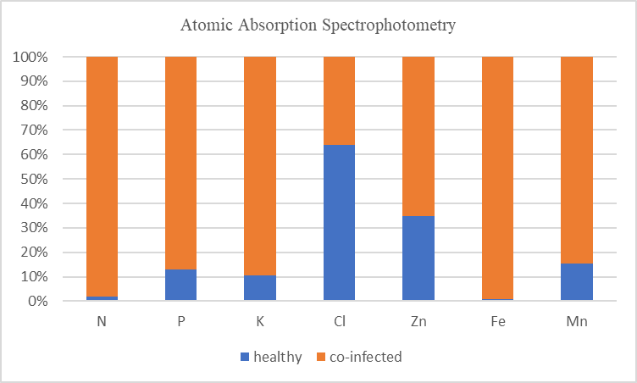
Figure 6: Atomic Absorption Spectrophotometry: Micronutrient’s concentrations in healthy and co -infected Citrus sinensis and Citrus aurantium soil samples.
The bar graph and table 6 illustrated that the minerals uptake by citrus species grown in the co -infected soil varied as compared to the citrus species grown in the healthy soil. Results indicated the significant p value i.e., 0.32 surpassed common significance levels taken as 0.05. This suggests that there is insufficient evidence to support the rejection of the null hypothesis by One-way ANOVA between the healthy and co- infected soil samples of Citrus sinensis and Citrus aurantium.
Discussion
Co-infection is devastating for citrus cultivars. It usually causes decline rate in nutrient uptake and defence mechanism responses which ultimately induced synergistic stress disadvantages to the trees accelerating with HLB effects with CBC (Gottwald et al. 2014). The co-infection resulted a significant reduction in citrus crop yield and quality, putting the economic viability of global citrus production at risk. Now more than ever, the global problem of co-infection in citrus orchards must be brought to light and ultimately managed for continued ecosystem health and resilience. Prior research as well also supports our citrus nutrient uptake work. A strong indication of the significance to nutrient acquisition within root architecture, and specifically the kind of roots that enhance nutrients absorption in citrus. It was seen that the level of importance that the mycorrhizal associations with the micronutrient uptake in plants also affected. This has implications about how root soil microbiomes may impact the nutrient requirements of citrus trees. Previous research has helped us to understand the intricate mechanisms that regulate uptake of micronutrients in citrus. Uptake of essential micronutrients like nitrogen (N), phosphorous (P), potassium (K), zinc (Zn), iron (Fe) and manganese (Mn). These may be processes wherein the needy resources are engaged such as nutrient uptake by roots or ion transportation and with certain physiological activities. The influence of environmental factors, soil conditions and pathogen presence on these mechanisms has been the subject in this investigation (Li et al., 2017).
This study correlates with the different prior studies have consistently shown that specific infections, like HLB, have the ability to disturb the balance of vital nutrients necessary for optimal plant development and the negative impacts of HLB on the absorption of nutrients were emphasized, with a specific focus on the imbalances in potassium (K) and iron (Fe) levels in citrus trees (Li et al., 2019). In a similar way another previous study which shown that the correlation between fluctuations in zinc (Zn) and manganese (Mn) concentrations in citrus plants, the essential micronutrients have been important for various enzymatic processes, the production of energy through photosynthesis, and the overall functioning of plant metabolism has been affected in co–infected cultivars due to their reduced uptake from soil (Jones et al., 2016). The disturbance of their equilibrium can lead to a series of consequences that negatively impact the well-being and productivity of citrus crops (Zhang et al., 2013). In comparison, our study offers a distinct viewpoint as it examined the concurrent influence of HLB and CBC on the absorption of micronutrients in citrus plants. The comprehensive understanding of challenges presented by co-infections has been facilitated by this holistic approach. The urgency to implement integrated management strategies for co-infected orchards is underscored by the noted deviations from the healthy baseline, which align with findings from previous studies (Gottwald et al., 2014; Zhang et al., 2015).
It has been indicated that the presence of HLB infection in citrus trees is often associated with changes in the pH levels of the surrounding soil. The presence of HLB leads to acidic conditions which affect microbial functions and nutrient accessibility in the soil, consequently affecting the overall well-being of citrus trees (Lehman et al., 2014). Electrical conductivity of soil altered as a result of HLB and CBC co-infection. These changes signify fluctuations in ion levels and the availability of nutrients (Stangoulis et al., 2017) showed the consistency with these results. Our study builds on this hypothesis and examines the effectiveness of similar interventions in the unique context of BCC and HLB co-infection. By synthesizing this information, their work highlighted the key role of soil health in maintaining optimal micronutrient levels. In our study analyzing soil micronutrient dynamics in co-infected orchards of citrus samples. By comparing our results with their objectives, we aim to describe context-specific strategies that addressed the unique challenges posed by coinfection scenarios. Their study emphasized integrated management practices, including foliar applications and soil amendments, to comprehensively address nutrient deficiencies in citrus groves. Essentially, our discussion aimed to derive practical and contextual recommendations for orchard management in the face of complex pathogen interactions through a thorough comparative analysis of these groundbreaking studies, thereby providing a valuable source of information for farmers and researchers (Wang, 2019).
Conclusion
Coinfection of Huanglongbing (HLB) and Citrus Canker (CBC), reduce the nutrient uptake from citrus leaf & soil by limiting nitrogen like, N, P, K in addition to more minerals include Zn, Cl, and Fe followed with Mn. The worldwide citrus industry has faced a problem. Another type of analysis included was one that tested the multistate nature between these diseases and how they impact nutrient uptake in the tree, which results to changes on microelement quantity present in the soil. In the present study useful information has been provided through quantitative PCR (qPCR) and atomic absorption spectrophotometric analyses as well as soil properties analysis. In this case, the citric leafs were analyzed for both highlighted PCR of CBC (five samples) soil pH and electrical conductivity. Atomic absorption spectrophotometer analysis revealed that nutrient uptake and concentrations, including nitrogen (N), phosphorus (P), potassium (K), iron (Fe), and copper (Cu), were lower in co-infected citrus plants compared to those in healthy soil. The co-infection has changed the concentrations of key nutrients in citrus leaves and soil. The study is a further step above earlier research with an integrated view of the challenges associated to the co-influence dynamics between HLB and CBC over nutrients. However, more extensive information on nutrient mechanisms will be necessary. Additionally, it's important to consider the impact of co-infections on different citrus cultivars.
Acknowledgement
Special thanks to Government Citrus Research Institute (CRI) Sargodha for their support.
References
Barbulova, A., Apone, F., and Colucci, G. (2014). Plant cell cultures as source of cosmetic active ingredients. Cosmetics, 2: 94–104.
Carr, A. C., and Maggini, S. (2017). Vitamin C and immune function. Nutrients, 9(11):11- 12.
Niaz, A.C., A. Aziz and M.A. Rehman, 2004. Citriculture in other lands. Proceeding international conference on Citriculture, pp: 27–35. University of Agriculture, Faisalabad, Pakistan.
Iglesias, D. J., M. Cercos, J. M. Colmenero-Flores, M. A. Naranjo, G. Rios, E. Carrera, O. Ruiz- Rivero, I. Lliso, R. Morillon, F. R. Tadeo, and M. Talon. (2007). Physiology of citrus fruiting. Brazilian Journal of Plant Physiology, 19: 333–362.
Bruening, G., Bove, J. M., Citron, P., Miller, P. W., Nault, L. R., Polek, M. L., and Ables, C. Y. (2010). Strategic planning for the Florida citrus industry: addressing citrus greening disease. USA: National Academy of Sciences, National Research Council.
Tatineni, S., U.S. Sagaram, S. Gowda, C.J. Roberston, W.O. Dawson, T. Iwanami, and N. Wang. (2008). In planta distribution of ‘Candidatus liberibacter asiaticus’ as revealed by polymerase chain reaction (PCR) and real-time PCR. Phytopathology, 98(9): 592-599.
Bové, J. M. (2006). Huanglongbing: a destructive, newly-emerging, century-old disease of citrus. Journal of plant pathology, 7-37.
Shahbaz, E., Ali, M., Shafiq, M., Atiq, M., Hussain, M., Balal, R. M., and Shahid, M. A. (2022). Citrus Canker Pathogen, Its Mechanism of Infection, Eradication, and Impacts. Plants, (1): 123.
Gottwald, T., J. Graham, and T. Schubert. (2000). Citrus canker: The pathogen and its impact. Plant Health Progress.
Schubert, T., S. Rizvi, X. Sun, T. Gottwald, J. Graham, and W. Dixon. (2001). Meeting the challenge of eradicating citrus canker in Florida – Again. Plant Disease, 85: 340-356.
Barbieri, H. B., Fernandes, L. S., Pontes, J. G. D. M., Pereira, A. K., and Fill, T. P. (2023). An overview of the most threating diseases that affect worldwide citriculture: Main features, diagnose, and current control strategies. Frontiers in Natural Products, 2: 104- 536.
Zhang, M., Yang, C., Powell, C. A., Avery, P. B., Wang, J., and Huang, Y. (2019). Field evaluation of integrated management for mitigating citrus Huanglongbing in Florida. Front. Plant Sciences, 9.
Khan, A.S., M. Nasir, A.U. Malik, S.M.A. Basra and M.J. Jaskani. (2015). Combined application of boron and zinc influence the leaf mineral status, growth, productivity and fruit quality of ‘Kinnow’ mandarin (Citrus nobilis Lour× Citrus deliciosa Tenora). Journal of Plant Nutrition, 38: 821-838.
Rashid, A., and J. Ryan. (2004). Micronutrient’s constraints to crop production in soils with Mediterranean type characteristics. Journal Plant Nutrition, 27: 959-975.
Etxeberria, E., Gonzalez, P., and Achor, D. (2012). Anatomical distribution of abnormally high levels of starch in HLB-affected Valencia orange trees. Physiological and Molecular Plant Pathology, 79(1): 14-21.
Cochran, W. G. (1977). Sampling Techniques (3rd ed.). Wiley.
Doyle, J. J., and Doyle, J. L. (1987). A rapid DNA isolation procedure for small quantities of fresh leaf tissue. Phytochemical Bulletin, 19(1): 11-15.
Gilani, K., Naz, S, Aslam, F., and Gurely, W. (2018). A Comparison of Zinc, Phosphorus and Potassium levels in leaves and fruit pulp of healthy and Huanglongbing affected citrus cultivars. Journal of physiology and pathology, 7: 1-2.
Li, W. B., Hartung, J. S., and Levy, L. (2006). Quantitative real-time PCR for detection and identification of Candidatus Liberibacter species associated with citrus huanglongbing. Journal of Microbiological Methods, 66(1).
Viljoen, A., and Mahomed, W. (2019). Development of a specific and sensitive PCR assay for the detection of Guignardia citricarpa. Plant Disease, 103(7): 1554-1559.
Damm, U., Cannon, P. F., Woudenberg, J. H. C., and Crous, P. W. (2013). The Colletotrichum acutatum species complex. Studies in Mycology, 73: 37-113.
Alloway, B. J. (2008). Zinc in Soils and Crop Nutrition. Brussels, Belgium: International Zinc Association Anonymous. 2010. Fruits, Vegetables and Condiments Statistics of Pakistan. Islamabad, Pakistan: Government of Pakistan, Ministry of Food, Agriculture and Livestock (Economic wing). 10-15.
Khan, A.S., M. Nasir, A.U. Malik, S.M.A. Basra and M.J. Jaskani. (2015). Combined application of boron and zinc influence the leaf mineral status, growth, productivity and fruit quality of ‘Kinnow’ mandarin (Citrus nobilis Lour× Citrus deliciosa Tenora). Journal of Plant Nutrition, 38: 821-838.
Alva, A., K., and Tucker, D., P., H. (1997). Surface decontamination of citrus leaves for macro and micro nutrient analysis. Proceeding of Florida State Horticulture Society, 110: 86- 88.
Tucker, D. P. H., A. K. Alva, L. K. Jackson, and T. A. Wheaton. (1995). Nutrition of Florida Citrus Trees. University of Florida Cooperative Extension Service.
Rumiani, M., Hamzehzarghani, H., Karegar, A., Ghaderi, R., and Zouhar, M. (2023). A soil sampling method to estimate the population density of Tylenchulus semipenetrans cobb, 1913 in infested citrus orchards of the Fars province in Southern Iran. European Journal of Plant Pathology, 165(1): 27-40.
Chaudhry, N.A. (2003). Citrus in Sargodha; Pakistan Horticulture. Pakistan Horticulture Foundation, 2: 51-58.
Steel, R.G.D., J.H. Torrie and D. Dickey. (1997). Principles and Procedures of Statistics: A Biometrical Approach. 3rd Ed. McGraw Hill Book Company Inc., New York: 43-49.
Gottwald, T., J. Graham, and T. Schubert. (2000). Citrus canker: The pathogen and its impact. Plant Health Progress.
Jones, D. L., Hodge, A., and Kuzyakov, Y. (2005). Plant and mycorrhizal regulation of rhizodeposition. New Phytologist, 168(1): 35-62.
Li, W., Hartung, J. S., and Levy, L. (2017). Quantitative real-time PCR for detection and identification of Candidatus Liberibacter species associated with citrus huanglongbing. Journal of Microbiological Methods, 120: 29-39.
Lehmann, A., Rillig, M. C., and Mäder, P. (2014). The dynamics of arbuscular mycorrhizal fungi in organic and conventional farming systems. PLoS ONE, 9(10): 111- 750.
Stangoulis, J.C.R. and R.D. Graham., L.E. Datnoff, W.H. Elmer, and D.M. Huber. (2017). Mineral nutrition and plant disease. American Pathological society, 7-10.
Wang, N. (2019). The citrus huanglongbing crisis and potential solutions. Molecular plant, 12(5): 607-609.

