Sanwal Bakhsh
Department of Plant Pathology
University of Arid Agriculture Rawalpindi, Pakistan
Email: Sanwalbakhsh60@gmail.com
Phone : +92-326-9747903
Date: 26/09/2024

The Editor-in-Chief
Pakistan Journal of Phytopathology
University Of Agriculture Faisalabad,Pakistan

Dear Editor-in-Chief,
I am pleased to submit an original research article entitled "Bio-Control of Septoria tritici Blotch in Wheat Using Trichoderma Species in Pakistan" authored by Sanwal Bakhsh, Saira Mehboob, Maha Sarfraz, Noor Ilahi, and Shahrayz, for consideration for publication as a research article in your prestigious journal, “Pakistan Journal of
Phytopathology”.

In this study, we performed a laboratory-based experiment using the dual culture technique to evaluate the potential of different species of Trichoderma as biological control agents against ZymoSeptoria tritici, the causal organism of Septoria tritici blotch (STB) in wheat. The findings from our laboratory experiments demonstrated that Trichoderma harzianum exhibited the highest antagonistic activity, achieving an 83% inhibition rate. This suggests that T. harzianum holds promise as a sustainable alternative to chemical fungicides in managing STB. The results could have significant implications for improving wheat productivity and promoting eco-friendly agricultural practices, particularly in regions where chemical control options are limited.

This manuscript represents original research that has not been published previously and is not under consideration for publication elsewhere. All authors have contributed significantly to this work and agree with the content of the manuscript. The research complies with the ethical standards of the journal, and no conflicts of interest are declared.
We believe that this study will be of interest to readers focused on plant disease management, sustainable agriculture, and biological control practices. We kindly request that the manuscript be considered for publication as a full research article.

Thank you for your time and consideration. We look forward to your positive response.

Sincerely,
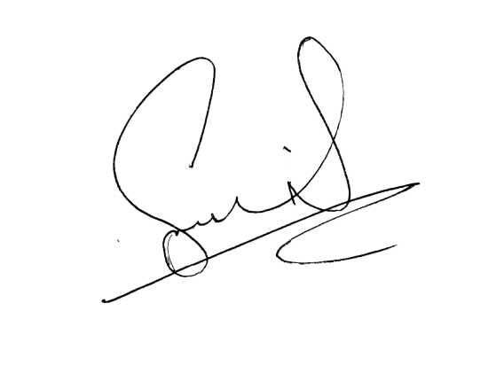
Corresponding Author
Sanwal Bakhsh
Department of Plant Pathology, University of Arid Agriculture,
Rawalpindi, Pakistan

