TITLE PAGE

a. Manuscript type: Original Research Article
b. Title: Phytochemical screening and estimation of antimicrobial activity of citrus peel
c. Running Title: Antifungal and antibacterial assay of citrus peel extracts
d. Authors: Uzma, Bashir*, Amna, Ali, Rahila, Hafeez, Muhammad Saleem Haider
e. Address of corresponding author: First Fungal Culture Bank of Pakistan (FCBP), Institute of Agricultural Sciences (IAGS), University of the Punjab, Quaid-e-Azam Campus, Lahore, Pakistan 54590.
f. Corresponding Author Emails: uzma.iags@pu.edu.pk, uzmamppl@yahoo.com
g. Number of table: 04
h. Number of figure: 01
i. Number of pages: 19
j. Author Address:
Dr. Uzma Bashir
Assistant Professor,
Institute of Agricultural Sciences (IAGS), University of the Punjab, Quaid-e-Azam Campus, Lahore, Pakistan 54590.

Fax No: 042-99231187
phone No: 042-99231846
PHYTOCHEMICAL SCREENING AND ESTIMATION OF ANTIMICROBIAL ACTIVITY OF CITRUS PEEL
Uzma Bashir*, Amna Ali, Rahila Hafeez, Muhammad, Saleem Haider
First Fungal Culture Bank of Pakistan (FCBP), Institute of Agricultural Sciences (IAGS), University of the Punjab, Quaid-e-Azam Campus, Lahore, Pakistan 54590.
*Corresponding author email: uzma.iags@pu.edu.pk, uzmamppl@yahoo.com
ABSTRACT
The present investigation evaluated the antimicrobial potential of aqueous and methanolic extract of Citrus reticulate fruit peel in vitro. The antimicrobial activity of C. reticulate fruit peel extracts were tested against ten strains of bacteria and five fungal strains. The stock solution of extract was prepared and 1%, 2%, 3%, 4% and 5% concentrations of aqueous and crude extract were used for antimicrobial assays by agar well diffusion technique. Afterwards results of zone of inhibition (mm) of different bacterial and fungal agents at various concentrations of C. reticulate are expressed as mean ± standard deviation. Extracts obtained from the organic solvent and water showed different antagonistic properties with the same bacterial strains. The antibacterial efficacy of methanolic peel extract against pathogenic bacteria showed varied level of inhibition. Moreover, in case of methanolic peel extract the growth of Syntrophospora sp., A. xylinum, M. visconsensis, X. nematophilis and Oscillospira sp. were exhibited maximum inhibition zone ranging from 36.0-47.0mm. However no antifungal activity was observed against aqueous and solvent extract. The results of the phytochemical screening indicated the presence of flavonoids, alkaloids, saponins, tannins, triterpenoids, phytosterols and steroids. The success of present investigation could lead to the developmentof cheap, easily available and relatively safe bactericides from citrus plant.
Key words: Citrus, fruit peel, antimicrobial activity, methanolic extract, phytochemical tests
INTRODUCTION
Plants which contain ingredients that can be used for healing purpose or which are forerunner of chemo-pharmaceuticals semi synthetic new medication is referred as medicinal plant (Salih et al., 2003). Medicinal plants probably the best resource to attain a range of drugs as phytochemicals are more specific. Phytochemical offer unique system for architectural variety and scientific performance which is essential for drug finding. Citrus belongs to Rutaceae family, common name is orange and this descends from South Eastern Japan, probably in Indian or Southern Chinese suppliers. Citrus is a light yellow, elliptically shaped berry fruits. Citrus fruit in general contain sugar, polysaccharide, organic-acid, fats, carotenoids, vitamins, minerals, flavonoid ingredients. citrus is an excellent resource of potassium, calcium mineral and vitamin C. citrus juice have been revealed to demonstrate anti-microbial activity against Vibrio cholera (Hiroyuki et al., 2006).
The peel of citrus or lime fruits and vegetables is a rich resource of flavanones and many polymethoxylated flavones, which are very rare in other plants. These substances, not only perform an essential physical and ecological role, but are also of commercial attention because of their wide range of applications in the food and pharmaceutical sectors. Major flavanones and poly-methoxy flavones of citrus farming is possibly one of the most essential professional and commercial agricultural activities of the world (Ortuno et al., 2006). An anti-microbial is a substance that destroys or stops the development of bacteria, fungus, protozoa or viruses. Antibiotics are those ingredients which are produced by living thing that destroys or stops the development of another micro-organism. Medications are generally used against bacteria, antiviral are used specifically for treating viral attacks. Anti-fungal are used to cure fungus attacks, some of these adverse reactions can be debilitating if the drug is not used properly. Several microbial derived antibiotics are currently in use to cure a variety of individual disease, therefore the action must be taken to control the use of antibiotics, develop new drugs either artificial or organic, for a long period, plant have a valuable source of organic products for maintaining individual health (Pandey et al., 2011). The purpose of present research was to estimate the antimicrobial activity of peel extract (methanolic and aqueous) of C. reticulata against bacterial and fungal strains in vitro and their pytochemical analysis which are responsible for antimicrobial activity.
MATERIALS AND METHODS
Test microorganisms: The tested bacterial strains [Xanthomonas axonopodis (FCBP: 007), Pseudomonas syringae (FCBP: 010), Xanthomonas nematophilis (FCBP: 112), Xenorhabdus luminescens (FCBP: 119), Kurthia gibsonii (FCBP: 225), Syntrophospora sp. (FCBP: 226), Acidovorax temperans (FCBP: 227), Oscillospira sp. (FCBP: 231), Acetobacter xylinum (FCBP: 239) and Moellerella visconsensis (FCBP: 253)] and fungal cultures [(Alternaria alternata (FCBP: 1238), Fusarium oxysporum (FCBP: 1211), Curvularia clavata (FCBP: 1251), Aspergillus niger (FCBP: 1214) and Aspergillus flavus (FCBP: 1142)] were procured from First Fungal Culture Bank of Pakistan (FCBP), Institute of Agricultural Sciences (IAGS), Lahore Pakistan.
Material collected: Plant used in this study was Citrus reticulate L. (Bitter Orange or lemon orange). The peels were collected from the local fruit juice shops. After collection, the peel was shade dried at room temperature (30–35 ºC). Twenty gm of peel of oranges and lemon was coarsely powdered using a mortar and pestle and were further reduced to powder using an electric blender. The powder was transferred into closed containers for further use.
Extract Preparation: Aqueous extract: 20 g of powdered samples of citrus peel was weighed and suspended in 200 mL of water for half hour and followed by filtering through Whattman filter paper. These extracts were evaporated to get paste which was transferred and stored in sterile bottles under refrigerator for further use. Methanolic extract: 20 g of powdered samples were added to 200 mL of methanol and extraction was done for 72 hours, followed by filtering through Whattman filter paper. The extracts were later evaporated to get paste of samples which were stored and refrigerated for supplementary tests.
Concentration of extract: The stock solution of the methanolic extract was prepared by dissolving 10 mg of the Citrus fruit peel extract in 10 mL dimethyl sulfoxide (DMSO). The following concentrations were prepared: 5%, 4%, 3%, 2% and 1% of aqueous and crude extract. For antimicrobial sensitivity testing, concentrations taken were from 1 to 20 μg/mL. Standard antibacterial agents, Tetracycline, and antifungal agent, Fluconazole (Belco Pharmaceuticals, Bahadurgarh, India) served as positive control. DMSO (HPLC grade) was used as negative control.
Antimicrobial Assay: The fungal and bacterial spore suspensions were prepared in normal saline by transferring the organism from fresh cultures (1 × 10⁸ cells/mL). Antimicrobial assay was performed with the help of agar well diffusion method (Tanaka et al., 2002). Nutrient agar plates were prepared for bacterial species while Malt extract agar for fungal isolates. Fifty µL inoculum of each species was uniformly spread on agar plates with the help of spreader, after 5 minutes one well approximately 5 mm diameter was bored with the help of borer. The equal volume (50 µL) of each concentration of aqueous and methanolic extract was poured into the wells on separate plates. The plate was incubated overnight at 37 ºC for bacterial species and at 25±27 ºC for fungal isolates. After incubation the zones of inhibition were measured and recorded. These studies were performed in triplicate. Data was statistically analyzed.
Phytochemical screening of extract: The citrus peel extract was analyzed for presence of various bioactive compounds.
1. Ninhydrin test: This was performed by following the method described by Ali et al. (2014). Crude extract was boiled with 2 mL of 0.2% solution of ninhydrin, appearance of violet color indicated the presence of amino acids and proteins.
2. Iodine test: Iodine test was carried out according to the method used by Bansode and Chavan (2012). Crude juice was mixed with 2 mL of iodine solution. Appearance of dark purple or blue coloration indicated the existence of carbohydrates.
3. Phenols and Tannins test: Phenols and Tannins indication test was carried out according to the process described by Lawal et al. (2013). Crude juice was mixed with 5 mL of distilled water and heated for 10 minutes, then added 5-6 drops of 1% ferric chloride. Appearance of dark green or blue black color shows the existence of phenols and tannins.
4. Alkaline reagent test: According to Lawal et al. (2013) test was done by accumulation of 2 mL of NaOH in crude juice then mixture appeared into yellow. After wards yellow color turned into colorless by adding little amount of diluted acid which indicated the presence of flavonoides.
5. Saponins test: This test was done by mixing of 0.2 mL of crude juice with 4.8 mL of distilled water in a test tube and it was shaken vigorously. The presence of saponins was indicated by the presence of stable foam in the test tube (Lawal et al., 2013).
6. Salkowski‘s test: Lawal et al. (2013) illustrated this test by merging of 2 mL of chloroform and 2 mL of concentrated H₂SO₄ in crude extract with gentle shaking. The steroidal reddish ring around the test tube showed the glycone portion of the glycoside.
7. Steroid test: Bansode and Chavan (2012) described this test by sidewise adding of 2 mL chloroform, 2 mL conc. H₂SO₄ and 2 mL acetic acid into crude extract. After that mixture turned into greenish coloration indicated the presence of steroids.
8. Cardiac glycosides test: This test was exhibited followed by the method described by Ali et al. (2014). Crude extract (2 mL) was mixed with 1mL of glacial acetic acid containing 1-2 drops of FeCl₃ solution; this was under layered with 1mL of conc. H₂SO₄. Brown coloration shows the characteristics of cardiac glycoside.
9. Phlobotannins test: This test was performed by Pandey et al. (2011) method with some modifications. For phlobotannins test citrus extract was boiled with 1% HCl and then red precipitates were observed.
10. Terpenoids test: Five milliliter of sample was added to 2 mL of chloroform and 3 mL of conc. H₂SO₄. Reddish brown color formed shows the presence of terpenoids (Ali et al., 2014).
11. Carbonyl test: Two milliliter of crud extract was mixed with few drops of 2, 4-dinitrophenyl hydrazine. Appearance of yellow crystals shows the presence of carbonyl (Kumar et al., 2011).
RESULTS AND DISCUSSION
In the present study the antimicrobial activities of the peel of citrus fruits has been investigated. The antimicrobial effect of C. reticulate fruit peel study involves a comparison of the inhibition zones of its aqueous and methanolic extracts (Table 1-3) with those of commercially developed antibiotics. Methanolic extract citrus peel showed a significant antibacterial activity against all the test organisms. The activity of C. reticulate fruit peel extract against both gram-positive and gram-negative bacteria is an indication of its broad spectrum activity, and thus can be used as source antibiotic substances for drug development that can be used for control of these bacterial infections. Results of zone of inhibition (mm) of different bacterial and fungal agents at various concentrations of C. reticulate are expressed as mean ± standard deviation (Table 1) and (Table 2), respectively. As per the antimicrobial investigations, the methanolic extract exhibited antibacterial activity against Oscillospira sp. with 47.0 mm, and appreciable activity with X. nematophilis (41.3 mm) (Table 2). Consequently no antifungal activity was observed against aqueous and methanolic extracts of citrus fruit peel (Table 3). The phytochemical screening results indicated the presence of carbohydrates (reducing sugars, hexose sugars, non-reducing polysaccharides, gums, and mucilages), flavonoid glycosides, coumarin glycosides, volatile oils, organic acids, fats and fixed oils as the main constituents (Figure 1). Finally phytochemical analysis exposed the existence of secondary metabolites like steroids, alkaloids; phenols and flavonoids etc. were present in trace amounts in the peel (Table 4).

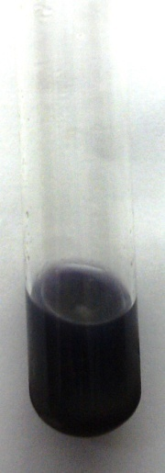
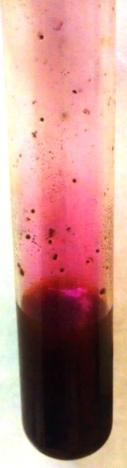
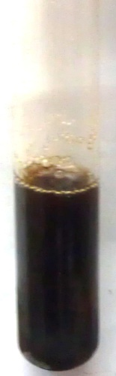
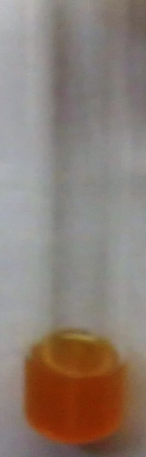
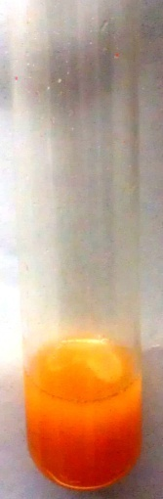
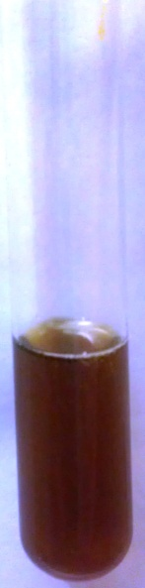
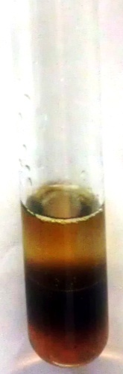
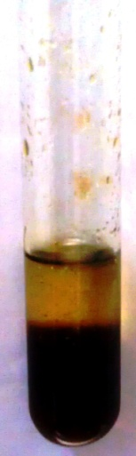
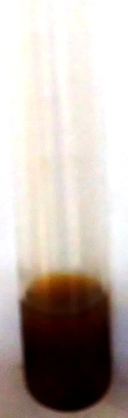
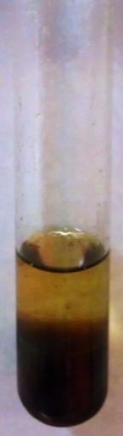
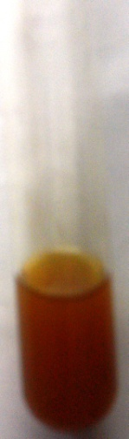
A
B
C
D
E
H
F
G
I
J
K

Figure 1. Phytochemical analysis of citrus peel extract. (A) Ninhydrine test (B) Iodine test (C) Tannin test (D) Flavenoides test (E) Saponins test (F) Salkowski test (G) Steroid test (H) Cardiac glycoside test (I) Phlobabatannis test (J) Terpenoids test (K) Carbonyl test
Table 1. Antibacterial Activity of aqueous extract of citrus peel against different bacterial species
FCBP Acc no | Name of Bacterial pathogens | Control | Concentration of Aqueous Extract  (Inhibition zone in mm)
FCBP Acc no | Name of Bacterial pathogens | Control | 1% | 2% | 3% | 4% | 5%
007 | Xanthomonas axonopodis | 28.9±0.09d | 11.8±0.12a | 12.4±0.14a | 13.0±0.09ª | 13.4±0.09b | 14.0±0.12b
010 | Pseudomonas syringae | 35.8±0.05c | --- ND | --- ND | --- ND | --- ND | --- ND
119 | Xenorhabdus luminescens | 35.8±0.04c | --- ND | 10.0±0.21cd | 11.3±0.15c | 12.0±0.09c | 12.0±0.14c
225 | Kurthia gibsonii | 35.8±0.09c | ---- ND | ---- ND | ---- ND | 10.0±0.09e | 10.3±0.15e
226 | Syntrophospora sp. | 40.9±0.09b | ---- ND | ---- ND | 10.3±0.07e | 11.0±0.04d | 11.0±0.09d
227 | Acidovorax temperans | 28.9±0.09d | --- ND | --- ND | --- ND | --- ND | --- ND
239 | Acetobacter xylinum | 40.9±0.06b | 11.0±0.01ab | 12.0±0.15ab | 12.0±0.09b | 13.2±0.07bc | 14.0±0.04b
253 | Moellerella visconsensis | 40.9±0.04b | 10.0±0.08b | 10.3±0.09c | 11.0±0.08cd | 12.0±0.09c | 12.00.07c
112 | Xanthomonas nematophilis | 40.9±0.09b | --- ND | --- ND | --- ND | --- ND | --- ND
231 | Oscillospira sp. | 45.8±0.03a | 10.0±0.09b | 11.3±0.13b | 12.5±0.24ab | 14.8±0.09a | 16.00.04a
ND: Activity not detected
Table 2. Antibacterial Activity of methanolic extract of citrus peel against different bacterial species
FCBP Acc no | Name of Bacterial pathogens | Control | Concentration of Methanolic Extract  (Inhibition zone in mm)
FCBP Acc no | Name of Bacterial pathogens | Control | 1% | 2% | 3% | 4% | 5%
007 | Xanthomonas axonopodis | 28.9±0.09d | 13.0±0.12e | 14.3±0.14f | 18.0±0.09g | 19.3±0.09h | 26.3±0.04g
010 | Pseudomonas syringae | 35.8±0.05c | --- ND | 12.3±0.06g | 18.3±0.08g | 24.0±0.09e | 31.0±0.14f
119 | Xenorhabdus luminescens | 35.8±0.04c | --- ND | 15.0±0.21e | 22.3±0.15e | 29.0±0.09c | 34.0±0.09e
225 | Kurthia gibsonii | 35.8±0.09c | ---- ND | 11.0±0.09h | 15.0±0.06h | 20.0±0.09g | 34.0±0.21e
226 | Syntrophospora sp. | 40.9±0.09b | 15.0±0.07d | 17.0±0.09de | 19.3±0.07f | 26.0±0.04ef | 37.0±0.09c
227 | Acidovorax temperans | 28.9±0.09d | 12.0±0.09f | 14.0±0.08f | 15.0±0.09h | 20.0±0.05g | 26.3±0.09g
239 | Acetobacter xylinum | 40.9±0.06b | 16.0±0.01c | 20.0±0.15c | 24.0±0.09d | 27.0±0.07e | 36.3±0.09d
253 | Moellerella visconsensis | 40.9±0.04b | 15.3±0.08d | 18.0±0.09d | 25.0±0.08c | 28.0±0.09d | 37.0±0.04c
112 | Xanthomonas nematophilis | 40.9±0.09b | 17.0±0.05b | 22.0±0.09b | 29.0±0.09b | 36.0±0.08b | 41.3±0.09b
231 | Oscillospira sp. | 45.8±0.03a | 20.0±0.09a | 24.3±0.13a | 30.0±0.24a | 37.0±0.09a | 47.0±0.09a
ND: Activity not detected
Table 3. Antifungal Activity of aqueous and methanolic extract of citrus peel against different fungal species

FCBP Acc no | Name of fungal pathogens | Inhibition zone in mm
FCBP Acc no | Name of fungal pathogens | Control | Aqueous extract | Methanolic extract
1238 | Alternaria alternata | 29.5±0.12 | ---- ND | ---- ND
1211 | Fusarium oxysporum | 36.9±0.06 | ---- ND | ---- ND
1251 | Curvularia clavata | 41.7±0.09 | ---- ND | ---- ND
1214 | Aspergillus niger | 27.8±0.06 | ---- ND | ---- ND
1142 | Aspergillus flavus | 37.8±0.09 | ---- ND | ---- ND
ND: Activity not detected
Table 4. Phytochemical analysis of peel extract of citrus fruit
Tests | Extract of citrus peel | Inference
Test for Proteins:  Ninhydrin test | + | Proteins present
Test for Carbohydrates  Iodine test | + | Carbohydrates present
Test for Phenols and Tannins | + | Phenols and tannins present
Test for Flavonoids  Alkaline reagent test | + | Flavonids present
Test for Saponins | + | Saponins present
Test for Glycosides  Salkowski‘s test | + | Glycosides present
Test for Steroid | + | Steroids present
Test for Cardiac glycosides | + | Cardiac glycosides present
Test for Phlobotannins | + | Phlobotannins present
Test for Terpenoids | + | Terpenoids present
Test for Carbonyl | + | Carbonyl present

The peel of citrus or lime fruits are a prosperous source of flavanones and many polymethoxylated flavones, which are very unusual in other vegetation. These substances, not only play an important physical and environmental role, but are also of commercial interest because of their variety of applications in the food and farming industry. In present investigation the fruit extracts were prepared from dried samples as has been revealed previously by study (Ekwenye and Edeha, 2010). In order to get anti-microbial activity of various plant ingredients against test micro-organism, Agar well diffusion method was used as has been conducted previously by Ramachandra et al. (2013).
The anti-bacterial activity of the ingredients suggests their possible use for the treatment of attacks caused by the analyzed bacteria. Prasad (2012) and Maruti et al. (2011) revealed that the solvent extract of citrus peel showed activity against different microbial strains while evaluating their results with our findings shows that our peel extract has a high degree of anti-bacterial activity. However, this distinction may be because of the difference in the phytochemical composition in various parts of the plant or may be also due to the extraction method used or ecological factors or difference in the genotypes of the citrus peel used (Osarumwense et al., 2011). The citrus peel extracts revealed higher anti-bacterial activity as that of the standard medications used in the research. All tested bacteria in this research were multiple drug resistant bacteria. The chemotherapeutic potential of the citrus peel could be due to the presence of flavonoids, alkaloids, saponins, tannins, triterpenoids, phytosterols and steroid chemicals. As new drug-resistant microbial stresses appear, herbal drugs are being looked as very important source for finding of new agents for the treatment various conditions related to attacks. Plants from the genus citrus or lime are well-known herbs used in traditional medicine for their efficiency against a variety of illnesses, such as skin disease, due to the advantage of the variety of additional metabolites accountable for their anti-bacterial activity. There has been increasing interest in the development of new types of effective and non-toxic anti-microbial compounds. . Conversely, no antifungal activity revealed against aqueous and methanolic extract of citrus peel and these results are similar to study of Okwu et al. (2007) and Osarumwense et al. (2011). The phytochemistry of C. reticulata methanolic extract revealed the presence of carbohydrates (reducing sugars, hexose sugars, non-reducing polysaccharides, gums, and mucilages), flavonoid glycosides, coumarin glycosides, volatile oils, organic acids, fats and fixed oils (Kumar et al., 2011). Most of the organic chemical constituents reported are known to possess aromatic phenolic compounds, which are known for their wide spectra of antimicrobial activity (Kabra et al., 2012).
In case of microbial attack a group of flavonoids (hydroxylated phenolic ingredients) produced by plants (Cowan, 1999). The flavonoids present in the citrus peel methanolic extract may be responsible for the anti-microbial action. Therefore, the existence of organic chemicals along with flavonoids might have provided high anti-microbial activity of methanolic extract of C. reticulata peel. In present study, tested bacterial strains were controlled with citrus extract with different levels of resistance. This is recommended that the phenolic ingredients might significantly promote the anti-bacterial action of the test extract. Further, medicinal and scientific tests are required to understand the procedure and the actual effectiveness of this herbal extract in treatment of various plant infections and diseases.
CONCLUSION
The outcomes showed that the methanolic extract of C. reticulata peel extract was able to inhibit tested bacteria used in this research with different degrees of inhibition. On the other hand, some examined bacterial strains were not scored self-consciousness against C. reticulata peel extract. In short, C. reticulata peel methanolic extract has a potential source of natural antimicrobials. Primary focus of the research is to minimize the growth of microbial species by using different ingredients of C. reticulata peel and the outcomes shows that these ingredients are capable to cure some of the microbial diseases in plants.
REFERENCES
Ali, S., S.M. Salman, M.T. Jan, M. Afridi and M.S. Malik. 2014. Comparative studies of various phytonutrients in citrus fruits. Pak. J. Chem. 4(2): 72-76.
Bansode, D.S. and M.D. Chavan. 2012. Studies on antimicrobial activity and phytochemical analysis of citrus fruit juicesagainst selected enteric pathogens. Int. Res. J. Pharm. 3(11): 24-32.
Cowan, M.M. 1999. Plant products as antimicrobial agents. Clin. Microbiol. Rev. 12: 564-82.
Ekwenye, U.N. and O.V. Edeha. 2010. The antibacterial activity of crude extract of Citrus sinensis (sweet orange). Int. J. Pharm. Bio. Sci. 1: 742-50.
Hiroyuki, T., K. Tetsuro, D. Masayuki, K. Afework and O. Fusao. 2006. Antimicrobial activity of citrus fruits juice against vibrio species. Int. Res. J. Pharm. 52(2): 157-160.
Kabra, A.O., G.B. Bairagi, A.S. Mahamuni and R.S. Wanare. 2012. In vitro Antimicrobial Activity and Phytochemical Analysis of the Peels of Citrus medica L. Int. J. Res. Pharm. Biomedical. Sci. 3(1): 34-42.
Kumar, A.K., M. Narayani, A. Subanthini and M. Jayakumar. 2011. Antimicrobial Activity and Phytochemical Analysis of Citrus Fruit Peels -Utilization of Fruit Waste. Int. J. Eng. Sci. Technol. 3(2): 12-28.
Lawal, D., J. Bala, S.Y. Aliyu and M.A. Huguma. 2013. Phytochemical screening and in vitro anti-bacterial studies of the ethanolic extract of Citrus senensis (Linn.) peel against some clinical bacterial isolates. Int. J. Inno. Appl. Stud. 2(2): 138-145.
Maruti, J., B. Dhanavade, S. Jalkute, D. Ghosh, D. Kailash and H. Sonawane. 2011. Study Antimicrobial Activity of Lemon (Citrus lemon L.) Peel Extract. Brit. J. Pharmacol. Toxicol. 2(3): 119-122.
Okwu, D.E., A.N. Awurum and J.I. Okoronkwu. 2007. Phytochemical composition and in vitro antifungal activity screening of extracts from citrus plants against Fusarium oxysporum of Okhra plant (Hibiscus esculentus). Afr. Crop Sci. Conf. Proceedings 8: 1755.
Ortuno, A.A., P. Baidez, M.C. Gomez, I. Arcas, A.G. Porras, S. Lidon, A. Del and J.A. Rio. 2006. Citrus paradisi and Citrus sinensis flavonoids: Their influence in the defence mechanism against Penicillium digitatum. Food Chem. 98(2): 351-358.
Osarumwense, P.O., L.O. Okunrobo and K.E. Imafidon. 2011. Phytochemical composition of Citrus sinensis (L.) Osbeck and its larvicidal and antimicrobial activities. Continental. J. Pharm. Sci. 5:15-9.
Pandey, A., A. Kaushik, S. Kumar and D. Tiwari. 2011. Evaluation of antimicrobial activity and phytochemical analysis of Citrus limon. J. Pharm. Biomedical. Sci. 13(13): 24-34.
Prasad, G. 2012. Evaluation of antimicrobial activity of Citrus aurantium against some gram positive and negative bacterial strains. Pharmacia I. 3: 14-26.
Ramachandra, Y.L., C. Ashajyothi, H.J. Sreepadaraja and S. Padmalatha. 2013. Antimicrobial activity of Citrus rind oil isolated from Citrus aurantium. Int. J. Pharma. World Res. 4(1): 46-54.
Salih, H.A. and A.M. Abass. 2003. Study of the fruit peels of Citrus sinesis and Punica granatum. J. Babylon Uni. (9) 3: 243-342.
Tanaka, H., M. Sato and S. Fujiwara. 2002. Antibacterial activity of isoflavonoids isolated from Erythrina variegata against methicillin resistant Staphylococcus aureus. Lett. Appl. Microbiol. 35: 494-498.

