Molecular Studies of Post-harvest Fungal Peach Fruit Rots; Fusarium sporotrichioides, Aspergillus niger, Aspergillus flavus, Penicillium chrysogenum and Cladosporium pseudocladosporioides
Abstract

Postharvest fungal rots are a continuous threat to perishable fruits worldwide. Fungal contamination is a significant factor affecting quality of peaches and resulting decline in their quantity. Postharvest health of peaches is of major concern for producers, consumers, marketers, and food industries globally. Early specie level detection of these deteriorating fungal rots is extremely important to adopt timely preventive measures and enhance shelf-life of peaches. In present study five fungal phytopathogenic rots were detected from peaches and identified based on molecular characterization using ITS universal fungal primers, EF-1α and β-tubulin (benA). Multi-locus characterization revealed fungal rots viz; Fusarium sporotrichioides, Aspergillus niger, Aspergillus flavus, Penicillium chrysogenum and Cladosporium pseudocladosporioides respectively. Phylogenetic tree was constructed in MEGAX software using Neighbour- Joining Method and 1000 bootstrap replicates were selected to represent the evolutionary history of the taxa analyzed. Prior to management of various fungal rots, their accurate diagnosis is compulsory. Our results are significant in developing opportune control strategies from the field to storage hence reducing qualitative and quantitative losses and to enhance shelf-life of peaches.
Keywords: Fusarium sporotrichioides, Aspergillus niger, Penicillium chrysogenum, Cladosporium pseudocladosporioides.

INTRODUCTION
Peach fruit is highly perishable after harvest, leading to substantial economic losses for grower and marketers (Spadaro & Droby, 2016). Several fungal pathogens contribute to this rapid decay (Moss, 2002; Kader, 2005). Peach is a stimulating fruit in handling practices and storage conditions because of its soft-flesh nature and texture (Zhao et al., 2015). It is estimated that about 25-30% loss of postharvest rots of peaches occurs in Pakistan (Rehman et al., 2020). In other parts of Asian continent, fungal postharvest phytopathogenic rots of perishable fruits contribute in about 30-40 % economic losses after harvesting in storage (Bashar et al., 2012; Parpia, 1976). Usually, the rapid loss in firmness of peaches during ripening process and infections caused by storage pathogens, fruit rot is observed which drastically restricts its shelf life which result delay in the progress of peach trade (Li et al., 2021). Phytopathogenic postharvest fungal rots are important issues limiting the storage life and market value of peaches, and ultimately leads to severe economic losses around the globe. Different postharvest fungal diseases of peach fruit include grey mold, black mold, green mold, blue mold, softening and rotting, caused by Fusarium sporotrichioides, Aspergillus niger, Aspergillus flavus, Penicillium spp, Rhizopus stolonifera, Fusarium spp., Alternaria spp., Collototrichum spp., and Cladosporium spp. all over the world which reduce nutritional, medicinal and economic value of peaches and effect storage period (Usall et al., 2015; Pscheidt & Ocamb, 2019; Sugar, 2002). Postharvest fruit losses usually develop along the food supply chain by fungal rots during handling, storage, transportation, processing, and marketing, thus resulting in the decline of quantity, quality and shelf life of perishable fruits. Fungal postharvest rots pose a serious threat limiting the market value of peaches, resulting in serious economic losses worldwide (Parfitt et al., 2010). Furthermore, postharvest fungal rots are often the major concern influencing consumer requirements.
Morphology based identification is a traditional method being used since ages. As technology progressed rapidly, novel trends for specie level identification of various plant pathogens are in practice. Among these PCR is one of the fastest and reliable technique for molecular level identification of fungal pathogens (Capote et al., 2012).
MATERIAL AND METHODOLOGY
Highly virulent isolates (16) collected from all district Rawalpindi Pakistan, were characterized based on molecular features and were further sequenced by using multi-locus genes. Genomic DNA extraction was carried out from a 48–72-hour old pure fungal culture using Prep Man Ultra Sample Preparation Reagent kit (Applied Biosystems TM, Foster City, CA, USA) (Hyeon et al., 2010; Elizaquivel & Aznar, 2008). About 50 μL of extraction reagent was transferred into micro-centrifuged Eppendorf tube that was labelled clearly and about 3-4 mm fungal mycelia was transferred to these tubes from pure culture petri plates. Micro-centrifuged sample tubes were vortexed for 30 seconds and heated in water bath for 8-10 min at 95ºC-100ºC. Further centrifugation at 16,000 rpm for 2 min was followed. Supernatant was transferred to new Eppendorf tubes whereas remaining fluid was discarded. Ultimately, extracted DNA was placed in 4ºC till further use. The universal region for fungi (ITS), were amplified by polymerase chain reaction against Fusarium spp. Aspergillus spp., Penicillium spp., and Cladosporium spp. Amplification was carried out by PCR with optimized conditions where amplification was carried out in a total 50 μL reaction. GoTaq® Green Master Mix (M712) was used prior to PCR for sample preparation and amplifications were performed in a (Bio-Rad T100) programmable thermocycler, 94ºC for 3 min; followed by 35 cycles at 95ºC for 30 sec, 55 °C (Fusarium spp), 59°C (Penicillium spp.), 60°C for (Aspergillus spp.) and 55°C for (Cladosporium spp.) followed by annealing for 1minute; denaturation for 1 min; and a final extension for 10 min at 72ºC. Gel electrophoresis was conducted for visualizing PCR product using (Nanopac-300), with 1.0% agarose gel (w/v) (Act gene USA). SYBER SAFE (100μg/ml) (Fisher Biotech) was used for staining having 1X Tris Borate acid EDTA (TBE buffer). Voltage (100 V) was adjusted for 30 minutes. Samples were loaded following (Quick-Load®) and regular molecular size for the comparison with bands of DNA on the gel was used according to the protocol suggested by (Southern, 1975). Gel Doc Tm EZ imager (Bio-Rad USA) was used for visualizing gel bands. ExoSAP-IT DNA purification kit was used for refining and purifying PCR product following standard protocol. Firstly, denaturation (capture buffer) added to DNA samples, secondly GFX Microspin column was used for binding the membrane, afterwards washing and drying was performed to remove excessive salts and contaminants for obtaining purified samples and finally the elution buffer for eluting the purified sample from the column was used.
96-wells DNA sequencing plate was used loaded with primers (forward and reverse) along with 2 µL aliquots of purified DNA in a specific standard order. DNA sequencing was carried out at Iowa State University DNA sequencing facility center, (USA). MEGAX software was used for alignment of DNA sequences and were further confirmed on National Centre for Biotechnology Information (NCBI) on GenBank database website followed by Basic Local Alignment Search Tool (BLAST) program. Aligned sequences were submitted to NCBI for accession numbers allocation. Geneious Prime sequence analysis software was used for alignment of DNA sequences by removing all sequence gaps (Saitou & Nei, 1987). Furthermore, all sequences obtained from NCBI website along with our sequences were aligned by MUSCLE alignment in MEGAX (Kumar et al., 2016). Phylogenetic tree was constructed using Neighbor joining method with 1000 bootstrap values and standard cut off value (Saitou & Nei, 1987).

RESULTS AND DISCUSSION
A total of 16 highly pathogenic isolates of five postharvest fungal pathogens viz. Fusarium sporotrichioides, Aspergillus niger, Aspergillus flavus, Penicillium chrysogenum and Cladosporium pseudocladosporioides, detected were subjected to molecular characterization for specie level identification and confirmation. Universal primers for fungi (ITS) and specific gene regions Translation Elongation Factor (EF-1α) and β-tubulin (benA) were used for amplification of (03) isolates of Fusarium spp. Whereas a total of (13) isolates belonging to remaining 4 fungal genera were subjected to amplification with Internal Transcribed Spacer (ITS) region. which is universal for all fungi (White, 1990). Furthermore, specific gene regions, Translation Elongation Factor (EF-1α) and β-tubulin (benA) were amplified for genomic DNA amplification of Fusarium specie complex. Molecular characterization confirmed the post-harvest rots as Fusarium sporotrichioides (Table 1), Aspergillus niger, Aspergillus flavus (Table 2), Penicillium chrysogenum (Table 3) and Cladosporium pseudocladosporioides (Table 4).
Furthermore, phylogenetic trees were constructed using MEGAX software and MUSCLE alignment. For F. sporotrichioides isolates inferred with ITS, EF-1α, β-tubulin (benA) gene regions of rDNA nucleotide sequences were constructed using Neighbour joining tree along with 1000 bootstrap replicates (Figure 1). Similarly, A. niger isolates were inferred with ITS gene region in Neighbour joining tree (Figure 2), A. flavus (Figure 3), P. chrysogenum (Figure 4) and C. pseudocladosporioides (Figure 5), respectively.

Table 1: Details of Fusarium spp. isolates accession number inferred with ITS, TEF and β-tubulin gene regions primer used in the molecular study
Sr. No. | Isolate ID on NCBI | District of origin | Accession No. GenBank (ITS) | Accession No. GenBank EF-1α | Accession No. GenBank β-tubulin (benA)
1 | FUS9SM | Poonch | ON180670 | ON312093 | ON312091
2 | FUS21K | Rawalpindi | ON180671 | ON312094 | ON312092
3 | FUS63KP | Islamabad | ON180672 | ON312095 | ON312093

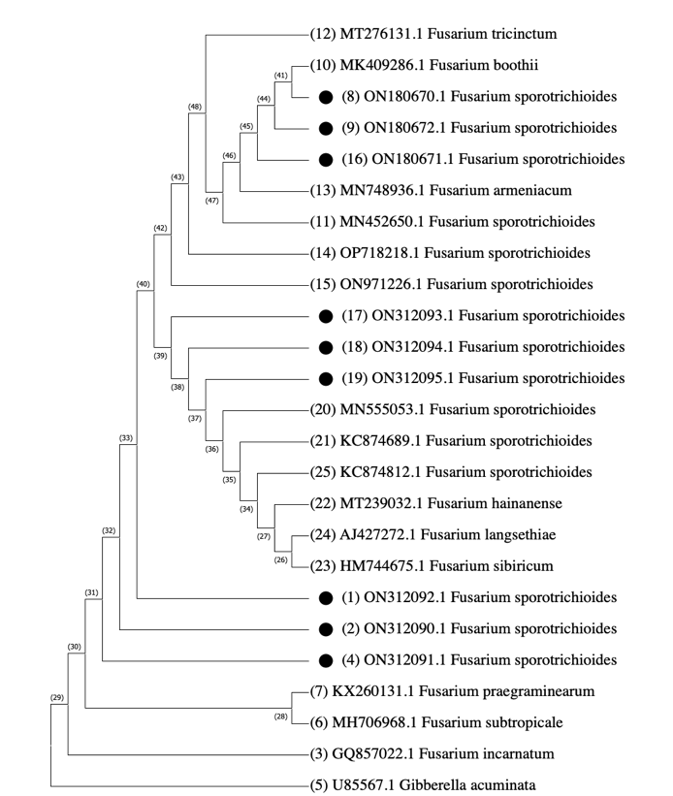
Figure 1 A phylogenetic tree constructed using MEGAX software and MUSCLE alignment. Isolates inferred with ITS, EF-1α, β-tubulin (benA) gene regions of rDNA nucleotide sequences of Fusarium isolates causing Fusarium rot of peach fruit. Neighbour joining tree construction method was applied along with 1000 bootstrap replicates. All missing data and gaps were removed while alignment in MEGAX software. Gibberella acuminata isolate (U85567.1) was used to root the tree.

Table 2: Details of Aspergillus niger, Aspergillus flavus isolates and their accession numbers assigned along with ITS gene region

Sr. No | Isolate ID on NCBI | District of Origin | Accession No. GenBank (ITS)
1 | ASN1 | Poonch | ON241768.1
2 | ASN2 | Rawalpindi | ON241769.1
3 | ASN3 | Poonch | ON241770.1
4 | ASF2R | Rawalpindi | ON228166.1
5 | ASF9S | Poonch | ON228168.1
6 | ASF63KP | Islamabad | ON228169.1

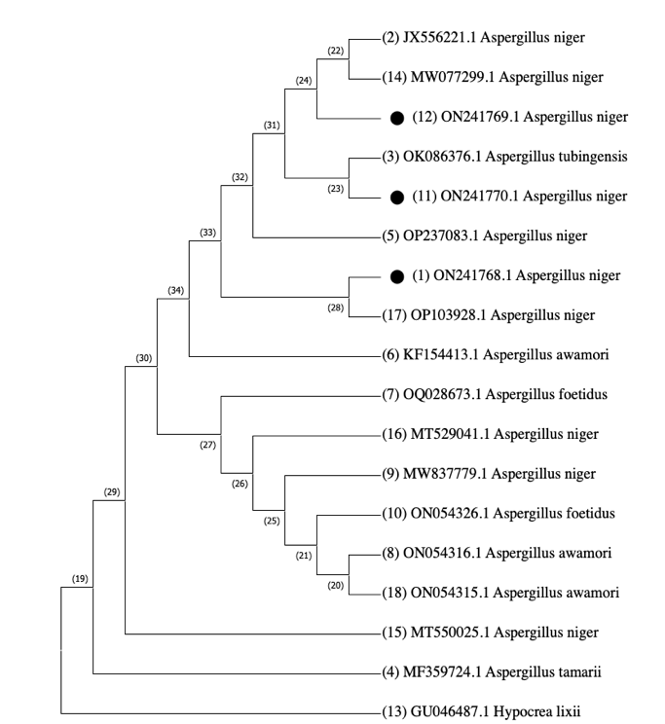
Figure 2 A phylogenetic tree constructed using MEGAX software and MUSCLE alignment. Isolates inferred with ITS gene regions of rDNA nucleotide sequences of Aspergillus spp. isolates causing black mold on peach fruit. Neighbour joining tree construction method was applied along with 1000 bootstrap replicates. All missing data and gaps were removed while alignment in MEGAX software. Hypocrea lixii isolate (MT449969.1) was used to root the tree.
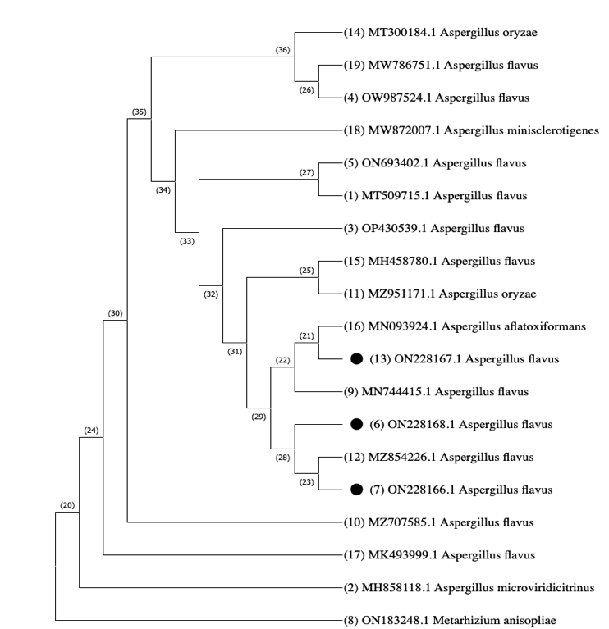
Figure 3 A phylogenetic tree constructed using MEGAX software and MUSCLE alignment. Isolates inferred with ITS gene regions of rDNA nucleotide sequences of Aspergillus spp. isolates causing green mold on peach fruit. Neighbour joining tree construction method was applied along with 1000 bootstrap replicates. All missing data and gaps were removed while alignment in MEGAX software. Metarhizium anispoliae (ON183248.1) was used to root the tree.

Table 3: Penicillium chrysogenum isolates along with assigned accession numbers
Sr. No | Isolate ID on NCBI | District of Origin | Accession No. GenBank (ITS)
1 | PEN11S | Rawalpindi | ON208825.1
2 | PEN13SM | Poonch | ON208826.1
3 | PEN21R | Islamabad | ON208827.1
4 | PEN43K | Poonch | ON208828.1

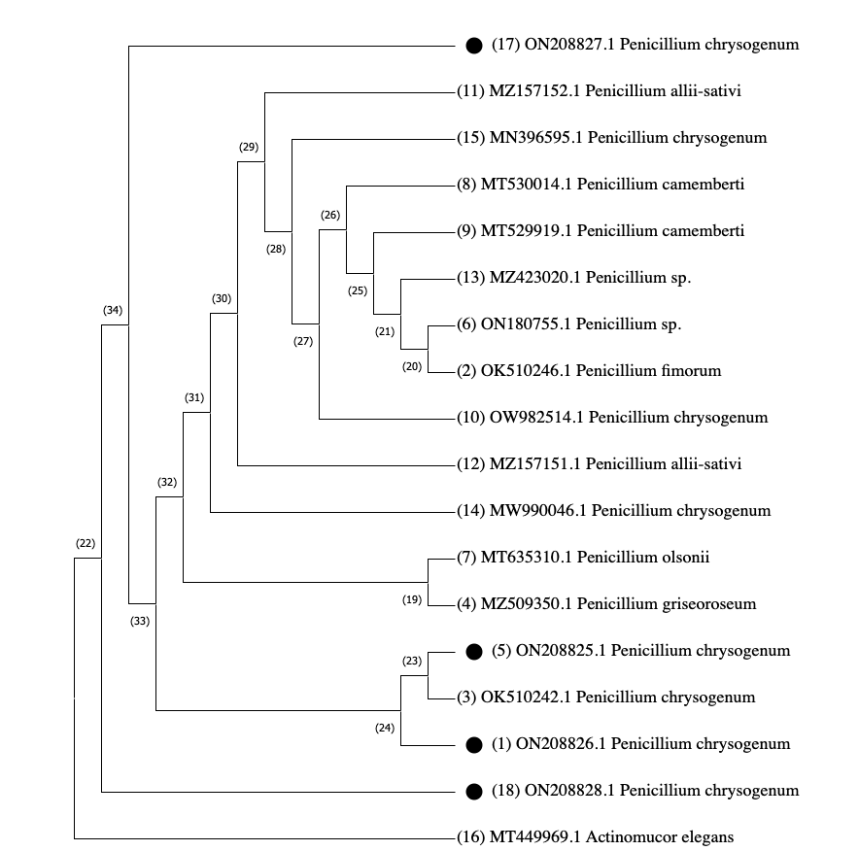
Figure 4 Phylogenetic tree constructed using MEGAX software and MUSCLE alignment. Isolates inferred with ITS gene regions of rDNA nucleotide sequences of Penicillium spp. isolates causing blue mold on peach fruit. Neighbour joining tree construction method was applied along with 1000 bootstrap replicates. All missing data and gaps were removed while alignment in MEGAX software. Actinomucor elegans isolate (MT449969.1) was used to root the tree.

Table 4: Cladosporium spp. isolates along with assigned GenBank accession numbers
Sr. No | Isolate ID on NCBI | District of Origin | Accession No. GenBank (ITS)
1 | CLD4KP | Poonch | ON228219.1
2 | CLD27KK | Rawalpindi | ON228220.1
3 | CLD9SM | Islamabad | ON228221.1

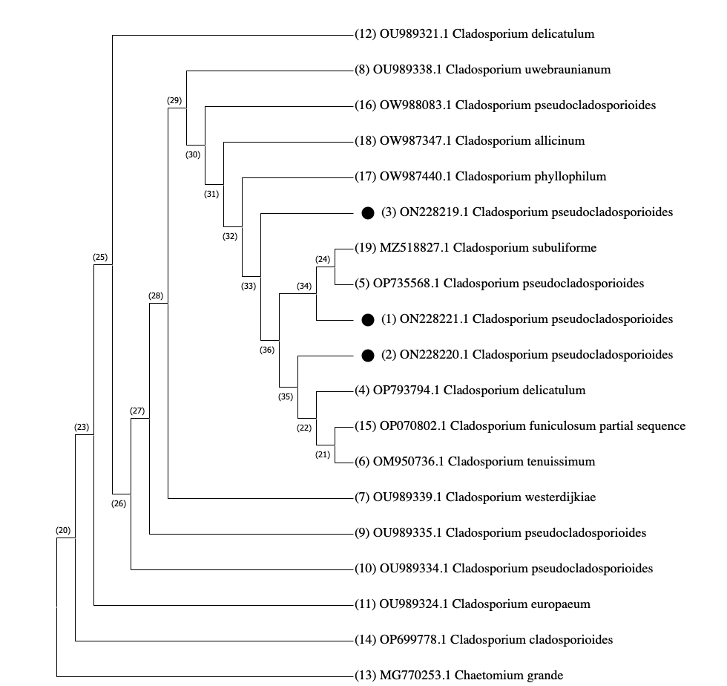
Figure 5 Phylogenetic tree constructed using MEGAX software and MUSCLE alignment. Isolates inferred with ITS gene regions of rDNA nucleotide sequences of Cladosporium spp. isolates causing Cladosporium rot on peach fruit. Neighbour joining tree construction method was applied along with 1000 bootstrap replicates. All missing data and gaps were removed while alignment in MEGAX software. Chaetmium grande isolate (MG770253.1) was used to root the tree.

Postharvest deteriorations primarily develop from damages that occur before and, most prominently, during or after harvest. Once spores of fungi are inoculated into these wounds, rapid fruit deterioration starts. Germinating conidia of fungi can also enter the intact fruit cuticle and then become established internally in the host (Adaskaveg et al., 2000). For accurate identification at specie-level, modern multi-locus sequencing are effective tools regarding molecular studies. Morphology based identification is a traditional method being used since ages. As technology progressed rapidly, novel trends for specie level identification of various plant pathogens are in practice. Among these PCR is one of the fastest and reliable technique for molecular level identification of fungal pathogens (Capote et al., 2012). In recent years for accurate identification at specie level DNA based characterization is most efficient and reliable method. Prior to management of various fungal rots, their accurate diagnosis is compulsory (Álvarez-Buylla, et al., 2012). Hence, molecular identification is considered the most accurate practice regarding characterization of various specimens and outlining the phylogenetic linkage between them (Freeman et al., 1998).
Narayanasamy in (2011) identified fungal rots based on symptoms and morphological features as traditional and conventional techniques. For accurate identification at specie-level, modern multi-locus sequencing are effective tools regarding molecular studies. Morphology based identification is a traditional method being used since ages. As technology progressed rapidly, novel trends for specie level identification of various plant pathogens are in practice. Among these PCR is one of the fastest and reliable technique for molecular level identification of fungal pathogens (Capote et al., 2012). In recent years for accurate identification at specie level DNA based characterization is most efficient and reliable method. Prior to management of various fungal rots, their accurate diagnosis is compulsory (Álvarez-Buylla, et al., 2012). Hence, molecular identification is considered the most accurate practice regarding characterization of various specimens and outlining the phylogenetic linkage between them (Freeman et al., 1998).
Many innovative methods for construction of phylogenetic trees are in practice. Among all of them, conferring the evolutionary history inferred by Neighbor-Joining method (NJM) is most accurate and reliable (Saitou & Nei, 1987). In present study the phylogenetic tree was constructed in MEGAX software using (NJM) and 1000 bootstrap replicates were selected to represent the evolutionary history of the taxa analyzed (Felsentein, 1985). Branches corresponding to partitions reproduced in minimum bootstrap replicates were collapsed and the percentage of replicate trees among which associated taxa were clustered together are represented prior to the branches (Taimura et al., 2004; Taimura, 2021; Stecher et al., 2020).

Conclusion
Present study revealed association of five different phytopathogenic rot fungi from peaches based on multi-locus sequencing. When in storage many biotic processes begin within peaches with reference to storage procedures, fungal rots exposure, and the microbial interaction in regulating different metabolites and complexes existing within this consistent association on the external surface of fruit. Due to intense fragile nature of peach, it is infected by numerous fungal infections after harvesting. Various fungal pathogens including black molds, blue molds, grey molds, Rhizopus rots, Cladosporium rots, fusarium rots, brown rots, etc cause risky spoilage to peaches. Prior to develop effective management strategies, exact specie level identification of phytopathogenic fungal rots is of extreme importance, to timely control fungal infection and adopt eco-friendly curative measures.
Conflict of Interest
No potential conflict of interest is declared.

Acknowledgement
Gull e laala performed experiment. Gull e laala, Gulshan Irshad and Farah Naz wrote manuscript. Ashfaq Ahmed Hafiz reviewed manuscript.
Authors Contribution
All authors equally contribute to the research.

REFERENCES

- Adaskaveg, J. E., Forster, H., and Thompson, D. F. 2000. Identification and etiology of visible quiescent infections of Monilinia fructicola and Botrytis cinerea in sweet cherry fruit. Plant Disease, 328-333.
- Álvarez-Buylla, A., Culebras, E., & Picazo, J. J. 2012. Identification of Acinetobacter species: is Bruker biotyper maldi-tof mass spectrometry a good alternative to molecular techniques. Infection Genetics and Evolution, 12(2), 345-349.
- Bashar, M. A, Shamsi, S., & Hossain, M. 2012. Fungi associated with rotten fruits in Dhaka Metropolis. Bangladesh Journal of Botany, 41(1), 115–117.
- Capote, N., Pastrana, A. M., Aguado, A., & Sánchez-Torres, P. 2012. Molecular tools for detection of plant pathogenic fungi and fungicide resistance. Plant Pathology, 151-202.
- Freeman, S., Katan, T., & Shabi, E. 1998. Characterization of Colletotrichum species responsible for anthracnose diseases of various fruits. Plant Disease, 82(6), 596-605.
- Felsenstein, J. 1985. Confidence limits on phylogenies: An approach using the bootstrap. Evolution, 39, 783-791.
- Kader, A. A. 2011. Postharvest biology and technology: An overview. InPostharvest Technology of Horticultural Crops, http://ucce.ucdavis.edu/files/datastore/234-2531.pdf
- Kumar, S., Stecher, G., & Tamura, K. 2016. MEGA7: molecular evolutionary genetics analysis version 7.0 for bigger datasets. Molecular Biology and Evolution, 33(7), 1870-1874.
- Li, M. X., Liu, C. F., Wang, R., Zheng, F. Y., Wang, J. J., Niu, C. T., & Li, Q. 2021. Optimization of Fermentation Process and Analysis of Aroma Components of Yellow Peach Wine. Journal Food Science Biotechnology, 40, 39–49.
- Moss, M. O. 2002. Mycotoxin review 1 Aspergillus and Penicillium. Mycologist, 16, 116-119.
- Narayanasamy, P. 2011. Detection of fungal pathogens in plants. In Microbial PlantPathogens-Detection and Disease Diagnosis. Springer, https://www.springer.com/gp/book/9789048197347
- Parfitt, J., Barthel, M., & Macnaughton, S. 2010. Food waste within food supply chains: Quantification and potential for change to 2050. Philosophy Transitional Research Society, 365, 3065–3081.
- Parpia, H. 1976. Post-harvest impact of their prevention on food supplies, nutrition and development. In: Symposium on Nutrition and Agricultural and Economic Development in the Tropics. Plenun Press New York, 195–206.
- Pscheidt, J. W., & Ocamb, C. M. 2019. Pear (Pyrus spp.) Storage rots. Pacific Northwest Plant Disease Management Handbook. Oregon State University, Corvallis, OR.
- Rehman, Z. U., Faisal, S. F., Humayun, S., & Muhammad, A. B. S. 2020. Peach Rot Disease Prevalence in the Markets of Federal Capital Territory, Pakistan. Pakistan Journal of Agricultural Research, 33, 429.
- Saitou, N., & Nei, M. 1987. The neighbor-joining method: A new method for reconstructing phylogenetic trees. Molecular Biology and Evolution, 4, 406-425.
- Spadaro, D., & Droby, S. 2016. Development of biocontrol products for postharvest diseases of fruit: The importance of elucidating the mechanisms of action of yeast antagonists. Trends in Food Science and Technology, 47, 39–49.
- Stecher, G., Tamura, K., & Kumar, S. 2020. Molecular Evolutionary Genetics Analysis (MEGA) for macOS. Molecular Biology and Evolution, 37, 1237-1239.
- Sugar, D. 2002. Management of postharvest diseases. Fruit Quality and Its Biological Basis. Sheffield Academic Press, 225-252.
- Tamura, K., Stecher, G., & Kumar, S. 2021. MEGA 11: Molecular Evolutionary Genetics Analysis Version 11. Molecular Biology and Evolution https://doi.org/10.1093/molbev/msab120.
- Tamura, K., Nei, M., & Kumar, S. 2004. Prospects for inferring very large phylogenies by using the neighbor-joining method. Proceedings of the National Academy of Sciences (USA), 101,11030-11035.
- Usall, J., Casals, C., Sisquella, M., Palou, L., & de Cal, A. 2015. Alternative technologies to control postharvest diseases of stone fruits. Stewart Postharvest Review, 11, 1–6.
- White, T. 1990. Page 315 in: PCR Protocols: A Guide to Methods and Applications. MA Innis et al., eds. In: Academic Press, San Diego, CA, https://onlinelibrary.wiley.com/doi/abs/10.1016/0307-4412(91)90165-5
- Zhao, X., Zhang, W., Yin, X., Su, M., Sun, C., Li, X., & Chen, K. 2015. Phenolic composition and antioxidant properties of different peach Prunus persica (L.) Batsch cultivars in China. International Journal of Molecular Sciences, 16(3). 5762-5778.

