Comprehensive Assessment of Quality Parameters in Oyster Mushrooms (Pleurotus spp.) Under Varied Substrates and Environmental Conditions
ªMuhammad Umer Hassan, ^{b}Saif Ullah, ^{b}Asim Mehmood, ^{c}Aqsa Amin, ªMuhammad Umer Shahzad
ªDepartment of Plant Pathology, University College of Agriculture, Sargodha, Pakistan
^{b}Crop Diseases Research Institute, National agriculture Research Centre, Islamabad, Pakistan
^{c}Department of Plant Pathology, Arid Agriculture University, Islamabad, Pakistan
Corresponding Author: Aqsa Amin*
Email:aqsaamin1999@gmail.com
ABSTRACT
The quality characteristics in oyster mushrooms (Pleurotus spp.) under various environmental conditions and substrate compositions are thoroughly evaluated in this study. The investigation encompasses temperature ranges of 10-15°C, 15-25°C, and 25-35°C, along with humidity levels of 65% and 85%. Key Parameters, including First Primordial Initiation (DPI), Number of Effective Fruiting Bodies (NFB), Biological Efficiency (BE), and Yield (in grams) per 500g of substrate dry weight, Stem Diameter, and Total Days of cultivation, were employed to gauge mushroom development. The findings reveal that the optimal conditions for Oyster Mushroom growth are observed at 15-25°C with 85% relative humidity, resulting in the highest Biological Efficiency (BE) at 56% compared to other environmental ranges. Notably, substrate A, a combination of wheat straw and sawdust, yielded the most favorable outcomes, exhibiting an average DPI of 7, NFB of 50, and a yield of 375g, with a remarkable BE of 75%. Additionally, cardboard and sawdust substrates displayed accelerated growth, registering average DPI values of 9 and 6, NFB counts of 45 and 46, and average yields of 366g and 251g, respectively. However, it is essential to note that wheat straw substrates exhibited a longer maturation period of 35 days and moderate growth, while leaves displayed slower growth, with an average DPI of 8 and a yield of 241g. In conclusion, this research underscores the intricate interplay between substrate composition, environmental conditions, and the quality parameters of Oyster Mushrooms. The study provides valuable insights into optimizing mushroom cultivation practices by strategically selecting suitable substrates and environmental settings to enhance both yield and quality.
Key Words: Oyster Mushrooms, Substrate Composition, Quality parameters, Mushroom Cultivation, Environmental Conditions.
INTRODUCTION
Mushrooms are enigmatic creatures has epigeous or hypogeous fruiting bodies with plenty of nutritional benefits {Bao, 2004 #241}{Bao, 2004 #241}{Bao, 2004 #241}(Bao, Kinugasa, & Kitamoto, 2004) and are macro-filamentous fungi (out of a total of 97330 other filamentous fungi (Patel, Naraian, & Singh, 2012). Mushrooms are abundant in biodiversity, and there are numerous varieties, each with special qualities and traits with 2000 edible out of 14-22000 mushrooms all over the world (Hawksworth, 2001). Mushrooms come in a beautiful variety of shapes, from the Amanita muscaria's towering, umbrella-like tops to the delicate, golden chanterelles lurking beneath the forest floor. Mushrooms are beautiful, but they also hold a wealth of undiscovered mysteries (Mahari et al., 2020). Multiple kinds of mushrooms, particularly oyster mushrooms (Pleurotus spp.), are raised for profit motives in the mushroom business. So mushrooms require having various favorable environments like temperature conditions, humidity, and substrate conditions (Haimid, Rahim, & Dardak, 2013).
The oyster mushroom scientifically known as Pleurotus ostreatus, was originally officially described in 1975 by N.J. Freiherr one of the Dutch scientists. Later, a German scientist incorporated these oyster mushroom species into the genus Pleurotus. Twenty-five oyster mushrooms are globally commercialized out of 38 mushrooms that are under the umbrella of the genus Pleurotus (Rathod, Gadade, Thakur, & Pathak, 2021).Oyster mushrooms, also known as Pleurotus species, are an edible mushroom that can be found all over the world but is notably prevalent in southeast, Europe, and China. Compared to other types of mushrooms, oyster mushrooms are the most straightforward, inexpensive, and quickest to cultivate. They also require a small amount of preparation and manufacturing technology (Mandeel, Al-Laith, & Mohamed, 2005). Agaricaceae is a family that has Oyster mushrooms that have no chlorophyll and are sporophytic in mode of nutrition (Randive, 2012). Spawn is a substrate in which mycelium is impregnated and grows, and it acts as a seed in the development of mushrooms (Senatore & Soriente, 2004), a variety of grains is used to produce spawn like sorghum, barley, and paddy grains also(Khonga, Khare, & Jongman, 2013) on comparison, sorghum is a mycelium carrier than wheat and rice grains because it has short spawn running time (Jongman, Khare, & Loeto, 2018). It is critical to keep the compost and substrate from drying out (BISWAS, Datta, & Ngachan, 2011).
They typically flourish in the trash and colonize decomposing organic matter in nature. They exude enzymes that break down the decaying organic matter into tiny fragments that are subsequently taken in as meals (Utami & Susilawati, 2017). The cultivation of oyster mushrooms, including P. ostreatus, is simpler, quicker, and more efficient than that of other mushroom species (Mandeel, Al-Laith, & Mohamed, 2005). The significant protein content is 30–40% on a dry weight basis. According to our most recent findings, key phases in the management of cholesterol homeostasis are impacted by the consumption of oyster mushrooms in the diet. The biological transformation and biological efficacy ranged from 16.7 to 38.8% and 37.2 to 78.7%, respectively (Ibrahim, Boon, Mazidi, & Yaacob, 2020). Mushrooms are recognized for their high vitamin C and B complex content, which is crucial for human wellness, and additionally for their protein content level, which varies from 1.6 to 2.5 percent along with the mineral (Nongthombam, Kumar, Ladli, Madhushekhar, & Patidar, 2021).
This research paper's main goal is to thoroughly assess the quality indicators of oyster mushrooms (Pleurotus spp.) under the influence of diverse substrates and various environmental factors, such as temperature and humidity. First Primordial Initiation (DPI), Number of Effective Fruiting Bodies (NFB), Biological Efficiency (BE), Yield in grams (g) per 500 g of substrate dry weight, Stem Diameter, and Total Days Needed for Cultivation are the main areas of emphasis. In order to improve mushroom growing techniques, the study tries to identify the ideal circumstances for mushroom development and yield, taking substrate type and environmental aspects into consideration.
MATERIAL AND METHODS
This study was conducted at the University of Sargodha's Tissue Culture Lab, College of Agriculture, and for the purpose of examining all aspects of oyster mushroom (Pleurotus ostreatus) production and comparing yields based on various substrates.
STRATEGIES FOR EXPERIMENT
Five different substrates were initially produced. In order to test all quality metrics affected by temperature and humidity in three different temperature seasons, a major common substrate, also known as Substrate A, was created by combining sawdust, wheat straw, and plant fibers in a 1:1:1 ratio. To test their yield potential, four more substrates—sawdust, wheat straw, cardboard, and leaves were also created. A laboratory instrument was used to shred cardboard to generate cardboard substrate. Plant material was manually chopped into short pieces and mixed with all substrates to create plant fibers. Each substrate received a complete moistening. The surplus water from the substrates should be drained from them in the laboratory using inclined steel macro-holed sieves because they were submerged in hot water at 60 °C for 18 hours to achieve a moisture content of 65–75%. This makes it possible to remove any remaining water and keep the moisture level at ideal levels. Add 5% lime to the substrate and let it sit for a week. When chicken dung is added, oyster mushrooms' nitrogen shortfall is addressed in a 5:1 ratio. Adding CaCO3 and CaSO4 to maintain pH balance is also crucial.
Each substrate was placed as 500g inside a bag made of polythene of 7*10 inches then gaping openings of the bags were sealed by cotton and closed by rubber rings. Three copies of each of the six treatments were performed. The hen was placed in an Autoclave machine for being autoclaved at 121 °C and 15-20 pounds of pressure, the bags were allowed to cool. The spawns were created using the spawn production technique on wheat grains and PDA plates that had been sterilized in LFC and kept at 5 °C. The multilayered spawning method was utilized since it produces outcomes more effectively. The bags were opened, 10% dry weight of spawn was added, along with 25 ml of sterilized distilled water, and then holes were formed, producing 15 holes that were all the same diameter 5mm in comparisons.
EVALUATIONS
First, temperature and humidity evaluations were performed. The second is to evaluate the yield diversity rate across different substrates. While two packets of five substrates (2*5=10) were isolated for substrate comparisons, six packets of substrate A were isolated for evaluation 1 at varied temperatures and relative humidity rates. The humidity was 85% at a temperature of 15 to 25 °C.
SPAWN RUN
Every bag that was placed in the isolation room at the tissue culture lab, which is 8 meters long and 6 meters wide and contains an air conditioner for proper aeration and cooling as well as to assist in controlling temperature, had all of its quality criteria checked. The lab also had windows and fluorescent lights (20–50 lux) that could offer light during the day and at night, respectively. To determine the effects of temperature on the biological effectiveness of oyster mushrooms, this experiment will endure for approximately 7 months.
QUALITY PARAMETERS ASSESSMENT
The number of effective fruiting bodies (NFB), the days needed for first primordial initiation (DPI), and biological efficiency were all consistently tracked. On all bags, biological effectiveness (BE) was seen. Researchers utilize NFB to analyses consistency, quality, yield estimation, research, and development. After harvesting, it was simple to manually count them. Because DMS is the distinguishing characteristic of oyster mushrooms, the diameter is measured using a screw gauge in millimeters for more accuracy and precision. Following harvest, the yield was quantified in grams using a weight balance. All of the information listed in the results was gathered. The weight of fruiting bodies per dry weight of substrate at the same weight unit, multiplied by 100, is the definition of biological efficiency. Yield was assessed using molecular weight balance.
RESULTS and DISCUSSION
Aspects of quality are also concentrated on successful economic and physical outcomes. The number of fruiting bodies, Days required for First Primordial Initiation (DPI), yield measured in grams over 500 g of substrate, diameter of the oyster mushroom stem, total days for maturation, and effects of temperature variations and on various substrate types on biological efficiency have all been thoroughly examined in this study.
EVALUATION 1
For testing the impacts of three temperature and relative humidity ranges, two bags of Substrate A with a dry weight of 500g were used, as shown in Table 1.
Temperature | Relative  Humidity | NFB | DPI | Yield in g / packet | Diameter (mm) of Stem | Total days for Maturation
10-15°C (winter) | 85 | 49 | 22 | 249 | 44 | 28
 | 65 | 43 | 25 | 228 | 46 | 28
 | Average | 46 | 23 | 239 | 45 | 28
15-25°C (march) | 85 | 52 | 19 | 280 | 48 | 31
 | 65 | 48 | 17 | 279 | 53 | 31
 | Average | 50 | 18 | 280 | 50 | 31
25-35°C( early summer) | 85 | 19 | 26 | 94 | 14 | 45
 | 65 | 19 | 30 | 102 | 16 | 48
 | Average | 19 | 28 | 98 | 15 | 46
Table 1 presents an array of quality indicators, including NFB (number of fruiting bodies), DPI (days for first primordial initiation), mushroom yield (measured in grams per 500g of substrate), stem diameter, and total maturation days. These parameters were assessed across multiple temperature ranges and encompassed two sample measurements.
EVALUATION 2
Five major substrates were tested for their impacts on yield and biological efficiency using two bags of each substrate, with a dry weight of 500g, while maintaining temperature and relative humidity at 15 to 25°C and 85%, respectively, as indicated in Table 2.
Substrates | Samples | DPI | NFB | Yield in g /packet | DIAMETER of STEM | Total days of maturation
Cardboard | 1 | 8 | 44 | 380 | 54 | 30
 | 2 | 10 | 46 | 351 | 52 | 30
 | Average | 9 | 45 | 366 | 53 | 30
Sawdust | 1 | 7 | 50 | 260 | 45 | 41
 | 2 | 5 | 42 | 241 | 36 | 42
 | Average | 6 | 46 | 251 | 41 | 42
Wheat straw | 1 | 11 | 46 | 340 | 34 | 35
 | 2 | 11 | 40 | 300 | 34 | 35
 | Average | 11 | 43 | 320 | 34 | 35
Leaves | 1 | 8 | 28 | 249 | 28 | 48
 | 2 | 9 | 18 | 232 | 30 | 48
 | Average | 8 | 23 | 241 | 29 | 48
Wheat-straw and sawdust combination | 1 | 7 | 53 | 397 | 53 | 31
 | 2 | 6 | 46 | 353 | 43 | 31
 | Average | 7 | 50 | 375 | 48 | 31
Table 2 provides a comprehensive overview of quality metrics, including NFB (number of fruiting bodies), DPI (days for first primordial initiation), mushroom yield (measured in grams per 500g of substrate), stem diameter, and total maturation days. These parameters were evaluated with two samples for each substrate, offering a robust analysis of mushroom growth.
EFFECTS OF TEMPERATURE AND HUMIDITY ON YIELD
Temperature is an important growing factor to focus on for the cultivation of every living thing. Changing in temperature increase or decrease the living thing’s grooming. Results indicate that the best yield occurs between 15 and 25°C (March), while at 10 to 15°C (winter), the NFB was 46 and the stem diameter was 45 mm, resulting in a yield weight of 280 g per 500 g of substrate A (wheat straw plus sawdust and plant fibers) on an average basis in just 28 days. Treatments reduce the production of substrate A (wheat straw, sawdust, and plant fibers) by up to 98g per 500g at 25–35 °C (early summer), and the best relative humidity (RH), as shown in Table 1, is 85%.
EFFECTS DUE TO VARIOUS SUBSTRATES ON YIELD
The substrate is an important growing medium for Oyster mushroom grooming. For the purpose of verifying precise measurements, each substrate was made separately and placed in two plastic bags. These were set up in the laboratory's culture room, which was kept at a comfortable 15 to 25 °C in March and had an 85% humidity level. At the same time, the equal amount of spawn was added to the bags. The highest yield of 375 grams per 500g of substrate 2 is produced by bases in wheat straw + sawdust due to the biggest number of NFB of 50 and DS of 48 on averages. The yield varies across different substrates and is lower in the leaves substrate, as shown in Table 2 and in the chart. By averaging the yields of 2 treatments for each substrate, as shown in Table 2 below, various substrates such as cardboard, sawdust, wheat straw, leaves, and wheat-straw and sawdust combination have yields in g of 366,251,220,241,375, respectively. This table also demonstrates the dependence of DPI and stem diameter.
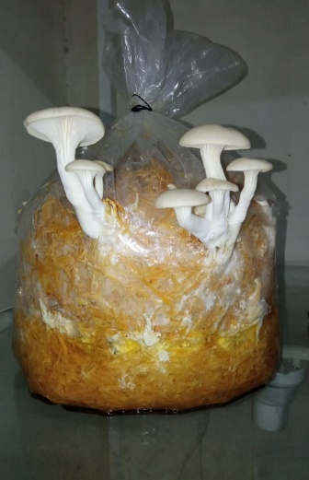  A | 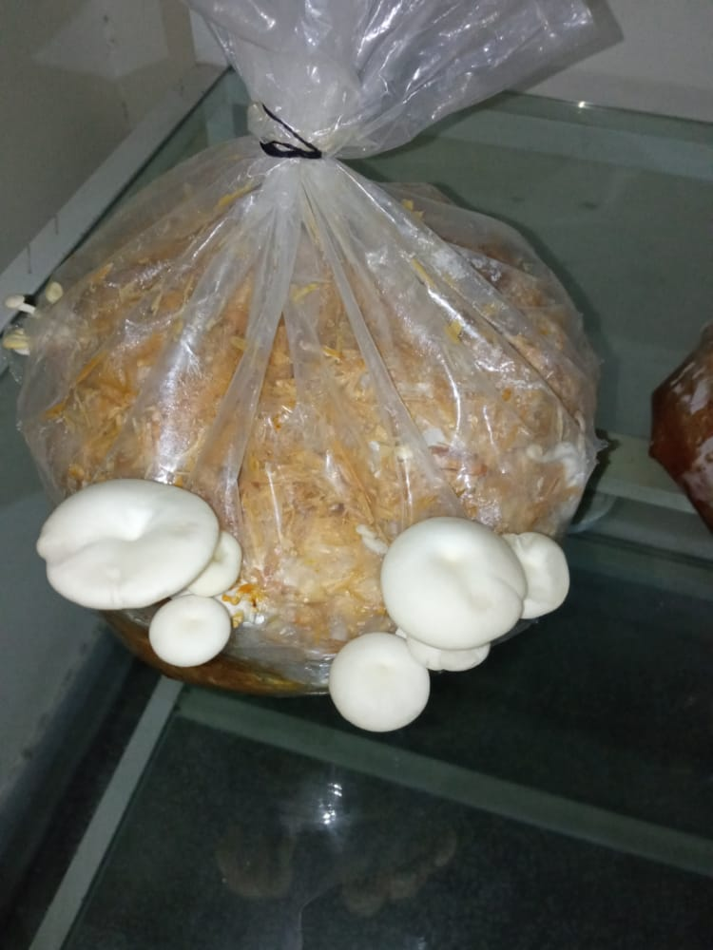  B | 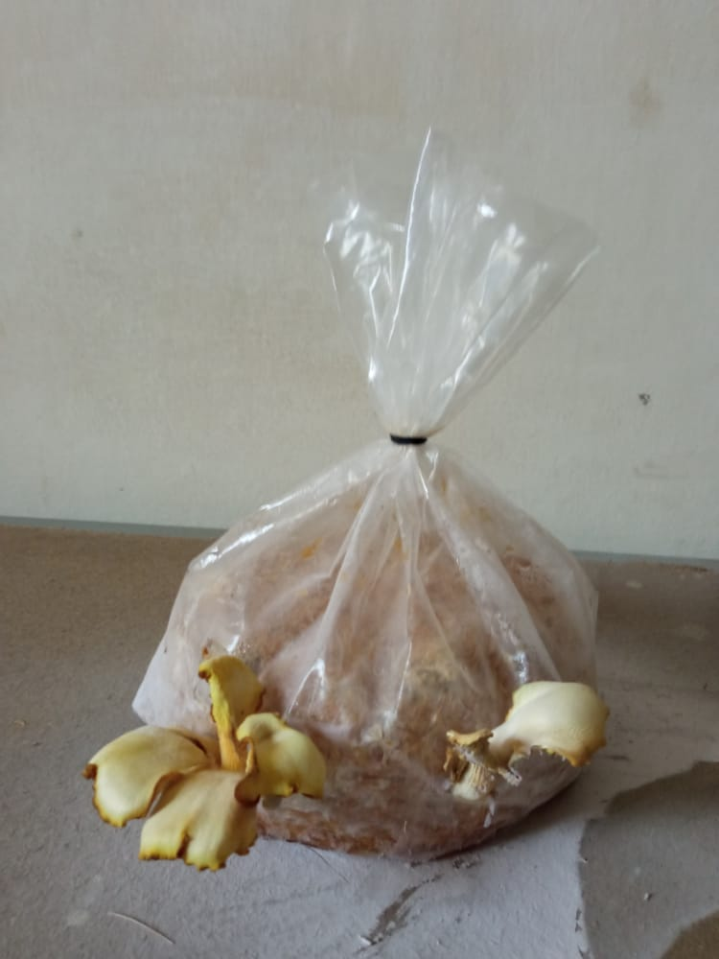  C
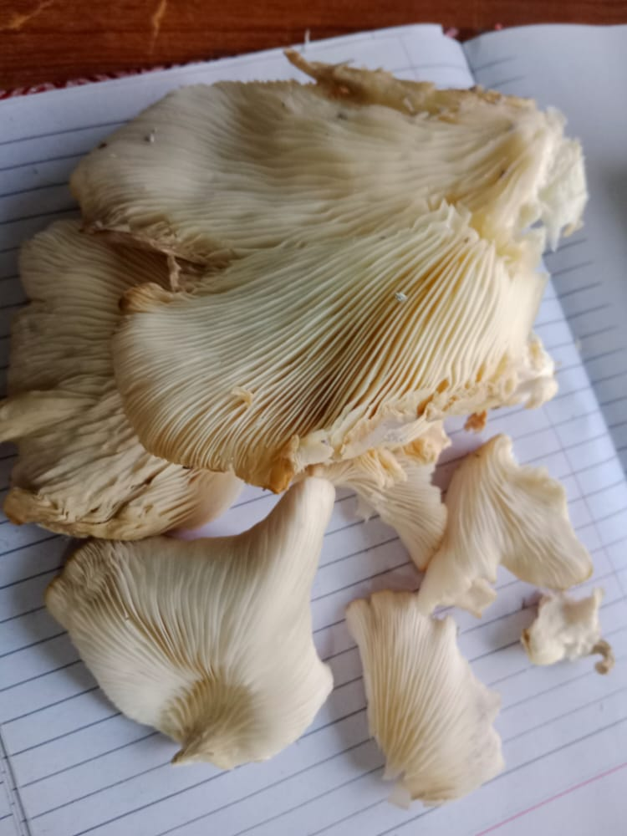  D | 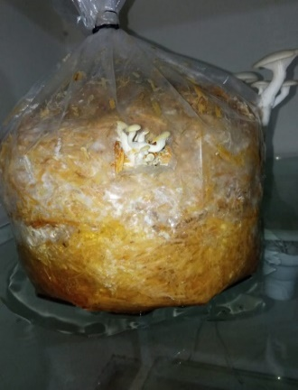  E | 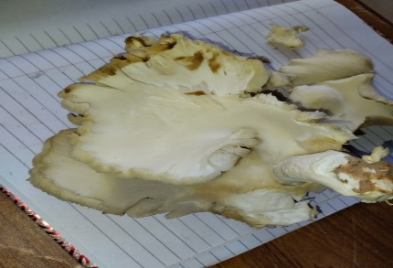  F
FIGURES A–F depicts the results of various experiments.

Chart 1 displays the changes in all quality indicators, including NFB (number of fruiting bodies), DPI (diameter of oyster mushroom stem), and total days needed for maturation owing to temperature variations.

Chart 2 displays the changes in all quality indicators, including NFB (number of fruiting bodies), The number of days needed for initial primordial initiation (DPI, size of the oyster mushroom's stem, Days required overall for maturation due to different substrates.
YIELD AND BIOLOGICAL EFFICIENCY
Results demonstrate that yield is also influenced by variations in the substrate. In the wheat-straw and sawdust mixture and cardboard substrates, the yield was higher at 375 g and 366 g, respectively, and lower in the leaves at 220 g. According to Pie Chart 1, the BE of cardboard is 73.2%, sawdust is 50%, wheat straw is 67.2%, leaves are 48.2%, and the combination of wheat straw and sawdust is 75%.
Chart 1 compares biological efficiency on various substrates.

Chart 2 compares biological efficiency percentages for various temperatures.
The temperature also interfered with the yield. When the temperature was between 5 and 25°C, the yield peaked at 280 g. The yield was 98 g, the lowest for summer temperatures of 25–35°C, and it rapidly decreases as the temperature rises. Table 1's yield at 10-15°C treatment is 239 g. Given temperature comparisons, BE is highest at 15–25°C since this range is very conducive to growth and lowest at temperatures in the early summer, as shown in Pie Chart 2.
Number of Fruiting Bodies
NFB is often higher at 15 to 25 °C (March) and falls when temperature rises or falls from this range to 10-15 °C and 25 to 35 °C, respectively. According to line graph 1, NFB was 46 and 19, respectively, at 10-15°C and 25-35°C. NFB in evaluation 2 was lowest in leaves, but it steadily increased to 50 in Substrate A due to the presence of more nutrients and a molecule that promotes growth and is located at the highest point in line graph 2.
TOTAL DAYS OF MATURATION
The number of days indicates how long the substrate needs to grow before reaching maturity, which varies according on the substrate and temperature ranges. Oyster mushrooms reach maturity in 31 days at 15 to 25 °C (March), growing faster as the temperature rises and slower as it falls below 10 °C. Substrate A (a mixture of wheat, straw, and sawdust) and cardboard both have lower TDMs of 31 and 30, respectively. Oyster mushrooms can mature in 48 days with leaves, for example, as illustrated in tables 1 and 2.
DAYS REQUIRED FOR THE FIRST PRIMORDIAL INITIATION (DPI)
The following phase that initiates a run of mycelial growth is the appearance of pinheads. DPI increased in a direct proportion to temperature over 25 °C. As can be seen in Table 1, DPI was lowest at 18 at 15–25°C. The Pinhead-like structures in evaluation 2 were developed earlier in the sawdust substrate in a period of six days. Cardboard took 9 days, Substrate A took 8, then leaves took 8, and the wheat straw substrate took 11 days, which was the maximum as stated in Table 2.
DIAMETER OF STEM
Additionally, DSM varies with respect to substrate and temperature. The first and second line graphs, respectively, demonstrate the variability of DS and its dependence on substrate type and temperature swings. When indicated in Table 1, DS is maximum during 15–25°C (March) at 50 and diminishes when we oscillate between 15–25°C. According to line graph 2 below, the highest DS values are provided by cardboard and a wheat-straw and sawdust combination at 53 and 48, respectively, while leaves have the lowest value at 29.
CONCLUSIONS
In conclusion, evaluation 1 has demonstrated that oyster mushrooms yield the most at 10-15°C, 85% relative humidity, and 47.8% biological efficiency. Evaluation 2 shows that the best substrates in terms of all quality indicators are cardboard and substrate A (wheat straw plus sawdust). It is determined that different substrate types, relative humidity ranges, and temperatures have an impact on the number of fruiting bodies (NFB), the number of days needed for first primordial initiation (DPI), the yield (measured in grams over 500 g of substrate), the diameter of the mushroom stem, and the total number of days needed for maturation. The number of fruiting bodies, or NFB, was highest for substrate A (a mixture of sawdust, wheat straw, and grains), and lowest for leaves. The greatest diameter of the stem in cardboard is TDM, which is less for substrate A (a mixture of wheat, straw, and sawdust) and cardboard and maximum for leaves. Cardboard has a BE of 73.2%, sawdust at 50.2%, wheat straw at 67.2%, leaves at 48.2%, and a combination of wheat straw and sawdust at 75%. DPI decreased from 18 to 15 to 25 degrees lower.
REFERENCES
Bao, D., Kinugasa, S., & Kitamoto, Y. (2004). The biological species of oyster mushrooms (Pleurotus spp.) from Asia based on mating compatibility tests. Journal of Wood Science, 50, 162-168.
BISWAS, S., Datta, M., & Ngachan, S. (2011). Mushrooms: A Manual for cultivation: PHI Learning Pvt. Ltd.
Haimid, M. T., Rahim, H., & Dardak, R. A. (2013). Understanding the mushroom industry and its marketing strategies for fresh produce in Malaysia. Economic and Technology Management Review, 8, 27-37.
Hawksworth, D. L. (2001). Mushrooms: the extent of the unexplored potential. International journal of medicinal mushrooms, 3(4).
Ibrahim, R., Boon, L. S., Mazidi, M. N. I. H., & Yaacob, N. D. (2020). Effects of electrical shock and blue LED treatments on the growth, yield and quality of grey oyster mushrooms (Pleurotus sajor-caju). Paper presented at the IOP Conference Series: Materials Science and Engineering.
Jongman, M., Khare, K. B., & Loeto, D. (2018). OYSTER MUSHRROM CULTIVATION AT DIFFERENT PRODUCTION SYSTEMS: A. Eur. Biomed. Pharm. Sci, 5(5), 72-79.
Khonga, E., Khare, K., & Jongman, M. (2013). Effect of different grain spawns and substrate sterilization methods on yield of oyster mushroom in Botswana.
Mahari, W. A. W., Peng, W., Nam, W. L., Yang, H., Lee, X. Y., Lee, Y. K., . . . Sonne, C. (2020). A review on valorization of oyster mushroom and waste generated in the mushroom cultivation industry. Journal of hazardous materials, 400, 123156.
Mandeel, Q., Al-Laith, A., & Mohamed, S. (2005). Cultivation of oyster mushrooms (Pleurotus spp.) on various lignocellulosic wastes. World Journal of Microbiology and Biotechnology, 21, 601-607.
Nongthombam, J., Kumar, A., Ladli, B., Madhushekhar, M., & Patidar, S. (2021). A review on study of growth and cultivation of oyster mushroom. Plant Cell Biotechnology and Molecular Biology, 22(5&6), 55-65.
Patel, Y., Naraian, R., & Singh, V. (2012). Medicinal properties of Pleurotus species (oyster mushroom): a review. World Journal of Fungal and Plant Biology, 3(1), 1-12.
Randive, S. D. (2012). Cultivation and study of growth of oyster mushroom on different agricultural waste substrate and its nutrient analysis. Advances in Applied Science Research, 3(4), 1938-1949.
Rathod, M. G., Gadade, R. B., Thakur, G. M., & Pathak, A. P. (2021). Oyster mushroom: cultivation, bioactive significance and commercial status. Frontiers in Life Science, 2, 21.
Senatore, W. S. D. B. P., & Soriente, M. A. K. G. S. (2004). Identification and characterization of Trichoderma species aggressive to Pleurotus in Italy. 浙江大学学报 (农业与生命科学版), 30(4), 469-470.
Utami, C. P., & Susilawati, P. R. (2017). Rice straw addition as sawdust substitution in oyster mushroom (Pleurotus ostreatus) planted media. Paper presented at the AIP Conference Proceedings.

