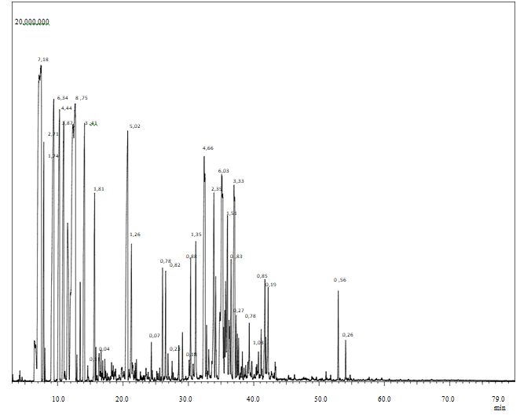
Figure. 1. Chromatogram of the essential oil of Pistacia lentiscus L.

