Caption of figures
Figure 1. Geographical regions to collect samples in Thailand (red dots).
Figure 2 Sugarcane symptoms caused by phytoplasmas. A and B: sugarcane white leaf; C: sugarcane grassy shoot.
Figure 3. Dendrogram constructed by the neighbour-joining method with 1000 bootstraps, showing the relationship between SCWL and SCGS based on the 50S sequences.
Figure 4. Dendrogram constructed by the neibour-joining method with 1000 bootstraps, showing the relationship between SCWL and SCGS based on the Ser sequences.
Figure 5. Dendrogram constructed by the neighbour-joining method with 1000 bootstraps, showing the relationship between SCWL and SCGS based on the SecA sequences.

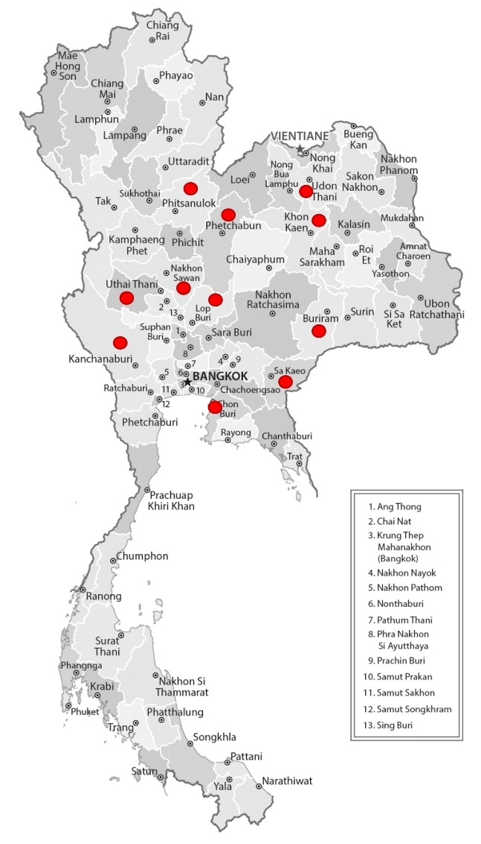
Figure 1. Geographical regions to collect samples in Thailand (red dots).

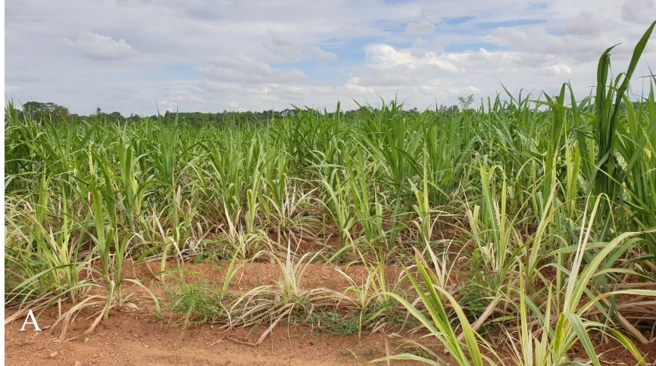
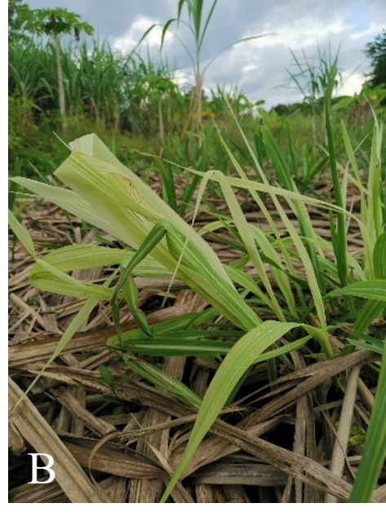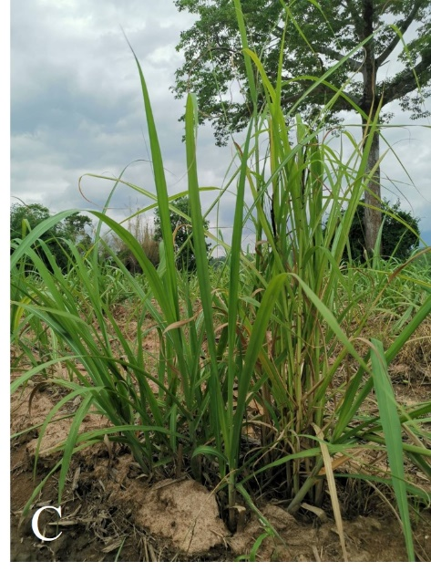
Figure 2 Sugarcane symptoms caused by phytoplasmas. A and B: sugarcane white leaf; C: sugarcane grassy shoot.
Figure 3. Dendrogram constructed by the neighbour-joining method with 1000 bootstraps, showing the relationship between SCWL and SCGS based on the 50S sequences
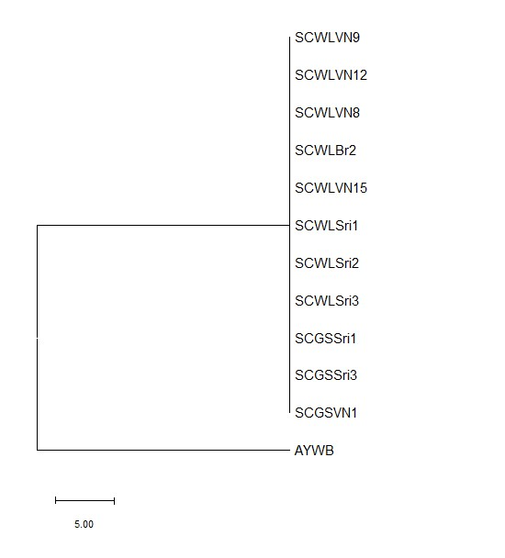
Figure 4. Dendrogram constructed by the neibour-joining method with 1000 bootstraps, showing the relationship between SCWL and SCGS based on the Ser sequences.

Figure 5. Dendrogram constructed by the neighbour-joining method with 1000 bootstraps, showing the relationship between SCWL and SCGS based on the SecA sequences.

