Title page
OYSTER MUSHROOM (PLEUROTUS SPP) YIELD PERFORMANCE ON DIFFERENT SUBSTRATES WITH ADDITION OF CHEMICAL AND BIOLOGICAL SUPPLEMENTS UNDER CONTROL CONDITION

Shazia Akram
shaziaakram1947@yahoo.com
Faculty of Bioscience and Technology for Food, Agriculture and Environment, University of Teramo, Via Renato Balzarini 1, 64100, Teramo, Italy

Rizwan Khan
rizwan9004@gmail.com
State Key Laboratory for Conservation and Utilization of Bio-Resources in Yunnan, Yunnan Agricultural University, Kunming 650201, P.R. China.

Owais Iqbal
owais.iqbal918@gail.com
State Key Laboratory for Conservation and Utilization of Bio-Resources in Yunnan/Yunnan-CABI Joint Laboratory for Integrated Prevention and Control of Transboundary Pests, Yunnan Agricultural University, Kunming, Yunnan 650201, China.

Muhammad Nabeel
nabeel@af.czu.cz
Department of Plant Protection, Faculty of Agrobiology, Food and Natural Resources, Czech University of Life Sciences Prague, Kamycka 129, 16500 Prague, Czech Republic

Sumbal Zaman
szaman2k12@gmail.com
Department of Plant Protection, Faculty of Crop Protection, Sindh Agriculture University, Tando Jam 70060, Pakistan.

Nimra Khanzada
nimrak62@gmail.com
Department of Plant Protection, Faculty of Crop Protection, Sindh Agriculture University, Tando Jam 70060, Pakistan

Muhammad Ali Khanzada
malikhanzada@sau.edu.pk
Department of Plant Protection, Faculty of Crop Protection, Sindh Agriculture University, Tando Jam 70060, Pakistan

*Corresponding author: owais.iqbal.918@gmail.com

OYSTER MUSHROOM (PLEUROTUS SPP) YIELD PERFORMANCE ON DIFFERENT SUBSTRATES WITH ADDITION OF CHEMICAL AND BIOLOGICAL SUPPLEMENTS UNDER CONTROL CONDITION
ªShazia Akram, ^{b}Rizwan Khan, ^{b,c,e}Owais Iqbal, ^{d}Muhammad Nabeel, ^{e}Sumbal Zaman, ^{e}Nimra Khanzada, ^{e}Muhammad Ali Khanzada
ªFaculty of Bioscience and Technology for Food, Agriculture and Environment, University of Teramo, Via Renato Balzarini 1, 64100, Teramo, Italy
^{b}State Key Laboratory for Conservation and Utilization of Bio-Resources in Yunnan/Faculty of Plant Protection, Yunnan Agricultural University, Kunming 650201, P.R. China
^{c}Yunnan-CABI Joint Laboratory for Integrated Prevention and Control of Transboundary Pests, Yunnan Agricultural University, Kunming, Yunnan 650201, China
^{d}Department of Plant Protection, Faculty of Agrobiology, Food and Natural Resources, Czech University of Life Sciences Prague, Kamycka 129, 16500 Prague, Czech Republic
^{e}Department of Plant Protection, Faculty of Crop Protection, Sindh Agriculture University, Tando Jam 70060, Pakistan

ABSTRACT
Oyster mushroom Pleurotus ostreatus is economically important, edible mushroom and known for its medicinal properties. Hence, integration of non-conventional crops in prevailing agricultural system can improve the economic status of the farmer. The aim of the study was to evaluated the suitability of various substrates with addition of chemicals and biological supplements to improve yield production. The spawn was prepared in Laboratory of Plant Pathology Agriculture Peshawar from the pure culture of P. ostreatus. The appreciable yields were obtained on chemical fortified substrates as compared to non-supplemented treatments which have a significant effect on the mushroom production. Overall, the highest mean yield (388 g) was recorded on wheat straw substrate supplemented with diammonium. In addition, biological supplemented substrate was significantly enhanced the yield performance of P. ostreatus expect of chicken manure substrate. The high yield (372 g) was observed on cotton waste substrate augmented with biological supplement rice husk. It is concluded that the addition of external nutrients including chemical and biological supplements can increase the yield of oyster mushroom and will be useful tool for the farmers to add supplements in substrates.

Keywords: Oyster mushroom, substrate, biological nutrients, di-ammonium

Practical application:
This research will contribute to the scientific knowledge related to the best substrate for the production of oyster mushrooms, involving the addition of chemical and biological supplements (formulations) to agricultural crop residues. The observed results are valuable for farmers aiming to achieve high yields and reduce pollution problems efficiently in terms of time and cost. According to the results obtained, it is suggested that to achieve a high yield of valuable crops, it is not necessary to invest heavily in cultivation. However, to increase the yield, it is recommended to add a certain quantity of supplements.

INTRODUCTION
Mushrooms are edible fungus which have been widely used in various medicinal product in Japan, China, and Korea. While in other countries, a special attention has been made as dietary supplement to improve health condition. The nutritional significance of mushroom products—whether as direct prebiotics, indirect probiotics, or both (synbiotics)—is supported by their impact on the gut microbiota and the inflammatory process due to the presence of β-glucans, enzymes, and secondary metabolites (Fokunang et al. 2022; Bell et al. 2022). Mushrooms are a valuable and affordable source of vitamins, minerals, and protein. Fresh mushrooms typically contain between 85% to 95% water, 4% carbohydrates, 3% protein, 1% minerals/vitamins, and 0.1% fat. Additionally, mushrooms are rich in phosphorus, copper, potassium, iron, and contain small amounts of calcium. Most mushroom cultivars belong to the phylum Basidiomycota. Among them, the oyster mushroom of the genus Pleurotus ostreatus has been successfully cultivated and commercialized, although some others belong to the phylum Ascomycota (Vital et al. 2015; Liu et al. 2018; Rubini et al. 2014). The production and consumption of edible mushrooms have ongoing for many years in developing countries. However, due to relatively simple cultivation process of oyster mushrooms, interest of the cultivation has surged in the past decade (Steyaert et al. 2010). Oyster mushrooms are also called "meat of the forest, which means high nutrition and can be compared with meat, eggs and milk (Mata et al. 2005). Several findings proved that mushrooms have anti-cancer, anti-cholesterol and anti-ulcer properties and also found useful in lung diseases and diabetes. Nowadays, due to their natural ability to thrive under various conditions and temperatures, the cultivation of oyster mushrooms has become an important aspect of agribusiness. However, mushroom cultivation is limited in developing countries, therefore their industries are still in its infancy (KAUSAR, BAJWA, and Research 2005). The primary issue concerning to mushroom cultivation technology is the lack of technical knowledge require for its growth. The Pleurotus species stands out as one of the most efficient lignocellulose solid-decomposing white-rot fungi, offering an effective method for harvesting and recycling agricultural waste products. Possessing distinctive properties, it thrives in various plant parts that are low in nutrients (Raman et al. 2021). The oyster mushroom has a saprophytes colonization ability to grow on agriculture wastage. In mushroom cultivation, both cellulose and lignin materials such as wheat straw, cotton waste, sorghum waste substrate, sawdust, sugarcane leaves and many others agriculture/industries waste are required for the spawning process and fruit growth (Yang, Guo, and Wan 2013). Therefore many agriculture waste materials are used as a substrate in production of Pleurotus (Mandeel et al. 2005; Poppe 2000). The composition of the substrates varies depending on their nature and yield, can be increased by using these substrates with addition of adequate quantity of supplements (Hu, Arantes, and Saddler 2011; Naraian et al. 2009; Miles and Chang 2004). A various substrate supplements have been suggested for cultivation of oyster mushrooms. These supplements are not limited to chemicals such as diammonium phosphate, ammonium nitrate, and potassium, but also include biological supplements (Naraian et al. 2016; Belewu and Belewu 2005). Nitrogen, phosphorus, and potassium are the main macronutrients needed by fungi to meet structural and energy requirements (Miles and Chang 2004). Biological supplements such as rice husk, chicken manure, wheat bran, mustard cake and soybean etc. can effectively increase mushroom production. Adding the right quantity of supplements to the substrate can significantly increase the production of oyster mushrooms. The different agricultural wastes can be utilized in mushroom production, helping to minimize the pollution caused by agricultural wastes. The utilization of low-cost agricultural waste materials for economically important end products will lead to the development of low-input farming techniques for rural communities. This will be a significant step towards decreasing the poverty rate (Bhatti et al. 2007). This research aims to determine the yield performance of oyster mushroom on various agriculture crop waste material substrates with the addition of some nutrients under controlled condition.
MATERIALS AND METHODS
Establishment of mycelial culture and spawn
The procedure of mushroom spawn production and inoculation of substrate are presented in figure 1. The mushroom mycelial culture was grown on the potato dextrose agar (PDA) media using test tube. For production of spawn, the pure mycelium from slants containing PDA medium was used. The barley and sorghum grains were soaked and washed with water, and boiled for 15 minutes. Then put the boiled grains on a sieve to drain completely, and were spread them on a clean plastic sheet to dry. The ingredients were thoroughly mixed and moisture was adjusted to 55–60%. These grains were mixed with calcium carbonate and then the mixture was distributed equally into 250 ml sterile jar, at the rate of 200g seeds per plastic bag and autoclaved at 121°C for 30 minutes, and then cooled the jar at room temperature. The cooled P. ostreatus spawns were evenly distributed into the seeds within the jar. The jars were incubated in a ventilated incubator at 26°C for 12 days and periodically shake the jar thoroughly by hand to distribute the mycelium within the grain. After 15days of incubation, the spawn is now ready for inoculation of the substrate.
Preparation of the substrates
Various substrates material including wheat straw, sorghum waste, sawdust, sugar cane leaves, maize leaves were collected from different field in local areas and cotton waste as a by-product from cotton mill was collected. The fresh substrate was dried before of any degradation in whole process. The large agro-waste straws were chopped into small pieces in range of 6 to 8 cm. The biological materials were purchased from local market. The substrate materials were soaked in water for 24 hours to absorb moisture and soften, after which they were placed on a wire sieve to drain off the excess water. The chemical nutrients from nitrogen sources include urea, di-ammonium phosphate, ammonium nitrate and biological supplements such as viz rice husk, chicken manure, wheat bran, mustard cake (MC) and soybean meal (SM) at rate of 10g/L in a water, were added in moist substrates. Polyethylene bags were filled with 1 kg of each substrate medium. These bags were closed with ribbon band and sterilized at 121°C for 15 minutes and were then cooled down to room temperature.
The spawn inoculated into various substrates with addition of nutrients by using lamp spawning method based on dry weight basis of substrates. The spawn was amended in to each substrate at 2% (w/w) and inoculated at 25°C under control condition. Holes were prepared for aeration in the plastic bag. After mycelia colonized the substrate, polyethylene bags were cut with help of sterilized scissor to grow out the mushroom in the cropping room. These bags were placed on shelves for further growth under control condition. The moisture content and humidity were checked twice a day at 9.00 am and 3.00 pm by using digital thermometer. The mycelia of the substrate was watered twice a day (during morning at 9.00 am and afternoon at 3.00 pm) using waterpot to maintain water activity and humidity around 70-90%.
Yield calculation and comparison of supplements on various substrates
The mature fruiting bodies were harvested by clean hands without damaging after two to three days of emergence. The substrates were maintained under the same conditions for another seven days to harvest the second and third flushes of the mushroom. Mushroom from different substrates and treatments were kept separately for fresh weight measurements. Efficacy of chemical and biological nutrients supplement were compared for mushroom yield after three flushes were calculated by adding their means in gram. The chemical and biological efficiencies were compared by calculating yield (means) of mushroom in three flushes (Iqbal, Rauf, and Sheikh 2016) by using the formula.
$$BE=\frac{Weight of fresh mushroom harvested per bag}{Weight of dry substrate per bag before inoculation}X100$$

Results
The effects of chemicals and biological supplements on agro wastes substrate on the growth of P. ostreatus yield was evaluated and are shown in (Table 1 & 2). The obtained yield production on various substrate and chemicals amendment comparison is represented in (Figure 2).
After three flushes, the oyster mushroom yield on different chemical and biological substrates were compared (Table 1 & 2). Of the seven substrates used, the highest mushroom mean weights (388 g) were obtained in three flushes on wheat straw substrate fortified with chemical di-ammonium (Table 1). Among five biological supplements; rich husk and soybean meal (sm) fortification in cotton waste substrate resulted the highest yield (Table 2).
Overall obtained yield (in means) of P. ostreatus was recorded after thee flushes with addition of chemical supplements i.e. urea, diammonium phosphate, ammonium nitrate on wheat straw substrate were 351, 388, 361, 344 g respectively as compare to control (344 g) treatment. On cotton substrate with addition of urea, diammonium phosphate, ammonium nitrate, resulted mean yields were 381, 377, 381, 357 g as compared to control (357 g) treatment. The mushroom yield on sorghum waste substrate with addition of chemical, the obtained yield was 343g, 345g, 356g as compared to control (338 g) as followed by yield on paddy straw with addition of chemical supplements were 350, 347, 358 g (Table 1). Saw dust substrate with addition of nutrients, the obtained yield was 353, 340, 344 g as compared to control it was lower as 335 g (Table 1). On sugar cane with addition of nutrients, obtained yield was 357, 341,346 g while in control it was 333 g (Table 1). Oyster mushroom yield after three flushes on maize substrate with supplementation of urea, diammonium phosphate and ammonium nitrate were 349, 352, 354 g respectively while in control, it was 341 g (Table 1).
Addition of biological supplements to substrate significantly increased yield except chicken manure to wheat straw, cotton wastes, Sugarcane and maize leaves substrates. The obtained yield on these four substrates fortified with chicken manure resulted in low yields as 342, 347, 330, 339 grams while in control the obtained yield was high as 344, 347, 333 and 341grams respectively (Table 2). The yield of P. ostreatus on wheat straw substrate with addition of rice husk, chicken manure, and wheat bran were 350, 342, 367 g followed by mustard cake (350 g) and soybean (367 g) while in control the obtained yield was 344 g (Table 2).
Table 1: The obtained yield in three flushes of Oyster mushroom (Ploeurotus spp) on different substrates with addition of chemical substrates
Chemical  supplements | Wheat straw substrate | Cotton waste substrate | Sorghum waste substrate | Paddy straw | Saw dust | Sugar cane leaves | Maize leaves
Urea | 351 | 381 | 343 | 350 | 353 | 357 | 349
Diammonium  phosphate | 388 | 377 | 345 | 347 | 340 | 341 | 352
Ammonium nitrate | 361 | 381 | 356 | 358 | 344 | 346 | 354
Control | 344 | 357 | 338 | 340 | 335 | 333 | 341

Table 2: The obtained yield (means) in three flushes of Oyster mushroom (Ploeurotus spp) on different substrates with addition of biological substrates
Biological  supplements | Wheat straw substrate | Cotton waste substrate | Sorghum waste substrate | Paddy straw | Saw dust | Sugar cane leaves | Maize leaves
Rice husk | 350 | 372 | 350 | 361 | 344 | 330 | 338
chicken manure | 342 | 347 | 344 | 348 | 336 | 330 | 339
wheat bran | 367 | 370 | 361 | 368 | 356 | 358 | 350
Mustard cake (MC) | 350 | 360 | 340 | 337 | 341 | 343 | 347
soybean meal (SM) | 367 | 371 | 358 | 335 | 338 | 342 | 349
Control | 344 | 357 | 338 | 340 | 335 | 333 | 341
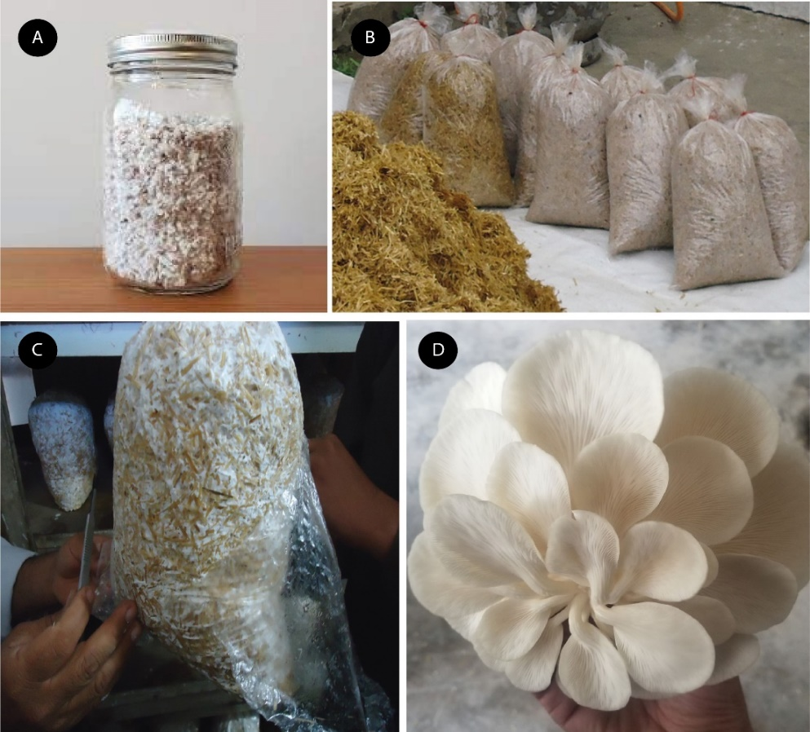

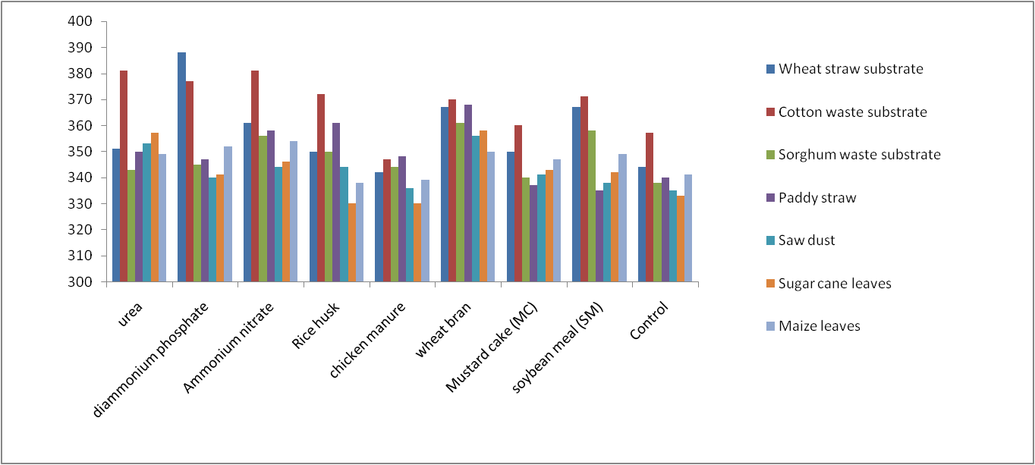
Figure 1. Cultivation of oyster mushroom. (A) the oyster spawn produced from pure mycelia, (B): preparation of wheat substate bags for mushroom production, (C): mycelia covered the whole substrate bag, and (D): The mature flushes of oyster mushroom.

Figure 2. Comparison of oyster mushroom (Ploeurotus spp) yield production using various substrates with amendment of supplements.

DISCUSSION
The Pleurotus spp are naturally grow on plant dead parts, which are usually deprived source of vitamins and nutrients. It has also been reported that mycelial growth and fruiting body development rely on lingo-cellulosic substance as these are good source of nitrogen and carbon with ratio of 50:1 respectively in different substrates (Thakur 2020; Du Plooy 2007; Koutrotsios et al. 2014). Most of these agro-waste substrate, nitrogen content is between 0.5 and 0.8%, therefore the addition of nitrogen to the various substrate helps in obtaining high mushroom yield (Naraian et al. 2009; Koutrotsios et al. 2014).
Thus, it is necessary to supplement other additives with substrate materials containing organic or inorganic nitrogen. The chemical and biological supplements addition in different agro waste substrates enhanced appreciable yield of the mushroom. It was reported that different agro substrates including wheat straw, cotton waste, sorghum waste substrate, sawdust, sugarcane leaves were suitable natural substrates on which Pleurotus spp grew very well (Chanakya, Malayil, and Vijayalakshmi 2015; Ashraf et al. 2013). The addition of supplements is beneficial for the production of P. ostreatus because these supplements are a major source of external nutrients and vitamins necessary for stimulating high mushroom yields (Hoa, Wang, and Wang 2015). The supplements were found best for P. ostreatus growth (Hoa, Wang, and Wang 2015; KHAN¹ et al. 2012). Our results are in line with observation of Tesfay et al. (2020) for mushroom cultivation. In this study, high yield of fruiting body on substrates with amended of supplements was observed while the lower growth was recorded in control treatment without amendments of supplements (Ashraf et al. 2013). The various chemical and biological supplements have stimulatory effect on mushroom cultivation with source of nitrogen (Curvetto et al. 2002). The comparison of our results regarding supplementation of different chemicals i.e. urea, diammonium phosphate, and potassium revealed that the fruit body yield was higher as compared to the control. These chemicals are good source of nitrogen which has essential macronutrients for better growth of mushroom. However, adequate amount of supplements is necessary for better growth of mycelium and fruiting body (Naraian et al. 2009) recommended that substrate with amendments of supplementation; the yield can be considerably enhanced (Pant et al. 2006). In the present study, the maximum yield efficiency has been achieved with biological supplements such as rice husk, wheat bran, mustard cake amendments on agro waste substrate as previously reported (Buendía, Pardo-Giménez, and de Juan-Valero 2016). The comparison of our results regarding supplementation of different chemicals and biological compounds revealed that the fruit body yield was higher as compared to the control. Our findings are in full agreement with the aforementioned observations (Sharma, Yadav, and Pokhrel 2013). The two biological supplements viz wheat bran and soybean cake (SM) showed the best results and are considered as first generation supplements (Sobhan 2006). In previous studies SM was found a better supplement, which is good source of fats and protein and also increased mushroom yields by prompting mycelium growth and fruiting bodies due to presence of amino acids (Obodai et al. 2003). In view of the above results, it was also found that agro waste products; wheat straw, cotton waste, sorghum waste substrate, sawdust, sugarcane leaves can be successfully used in mushroom cultivation. Various researchers confirmed that supplementation of various compounds at adequate concentrations showed a better result by enhancing growth rate and fruit body yield. Our results are in line with Onyango et al. (2011) that Mustard cake (MC) is also the best supplement to promote mushroom growth and its fruit. Therefore, cultivation of Pleurotus spp cultivation on agro waste substrate i.e. cotton, wheat, maize, sorghum, paddy straw and saw dust amended with adequate concentrations especially 2 % for biological supplements and 0.5 % with chemical supplements, respectively is suggested for enhanced mushroom yield. The addition of rice husk to agro waste substrate significantly increased mycelium growth and fruit body formation resulted in high mushroom yield (Obodai et al. 2003). The supplementation of chicken manure to wheat straw, cotton wastes, sugarcane and maize leaves substrate resulted in yield losses and this may be due to presence of high nitrogen content of the substrate (Bellettini et al. 2019; Sreekrishnan, Kohli, and Rana 2004).
CONCLUSION
P. ostreatus is known for its medicinal properties and also contribute to agribusiness. The yield performance of oyster mushrooms grown on various substrates with the addition of various biological nutrients improved its production as compared to non-supplemented treatments. So, it is suggested to use these substrates with the addition of various biological nutrients to facilitate the farmer in profitable agribusiness.
Conflict of Interest
The authors affirm that they possess no conflicts of interest.
ACKNOWLEDGEMENTS
Not applicable

REFRENCES
Ashraf, Jawad, Muhammad Asif Ali, Waqas Ahmad, Chaudhry Muhammad Ayyub, Jamil %J Food Science Shafi, and Technology. 2013. 'Effect of different substrate supplements on oyster mushroom (Pleurotus spp.) production', 1: 44-51.
Belewu, MA, and KY %J African journal of Biotechnology Belewu. 2005. 'Cultivation of mushroom (Volvariella volvacea) on banana leaves', 4.
Bell, V, CRPG Silva, J Guina, and TH Fernandes. 2022. 'Mushrooms as future generation healthy foods', Frontiers in Nutrition, 9: 1050099.
Bellettini, Marcelo Barba, Fernanda Assumpção Fiorda, Helayne Aparecida Maieves, Gerson Lopes Teixeira, Suelen Ávila, Polyanna Silveira Hornung, Agenor Maccari Júnior, and Rosemary Hoffmann %J Saudi Journal of Biological Sciences Ribani. 2019. 'Factors affecting mushroom Pleurotus spp', 26: 633-46.
Bhatti, MI, MM Jiskani, KH Wagan, MA Pathan, and MR %J Pak. J. Bot Magsi. 2007. 'Growth, development and yield of oyster mushroom, Pleurotus ostreatus (Jacq. Ex. Fr.) Kummer as affected by different spawn rates', 39: 2685-92.
Buendía, Mª Raquel Picornell, Arturo Pardo-Giménez, and José Arturo %J Mycology de Juan-Valero. 2016. 'Reuse of degraded Pleurotus ostreatus (Jacq.) P. Kumm. substrate by supplementation with wheat bran. Quantitative parameters', 7: 53.
Chanakya, HN, Sreesha Malayil, and C %J Energy for sustainable development Vijayalakshmi. 2015. 'Cultivation of Pleurotus spp. on a combination of anaerobically digested plant material and various agro-residues', 27: 84-92.
Curvetto, Nestor Raul, D Figlas, R Devalis, and S %J Bioresource Technology Delmastro. 2002. 'Growth and productivity of different Pleurotus ostreatus strains on sunflower seed hulls supplemented with N–NH4+ and/or Mn (II)', 84: 171-76.
Du Plooy, Gertina Wilhelmina. 2007. 'Pests, pathogens, competitors and weed fungi of cultivated oyster mushrooms (Pleurotus spp) in South Africa', University of Pretoria.
Fokunang, Estella Tembe, Mbong Grace Annih, Lem Edith Abongwa, Manju Evelyn Bih, Tchadji Mayoudom Vanessa, Dobgima John Fomnboh, and Charles Fokunang. 2022. Medicinal mushroom of potential pharmaceutical toxic importance: Contribution in phytotherapy (IntechOpen).
Hoa, Ha Thi, Chun-Li Wang, and Chong-Ho %J Mycobiology Wang. 2015. 'The effects of different substrates on the growth, yield, and nutritional composition of two oyster mushrooms (Pleurotus ostreatus and Pleurotus cystidiosus)', 43: 423-34.
Hu, Jinguang, Valdeir Arantes, and Jack N %J Biotechnology for biofuels Saddler. 2011. 'The enhancement of enzymatic hydrolysis of lignocellulosic substrates by the addition of accessory enzymes such as xylanase: is it an additive or synergistic effect?', 4: 36.
Iqbal, SH, C Abdul Rauf, and M Iqbal Sheikh. 2016. 'Yield performance of oyster mushroom on different substrates'.
KAUSAR, Tasnim, Rukhsana %J Pakistan Journal of Scientific BAJWA, and Industrial Research. 2005. 'Incorporation of button mushrooms in Pakistani dishes', 48: 417-21.
KHAN¹, NASIR AHMAD, M Ajmal¹, M INAM UL HAQ, NAZIR JAVED¹, M Asif Ali, RANA BINYAMIN¹, and SAJID ALEEM %J Pak. J. Bot KHAN¹. 2012. 'Impact of sawdust using various woods for effective cultivation of oyster mushroom', 44: 399-402.
Koutrotsios, Georgios, Konstantinos C Mountzouris, Iordanis Chatzipavlidis, and Georgios I %J Food chemistry Zervakis. 2014. 'Bioconversion of lignocellulosic residues by Agrocybe cylindracea and Pleurotus ostreatus mushroom fungi–Assessment of their effect on the final product and spent substrate properties', 161: 127-35.
Liu, Qizheng, Husheng Ma, Ya Zhang, and Caihong %J Critical reviews in biotechnology Dong. 2018. 'Artificial cultivation of true morels: current state, issues and perspectives', 38: 259-71.
Mandeel, QA, AA Al-Laith, SA %J World Journal of Microbiology Mohamed, and Biotechnology. 2005. 'Cultivation of oyster mushrooms (Pleurotus spp.) on various lignocellulosic wastes', 21: 601-07.
Mata, G, DM Murrieta Hernández, LG Iglesias %J World Journal of Microbiology Andreu, and Biotechnology. 2005. 'Changes in lignocellulolytic enzyme activites in six Pleurotus spp. strains cultivated on coffee pulp in confrontation with Trichoderma spp', 21: 143-50.
Miles, Philip G, and Shu-Ting Chang. 2004. Mushrooms: cultivation, nutritional value, medicinal effect, and environmental impact (CRC press).
Naraian, R, RK Sahu, S Kumar, SK Garg, CS Singh, and RS %J The Environmentalist Kanaujia. 2009. 'Influence of different nitrogen rich supplements during cultivation of Pleurotus florida on corn cob substrate', 29: 1.
Naraian, Ram, MP Singh, Siya %J International Journal of Current Microbiology Ram, and Applied Sciences. 2016. 'Supplementation of basal substrate to boost up substrate strength and oyster mushroom yield: an overview of substrates and supplements', 5: 543-53.
Obodai, M, J Cleland-Okine, KA %J Journal of Industrial Microbiology Vowotor, and Biotechnology. 2003. 'Comparative study on the growth and yield of Pleurotus ostreatus mushroom on different lignocellulosic by-products', 30: 146-49.
Onyango, BO, Valerie A Palapala, PK Axama, SO Wagai, and Bernard M Gichimu. 2011. 'Suitability of selected supplemented substrates for cultivation of Kenyan native wood ear mushrooms (Auricularia auricula)'.
Pant, Deepak, U Gangi Reddy, Alok %J World Journal of Microbiology Adholeya, and Biotechnology. 2006. 'Cultivation of oyster mushrooms on wheat straw and bagasse substrate amended with distillery effluent', 22: 267-75.
Poppe, J %J Mushroom Sci. 2000. 'Use of agricultural waste materials in the cultivation of mushrooms', 15: 3-23.
Raman, Jegadeesh, Kab-Yeul Jang, Youn-Lee Oh, Minji Oh, Ji-Hoon Im, Hariprasath Lakshmanan, and Vikineswary Sabaratnam. 2021. 'Cultivation and nutritional value of prominent Pleurotus spp.: an overview', Mycobiology, 49: 1-14.
Rubini, Andrea, Claudia Riccioni, Beatrice Belfiori, and Francesco %J Mycorrhiza Paolocci. 2014. 'Impact of the competition between mating types on the cultivation of Tuber melanosporum: Romeo and Juliet and the matter of space and time', 24: 19-27.
Sharma, Soniya, Ram Kailash P Yadav, and Chandra P %J Journal on New Biological Reports Pokhrel. 2013. 'Growth and yield of oyster mushroom (Pleurotus ostreatus) on different substrates', 2: 03-08.
Sobhan, Md Abdus. 2006. 'EFFECT OF DIFFERENT SUPPLEMENTS WITH DIFFERENT LEVELS TO PADDY STRAW SUBSTRATE ON THE GROWTH AND YIELD OF OYSTER MUSHROOM'.
Sreekrishnan, TR, Sangeeta Kohli, and Vineet %J Bioresource technology Rana. 2004. 'Enhancement of biogas production from solid substrates using different techniques––a review', 95: 1-10.
Steyaert, Johanna M, Richard J Weld, Artemio Mendoza-Mendoza, and Alison %J Microbiology Stewart. 2010. 'Reproduction without sex: conidiation in the filamentous fungus Trichoderma', 156: 2887-900.
Tesfay, Teklemichael, Tesfay Godifey, Roman Mesfin, and Girmay %J AMB Express Kalayu. 2020. 'Evaluation of waste paper for cultivation of oyster mushroom (Pleurotus ostreatus) with some added supplementary materials', 10: 1-8.
Thakur, M. P. 2020. 'Advances in mushroom production: key to food, nutritional and employment security: A review', Indian Phytopathology.
Vital, Ana Carolina Pelaes, Priscila Akie Goto, Letícia Naomi Hanai, Sandra Maria Gomes-da-Costa, Benício Alves de Abreu Filho, Celso Vataru Nakamura, Paula Toshimi %J LWT-Food Science Matumoto-Pintro, and Technology. 2015. 'Microbiological, functional and rheological properties of low fat yogurt supplemented with Pleurotus ostreatus aqueous extract', 64: 1028-35.
Yang, WenJie, FengLing Guo, and ZhengJie %J Saudi journal of biological sciences Wan. 2013. 'Yield and size of oyster mushroom grown on rice/wheat straw basal substrate supplemented with cotton seed hull', 20: 333-38.

