Research trends of begomoviruses from first detection to geographical distribution, diversity, and prevalence
Muhammad Shafiq Shahid¹* and Nisar Ahmed²

¹ Department of Plant Sciences, College of Agricultural and Marine Sciences, Sultan Qaboos University, Al-Khod 123, Oman
² Department of Economics and Finance, College of Economics and Political Science, Sultan Qaboos University, Al-Khod 123, Oman

* Correspondence: Shahid M. S. E-mail mshahid@squ.edu.om Tel: +968-24141209
ORCID: Shahid M. S: https://orcid.org/0000-0002-3550-0000

Abstract
Begomoviruses are single-stranded (ss) and circular DNA viruses that are a main threat against world food security. Since they were first identified as a distinct group of viruses at least one begomovirus (tomato yellow leaf curl virus) has become a global problem. During last two decades, movement of agricultural produce globally and introduction of cryptic whitefly (Bemisia tabaci) vector complex have helped to evolve the recombinant and mutated strains of begomoviruses into diverse geographical areas. Different technologies, like Polymerase chain reaction, rolling circle amplification followed by high throughput sequencing technologies have exclusively been used in detection and characterization of ssDNA begomovirus complexes. To encompasses and analyze the literature developed in begomoviruses research, a systematic analysis was carried using Scopus database platform. R-based Bibliometrix interface and VOSViewer were utilized to study different aspects such as publication growth trend, core journals, leading authors and countries as well as to identify the collaboration partnerships among different authors from various countries followed by co-occurrences related to authors search keywords. Considerably high publication growth was witnessed highlighting the virus diversity followed by evolution of recombinant viral strains and host virus interaction. The advancement in technology reveals the significant effect of various discovery and distribution parameters on the begomoviruses. This is the first comprehensive study to evaluate both the quality and quantity of begomoviruses research since its first detection.
Key words: Bibliometric, begomovirus, betasatellite, alphasatellite, scholarly article
Introduction
Phytopathogenic viruses with genomes consisting of circular single-stranded (ssDNA) that are transmitted by whiteflies of the cryptic species complex Bemisia tabaci are classified in the genus Begomovirus genus (family; Geminiviridae) [44]. Virus diseases now known to be caused by begomoviruses were first recognized in the late 1930s [39]. Not until the late 1970s did it become evident that this group of viruses was unusual in having both geminate particles and genomes of begomoviruses [13-14].
Initially classified as geminivirus Sub-group III [16], the formal establishment of the genus Begomovirus in the family Geminiviridae did not happen until 1999 [32]. All B. tabaci transmitted geminiviruses were (and still are) classified in the genus Begomovirus-named after the first begomovirus for which geminate particles and a ssDNA genome were identified, Bean golden yellow mosaic virus (note that for some time this species was known a bean golden mosaic virus - hence the name be-go-mo-virus for the genus). Despite all the recent changes in the family Geminiviridae - the addition of further genera and revisions of the taxonomic criteria for the genera (including for begomoviruses) – the make-up of the genus Begomovirus has remained essentially unchanged, except for an ever-increasing diversity of viruses being identified. The only major changes for researchers investigating diseases caused by begomoviruses have been the identification of the beta- and alphasatellites in 1999-2000 [24; 34] and the realization that B. tabaci is a complex of species consisting of numerous morphologically indistinguishable cryptic species [19], with not all cryptic species transmitting a particular virus with equal efficiency [30].
In the Old World many begomoviruses, particularly those with monopartite genomes, have been shown to associate with ssDNA satellites identified as betasatellites [6]. Betasatellites may enhance the symptoms and extend the host ranges of their helper viruses [45]. Many begomovirus-betasatellite complexes are also accompanied with satellite-like molecules recognized as alphasatellites [7]. A small number of alphasatellites have also been detected in the New World associated with begomoviruses having bipartite genomes. Alphasatellites may either attenuate or exacerbate helper virus symptoms and are involved in overcoming host plant defenses [7].
The study outlined here presents an analysis of the published whole research on begomoviruses and their associated satellites, with the aim of identifying research collaborations, influential publications, productive authors and trends in this rapidly evolving area of study. Further the results of this study will be important to researchers, research organizations and research funders active in begomovirus research. Recently Khan [20] have carried out basic studies on the analysis of the research literature on the cotton leaf curl disease CLCuD) complex. Their study thus considered a sub-set of the literature examined here and is complementary to the study presented in the paper here.
Material and Methods
Articles related to begomoviruses complex were identified by keyword search from the Scopus database. The relevant articles were identified by scanning the abstract, title and author provided keywords using a comprehensive list of selected words alone or in combination with the addition of Boolean operators (OR/AND). The following final “Boolean” search was carried out in SCOPUS on April first, 2021: TITLE-ABS KEY (("begomovirus*" OR "begomoviruses*" OR "betasatellite*" OR "betasatellites*" OR "alphasatellite*" OR "alphasatellites*" OR "DNAβ*" OR "DNA-β*")). Further, to do an analysis of quality and relevant articles, various filters wear also applied. Firstly, we limited the subject area to cover only begomovirus and associated DNA satellite studies. Secondly, we kept only journal articles and removed books, book chapters and conference proceedings. Thirdly, we removed the articles other than the English language, which resulted in 2579 articles at this stage. To make sure that all the articles were related, the authors manually screened the title, abstract, and authors keywords to eliminate the unrelated or replicated articles. Additionally, a manual search, for articles published before the term “begomovirus” came into widespread usage, added papers such as Stanley and Gay [39], the first begomovirus sequence, and Navot et al. [29], the first sequence of a monopartite begomovirus. The final dataset consisted of 2,335 articles (after applying filters and manual scanning) which were exported into the R-based Bibliometrix interface for the detailed bibliometric analysis [2]. Network assessment as well as “link strength” among different countries of publication production were done using VOSviewer program [15]. The distribution of the scientific productivity of authors were calculated as described by Lotka' Law [22].
Results and Discussion
General growth trend in begomovirus literature
The annual article increase trend of the begomovirus articles is graphically represented since their first detection. From Fig. 1 it could be seen that after first detection of begomovirus in 1964 there is a gap of thirteen years until the second articles was published. This could represent the early discovery of ssDNA viruses where the articles tendency is somewhat unstable. Over the abstracts’ investigation, it was believed that begomovirus research for this period were merely aiming on detection of newly emerged ssDNA molecules and proving the transmission of this molecule to the healthy host plants Datura and tomato and confirming the virus transmission with respect to the insect vector. Although, the number of begomovirus articles being available have slow with no apparent trend but stable increase, especially from 1977 to 1990. However, in the late 1990’s the number of begomovirus publications per year were increased continuously. During this time span, there is noticeable event such as cotton leaf curl disease (CLCuD) caused by multiple begomovirus species and betasatellite complex epidemic knockout in Pakistan, and in later years this CLCuD was spread to the neighboring country India resulted in heavy losses to the cotton industry [25]. Similarly, another resistance breaking epidemic caused by a recombinant strain of cotton leaf curl Khokhran virus-Burewala strain (CLCuKoV-Bu) was also reported [1]. This epidemic caused by CLCuKoV-Bu severely hit the cotton industry in cotton growing countries in the Subcontinent [1]. Moreover, another unique event occurring was the discovery of DNA satellites (alphasatellite and betasatellite) in monopartite begomovirus complex, after the discovery of alphasatellite and betasatellite many new begomovirus complexes were identified which gain highest attention of the researcher about their role in pathogenicity, movement, component exchange, resistance and post transcriptional gene silencing [33; 27; 40]. Further, the movement of tomato leaf curl New Dehli (ToLCNDV) originated from Indian subcontinent to the Far East, Middle East, North Africa, and European countries [3; 17; 43]. Similarly, the another prominent begomovirus watermelon chlorotic stunt virus (WmCSV) transmitted from Middle east to the western hemisphere [11] and cotton leaf curl Gezira virus (CLCuGeV) from Middle east to the North American [41] and overall, the world spreading begomovirus tomato yellow leaf curl virus (TYLCV) from Middle East to the whole world greatly impact on the begomovirus movement and distribution to the diverse regions and countries which receive substantial attention from many researchers [20; 31; 43; 36]. Additionally, the emergences of recombinant as well as new species of begomovirus from different vegetables, ornamental, fruits, and alternate host plants also play a key role in the growth of begomovirus literature [26; 35]. After 2010, the number of publications excel 100 articles annually, which also indicating the role of the virus transmission by its insect vector (B. tabaci), trade for agriculture produce among different countries and continents as well as use of different virus detection protocols and sequencing technologies have played a key role in begomovirus complex distribution among wide geographical areas [11; 41]. It is rather obvious from Fig. 1 that during (1964–2009), the aggregate number of begomovirus articles is 715 while during (2010 to March 2021), a total of 1583 article prints were documented, which is almost 2 times greater than aforementioned 45 years.

Peer reviewed journal analysis
Bradford [4] provided a method of categorizing journals in zones based on the total number of articles published in a field, where each zone consists of an approx. equal number of scientific papers [12]. He formulated it as a law that states "if scientific journals are arranged in order of decreasing productivity of articles on a given subject, they may be divided into a nucleus of periodicals more particularly devoted to the subject and several groups or zones containing the same number of articles as the nucleus when the numbers of periodicals in the nucleus and succeeding zones will be as 1: n: n² ...". Overall, 2,337 begomovirus reported peer review articles were published in 363 journals during 1964–2021-time span. According to the Bradford law, of the 363 journals analyzed were divided into three zones, zone 1 is reported for by 8 journals (Archives of Virology, Virology, Virus Research, Virus Genes, Plant Disease, Journal of General Virology, Phytopathology, Plant Pathology) and these journals are categorized in Group A, Journals 782 and 770 distributed into Zones 2 and 3 are which were categorized as Group B and C, respectively (Fig. 2). After analyzing begomovirus publications by journals in independent groups, Group A provide the maximum begomovirus articles, about 34 % out of 2,335 papers, despite the fact this group characterized the least number of journals, that is 8. At the same time Group B and C, each provided 33 % the total published articles.
Fig. 3 exhibits the top 10 highly prolific journals in begomovirus publications during the course of the five decades (1964–2021) along with their citation and h-index. From this plot, the journals with most publications are Archives of Virology (n=219/9.4% publications), Virology and Virus Research (n=100/4.3% publications) each. The rise in article number in these journals is associated with the growth trend of the type of study of begomoviruses which could be categorized into several aspects, for example, newly discovered viruses, including high throughput sequencing, virus nucleotide sequence which is genomically different from the typically from the existing genus or family, annotated sequence record, phylogeny, epidemiology studies, virus biology, virus replication and virus-host interactions/biology, virus population, viral pathogenesis and virus evolution and papers on virus taxonomy, classification, and nomenclature. These research areas additionally, promote the article scopes of the abovementioned high rank journals, among them Arch of Virol emphasized works in the area of begomovirus discovery, annotated sequence record, phylogeny, epidemiology studies, host plant-virus interactions, virus population studies as well as taxonomy, classification, and nomenclature articles. Overall, all the journals showed an increasing number of article trends with time, however, the Arch of Virol papers published up to the early to mid-2000s, at which point there has been a steep decline. This is not due to a decline in total numbers of papers but rather suggests the papers are being published elsewhere. The appearance of three open access journals, in addition to Virology Journal, in the list of journals publishing high numbers of begomovirus papers, all of which were established quite recently (PloS ONE - 2006, Scientific Reports - 2011, Viruses – 2009, Virology Journal – 2004), indicates that publication of begomovirus papers is moving to open access. Whether the recent provision of the ability to publish “open access”, in parallel with the traditional subscription type publications, by the majority of previously subscription only journals will slow the decline in begomovirus publications in these journals remains to be seen. The Fig. also differentiates the journal based on total citations and h-index gain by each journal, where Virology journal gain (TC=5292 and 52h-index), Arch of Virol (TC=5806 and 37 h-index) and Journal of General Virology (JGV) (TC= 4742 and 45 h-index) (Fig. 3). Although the JGV could not gain top position having a smaller number of publications, however JGV and Virus Res journals managed to contribute higher citations and h-index value compared to Arch of Virol which contributed highest percentage of total article publication among all 363 journals. This suggests that the articles published in Virus Res and JGV journals manage to get recognition among readers and proved as substantial in contribution into the productivity of these journal. Since, these journals target wider virology community for their broad interests by publishing about the understanding of virus biology, including virus replication, virus-host biology and viral pathogenesis.
Country analysis
Overall, among the whole scientific literature produced, 71 unique countries have participated to begomovirus related literature. Among them, 3 have more than 200 while next 3 have more 100 begomovirus articles each, and are recognized as highly dynamic countries, which include six Asian, three American, five European, three Middle Eastern, one of each Australian and African countries. This widespread interest highlights the near global pervasiveness of begomoviruses. Two countries in the Fig. 4, Germany and the United Kingdom stand-out in not suffering from any known endemic begomovirus problems. The interest of researchers in Germany and the UK likely stems from support given to former colonies in combatting their begomovirus problems. Fig. 4 exhibited that the leading countries with outstandingly published articles (above 200), where India, despite appearing to join the begomovirus research efforts quite late, produced the most publications (n=416; 17.8%), followed by China (n=262; 11.2%), USA (n=256; 10.9%), Pakistan (n=147; 6.3%) and Brazil (n=107; 4.6%). Additionally, it is evident that there is pretty a significant jump in article number among India and 2nd and 3rd highly productive countries, China and USA, which is roughly a 2-fold variance. It is apparent that the total number of articles by India spiked up drastically, creating it the leading country in the begomovirus study. This high productivity by India could be attributed due to different factors, their growing agriculture crops (vegetables, fruits and ornamentals), support of research funding from India government as well the involvement of many researchers and establishment of many virology laboratories on begomovirus research in the country. Moreover, India and Pakistan are two developing countries who faced different epidemics (such as pre-epidemic, epidemic, resistance breaking and post-resistance breaking) of cotton leaf curl disease as well as emergence of several prominent bipartite and monopartite begomovirus species and strains which substantial affected the agriculture industries of these countries. Prominently as several strains of Cotton leaf curl virus, Tomato leaf curl New Dehli virus, Mungbean yellow mosaic India virus, Chilli leaf curl virus as well as many other begomoviruses which were first discovered from these countries and latterly identified from neighbor countries, Middle East, Africa and the European countries [21; 23; 35; 37]. It is to be mentioned that few articles can be associated to multiple countries as a result of mutual collaborations and partnerships among institutions and/or researchers from various areas of the world.
Further, if only publications with authors from a single country (SCP) are considered the order of top five countries remains the same. However, for publications with authors from multiple countries (MCP) the order is quite different with the USA at the top with (frequency n=80) publications, followed by China (frequency n=55), Pakistan (frequency n=49), India (frequency n=46) and Brazil (frequency n=33). Further, it was noticed that collaborations were more frequently between low- and high-income countries, with Pakistan (frequency n=49) and China (frequency n=46) the most common junior partners in collaborations and the United States the most common senior partner. Collaborations between South Africa and the United States (frequency n=35) and between Pakistan and Oman (frequency n=28) were also quite common. Collaborations of the United States, Australia and European countries with countries in African occurred frequently. However, relatively few collaborations were evident between Asian and African countries. This frequent collaboration of US with low-income countries could be attributed to different collaborating plans by the US government such as United States Department of Agriculture (USDA), Agricultural Research Service (ARS). Moreover, these low-income countries also initiated different higher education and training programs to visiting US institutes and research centers which significantly enhance collaboration trend among these countries.
Fig. 5 demonstrates the alliance network among different countries having minimum five research articles in begomovirus related study. As it is evident in the Fig., five clusters are formed where cluster one made by US, China, Israel, Jordon, Cameron and Saudi Arabia, cluster two United Kingdom, India and Sri Lanka, cluster three Brazil, Spain, France, Argentina, Mexico, Colombia, Costa rica, Venezuela and Burkina faso, cluster four Pakistan and Oman, cluster 5 Japan, Australia, New Zealand, Iran and South Africa another cluster made by Italy, Nigeria, Uganda and Tanzania. In the Fig. 5 it is obvious USA, India, China and Pakistan are demonstrated in bigger circles contrasted to the rest of the indexed countries. This implies the strong collaboration network, where several research papers have jointly been published by these countries compared to others. In Addition, Table 1 summarizes the relationship strength between the leading 10 countries and the citation scores of the countries’ total articles. For every country, the number of links reveals the number of countries a specific country work in partnership. The first three countries having highest partnership network (25 links) are US, India and UK (19 links), whereas the countries with lowest possible partnership link number (18 links) is noted for Australia, Germany and Pakistan. Both US and Pakistan determine maximum total link strength, which are 243 and 139 respectively, suggesting that US and Pakistan have the strong research partnership with other countries. Likewise, citation score and their normalized values are utilized to investigates the quality of begomovirus complex work and articles published by each of the countries (Table 1).
Moreover, total as well average article citation was calculated and it can be observed that although US and United Kingdom has the smaller number of begomovirus publications than China and India, however there total and average article citations are higher than these countries (Fig. 6). The high average article citations acquired by UK might be credited to the early discovery of begomoviruses [38]. These initial articles benefit the UK to obtain a significant number of citations which likely these publications to be considered as guidance resource by other scholars working on this field. Subsequently India, China and Pakistan barely begun to publish considerably greater number of begomovirus articles in recent decade, the citation amount is yet expanding and has not obtained considerable interest from other virologists. Very interesting trend can be seen for Israel which publish a smaller number of research articles from US, China, India and Pakistan on this topic but the average article citation much higher even close to the US (Fig. 6). The high average article citation amount achieved by Israel may be credited due to the discovery of world transmitted tomato infecting begomovirus, tomato yellow leaf curl virus [28]. Furthermore, the normalized citation amount achieved by UK presents the maximum score (228.25). As for other countries shown in Fig. 6 and registered in Table 1, the normalized citation numbers are significantly lower than 3 high rank countries nonetheless yet effectively good, wherein the citation numbers are below 100. Based on analyzed data, 160 institutions have contributed in the begomovirus complex research study. The highly effective institutions related to articles publication number are indexed in Table 2 with authors. Of these, one from Chinese, Pakistani, US, Israel, Spain and Germany, institutes which published more than 50 articles. The leading 3 institutions published more than 100 articles are led by Zhejiang University (China; publications) followed by National Institute for Biotechnology and Genetic Engineering (Pakistan; publications) and Universidade Federal De Viã§Osa (Spain; publications). In various countries, the foundation of begomovirus-associated study labs, number of researchers and occurrence of begomoviral disease had supported the establishment of a hub where scholars will share their sources to perform a variety of aspects of research on the begomovirus research. Therefore, this approach will help to improve the institution’s research efficiency and repute as well as its scientific literature.
Authorship analysis
The authorship evaluation confers appreciation to persons that are believed to have made substantial research involvement to begomovirus research right through its first detection. Thus, an analysis of the output of papers per author shows that 64% of authors have published only one article, which is somewhat greater than predicted by Lotka's law (Table 3). However, the numbers of authors contributing two papers each (16%) and three papers each (7%) is in accordance with Lotka's law. Overall, only 2% of author produced 10 or more papers. The most influential authors, authors that have published the more impactful papers, in begomovirus research, as determined by a number of different metrics, are shown in Fig. 7. Based on total numbers of publications the list is topped by Briddon RW, Mansoor S and Brown JK with 158 (6.64%), 113 (4.66%) and 75 (3.1%) publications, respectively. If ranked on total numbers of citations, the top ranking will remain the same, but the names lower down differ. This difference is likely due, at least in part, to authors who have retired from research having published relatively low numbers of papers but with high numbers of citations, such as Stanley J (6053) and Fauquet CM (4948). However, most of the authors continue to be productive in publishing papers on begomoviruses.
Based on the total citations/h-index, which identifies numbers of highly cited papers, the rankings remain very much the same as ranking based on total numbers of papers but with Stanley J jumping to the top of the list with Briddon RW (Table 2). Similarly, Fauquet C.M. and Markham P.G. jump from bottom to top and were able to register them into the top 10 list of highly cited authors. This indicates that, although having published fewer papers, the papers by Stanley J, Fauquet C.M. and Markham P.G. were more highly cited. The ranking based on the g_index, which favours more highly cited publications, very much mirrors the rankings based on total numbers of publications. However, if the numbers of years since an author began publishing papers on begomoviruses is taken into account (the m_index), so averaging out the numbers of papers over time, the list is topped by Martin DP (1.438) and Varsani A (1.429). This indicates that these two authors have published more papers per year over their careers working in this field of science than those lower down the list. These two authors are followed by Briddon RW (1.375), Liu SS (1.357) and Mansoor S (1.333) (data not shown).
It is observed that the authors documented are not just from the high rank countries affiliation, namely as India and China. However, majority of them are from the low-ranking countries (Pakistan, UK and USA). Among top 10 authors, Pakistan led with the maximum number of productive authors (3 authors), afterwards China and Spain (each 2 authors) and USA, Germany and Israel each (1 author). An interesting perception is received as majority of them are associated to the same institute of a single. The enormous research concentrates towards begomovirus study demonstrated by the Pakistani scholars from National Institute for Biotechnology and Genetic Engineering (NIBGE) resulted the most productive institution in begomovirus research. Concerning the Spanish researchers, both are affiliated with the single university in the country (Consejo Superior de Investigaciones Científicas) whereas the exclusively effective Chinese researcher represented to Institute of Biotechnology and Institute of Insect Sciences from Zhejiang University, China.
Fig. 7 describes the co-authorship links between highest 35 effective authors in begomovirus research. This collaboration link does not signify the general collaboration networks between all authors due to the limitation in including only of the most efficient authors using fraction counting and authors with more than 25 begomovirus publications. Out of seven authors the three major clusters noticed in conjunction with their corresponding authors are like this; Red cluster (leader: Moriones E.), Green cluster (leader: Briddon R.W.) and Blue cluster (leader: Czosnek H.). These authors represent highest co-authorship relationship (> 12 links/ author) and relatively powerful collaboration network strength along with other co-authors, which emphasizes their massive research alliance activity. The evidence related to authors’ partnership intensity and citation score is given in Table 2. The word ‘link’ describes to the frequency of co-authors a specific author is associated to whereas the term ‘total link strength’ refers to the whole extensiveness of the author’s collaboration activity which is exhibited over the thickness of the link curves (Fig. 7). It is worthwhile declaring that as this partnership network is restricted to top 35 authors, the collaborations number (number of links) and collaboration strength (total link strength) did not correspond to the real co-authors liaison between every author elated to begomovirus research. Table as well as collaboration network Fig., demonstrated that Briddon R. W. is the extremely leading author with maximum number of collaborations including the highly prolific authors (23 collaborations) including having enormous rise in collaboration strength (130) in contrast to the other authors. This is a extremely likely observation since Briddon R. W. is recognized to be involved in begomovirus research particularly actively studied on different epidemics of CLCuD in South Asian countries as well as involved in collaboration with several other authors, which is further endorsed with the maximum citation number as well as normalized citation count (253.51) achieved by him. Since Briddon R. W. is associated with NIBGE, this justifies the substantial number of begomovirus scholars arriving from a single Institute. Likewise, another author, Mansoor S. who is associated to the same institute, have achieved to influence in this field of study as both accomplish somewhat considerable collaboration strength (105) and reasonably high normalized citation score (134.24). As for the US and Chinese authors, Brown J. K. and Zhou X., who are amongst the topmost 10 prolific authors in the begomovirus study, this is a fairly remarkable accomplishment as US started to indicate importance in the begomovirus research.
Author Keyword’s analysis
Author keywords are catchy phrases that describe the discipline or research problem of a research article. Appropriate keywords are mandatory to be defined by authors to make sure a specific publication is able to fascinate researchers from the similar research area, therefore growing its citation number. With regard to the begomovirus research, bibliometric analyzed emerge in overall of 2,986 keywords. The existence of the authors keywords is a set of minimum existence of 6, resulted in 184 items created into keywords co-occurrence network visualization as per Fig. 8. Every keyword is characterized by a circle and the size of the circle emphasized the existence of the keywords. The bigger the circle, the more frequent a specific keyword being employed in begomovirus publications. The correlation links between keywords indicate the co-occurrences of the linked keywords. The intensity of a link among particular keywords can be calculated from the width of its link arc. As anticipated, the term “begomovirus” influenced the author keywords, having major presence in articles (exhibited by largest circle) and broadest linkage with other keywords (connected by number of links and link strength). Likewise, as noticed, the author keywords have been categorized into three main clusters: Cluster 1 (pink), Cluster 2 (red) and Cluster 3 (green). Keywords of the identical color cluster indicated moderately similar topic discussed by the relevant publications. Mentioning to the three major clusters, proper subfield grouping could be distributed based on the leading keywords in the corresponding clusters. In Cluster 1 (pink), keywords such as “begomovirus”, “monopartite”, “bipartite”, “betasatellite”, “alphasatellite”, “RCA”, “PCR”, “epidemiology”, and “gene silencing” are seemingly related to the epidemiology study of begomoviruses. With respect to keywords in Cluster 2 (red), they serve the study of host virus interaction, gene silencing and RNA interference. This field of research is revealed by the use of keywords such as “RNA interference”, “gene silencing”, “RNA silencing”, “post transcriptional gene silencing”, “transcription”. Next, the keywords in Cluster 3 (green) symbolize the topic are and the role of vector (B. tabaci) transmitting the begomoviruses into different agricultural crops followed by the pathogenicity analysis using agrobacterium mediated inoculations. Example of the inferred keywords are “B. tabaci”, “Whitefly vector”, “virus transmission”, “circulative transmission”, “plant defense”, “infectious clones”. Moreover, excluding to the above terms several other terms that established reasonably high occurrences in begomovirus publications are used. Begomovirus, whitefly, B. tabaci, Gene silencing, Betasatellite and Alphasatellite are part of key circular single stranded DNA viruses’ studies, hence these keywords are mostly used by the authors. It can be concluded that these terms/keywords are including the fundamental terms in begomoviruses articles with application to resistance mechanism in agricultural field. During the initial discoveries, few articles exhibited keywords such as “Geminivirus”, “Geminiviruses” in considering to these keywords, it is indicated that during early period, the begomoviruses were not classified taxonomically, but later on begomoviruses were grouped according to the ICTV guidelines. Finally, during the last few decades, the keywords that stand out more are “begomovirus”, “whitefly”, “betasatellite”, “pathogenicity” and “alphasatellite”. These terms/keywords endorsed that during this era, the field of study of begomoviruses topic is more focused towards begomovirus detection, discovery and epidemiology related studies. Additional nature of study areas was involved as Gene function, suppression of gene silencing followed by resistance mechanism against begomoviruses and associated complex.
Highly quoted begomovirus articles analysis
Papers published earlier will normally accumulate a greater number of citations than papers published more recently. For a meaningful comparison of individual papers, it is therefore important to analyze average citations per year. The top 20 highly cited articles related to begomovirus study were isolated in Table 4. The papers with the highest numbers of citations per year are Zerbini et al. [44] and Brown [10] with 62. 57 and 58.33 average citations per year, respectively, are taxonomy papers and likely owe their high levels of citation to being mentioned in the introduction sections of many papers – particularly the case for Zerbini et al. [44], since it covers all geminiviruses not just begomoviruses which were removed this list including review articles with gain highest citation compared to the research articles. The two papers may also be an indication of the ongoing interest in characterizing new begomovirus species/strains/isolates. In the final list of the 13 begomovirus research articles only with the highest average number of citations per year is given in Table 4. In other words, we have yet to see the known begomovirus diversity become saturated. The highest ranked research paper (position 1), Padidam et al [29], was the first to highlight the importance of recombination for begomovirus evolution which continues to be an area of interest to all working on begomoviruses.
It is interesting to note that, of the top 13 papers, a majority (5) deal either directly or indirectly with tomato yellow leaf curl virus (TYLCV). This is an indication of the importance of TYLCV to agriculture globally and the efforts that have been expended to understand and counter the virus. Three of the papers in the list deal with alpha- and betasatellites, an indication of the importance of, and interest in, geminivirus-associated satellites since they were first reported in 1999-2000. Similarly, 3 papers deal with the vector of begomoviruses, a research area that has bloomed recently with the realisation that B. tabaci is a species complex and not all cryptic species transmit all begomoviruses with equal efficiency. Another area of research interest to the begomovirus community is plant-virus defense/counter defense, with two relevant papers in the list. The presence of one methods paper, dealing with amplification of betasatellites [5], indicates that there is continuing interest in characterising geminiviruses and their associated satellites. Of the 13 papers listed, 6 are published in open access journals. This number is likely due to the only recent establishment of the open access journals. Nevertheless, this highlights the trend to open access publishing of begomoviruses papers.

Current research perspective and future prospects
The number of articles on begomoviruses have increased enormously, primarily during the last decade (2011–2021) recording substantial growth (67.8%) growth compared to the earlier three decades which are only (32.2%). This shows that the development of technologies has started to become an important contributor in the discovery, virus host interaction and resistance mechanism of begomoviruses research. With growing number of articles on begomoviruses accompanied by alphasatellite and betasatellite each year, it is anticipated to expand further with broader research topics to be discussed and also develop the existing research areas. However, the advancement of technologies like High throughput sequencing (HTS) is undeniably an efficient way for the discovery of various begomovirus of strains. The outstanding achievement of this technology in virology has drawn tension from several scholars and organizations to include HTS primarily in their plant protection followed by in breeding program. In our bibliometric study, the development in growth of begomoviruses articles have been truly exhilarating, particularly during the course of last decade, where rapid increase in article production happened. With an aggregate number of publications during the last decade is roughly 2 times higher than in the first 3 decades. It may possibly be expected that the total number of begomoviruses research articles in 2021 will persistently multiply crossing the overall total published articles in 2020. This enormous development in begomovirus complex literature is shared by investigators from just about 93 countries, including 4 leading contributors such as India, China, US and Pakistan. United States contribute significantly due to their strong collaboration links with numerous Asian, European and Middle Eastern countries. The research area of begomoviruses have extended extensively during last few years holding wide range of research areas including epidemiology, diversity, resistant mechanism and gene silencing study. Additionally, these areas of research are further validated by the authors keywords evaluation, indicating strong connection concerning keywords that associated to a specific research area. Similarly for research journal evaluation, the majority of the top cited articles are accepted by journals listed in the top 10 productive research journals for begomoviruses publications maintaining fairly good impact factors among the plant virology journals. Future research should maintain to emphasis on the aforesaid research topics including concentrating on the begomoviruses control strategies with the application of modern agricultural biotechnology and recombinant DNA technology approaches.
Concluding remarks
This study presented here has analysed research output on begomoviruses and satellites during the whole-time span. The number of published articles has gradually been increasing over the six-decade study period, but particularly since early 1995. The increasing publication output may be attributed not only to the agricultural significance of this group of viruses but also due to the ease with which they can be manipulated as a means of studying virus-plant and virus–vector interactions.
Despite the fact that it is over five decades since the first begomovirus was characterised at the sequence level [38] it is evident from the increasing numbers of papers published, and the fact that some of the most highly quoted papers concern the characterisation of viruses, that begomovirus research remains in the expansion phase – meaning that efforts continue to identify and characterise viruses.
Although the numbers of begomovirus papers published annually continues upwards, it is evident that, with one possible exception, the numbers of papers published in the classical pay-to-publish journals is declining. This likely indicates a move to journals that publish under the open access model. The open access journals did not rank highly in the analyses conducted here since they were established only relatively recently. It is likely that they will come to dominate in the future.
Acknowledgments
The authors acknowledged the support of Sultan Qaboos University to perform this study and thank Rob Briddon for assistance in improving the English of the manuscript.

Conflicts of interests
MSS is a former PhD student of Dr. R.W. Briddon and Dr. S. Mansoor and continues to publish papers with them. MSS also spent a period of six months, during his PhD studies, in the lab of Dr. J.K. Brown, funded by the Government of Pakistan.
References.
- Amrao, L. Amin, I. Shahid, M.S. Briddon, R.W. and S. Mansoor. 2010. Cotton leaf curl disease in resistant cotton is associated with a single begomovirus that lacks an intact transcriptional activator protein. Virus Research, 152(1-2): 153-163.
- Aria, M. and C.Cuccurullo. 2017. bibliometrix: An R-tool for comprehensive science mapping analysis. Journal of Informetrics, 11: 959-975.
- Barboza, N. Blanco-Meneses, M. Hallwass, M. Moriones, E. and A.K. Inoue-Nagata. 2014. First report of Tomato yellow leaf curl virus in tomato in Costa Rica. Plant disease, 98(5): 699-699.
- Bradford, S.C. 1934. Sources of information on specific subjects. Engineering: An Illustrated Weekly Journal (London), 137: 85–86.
- Briddon, R.W. Bull, S.E. Mansoor, S. Amin, I. and P.G. Markham. 2002. Universal primers for the PCR-mediated amplification of DNAβ; a molecule associated with some monopartite begomoviruses. Molecular Biotechnolgy. 20(3): 315-318.
- Briddon, R.W. Bull, S.E. Amin, I. Idris, A.M. Mansoor, S. Bedford, I.D. Dhawan, P. Rishi, N. Siwatch, S.S. Abdel-Salam, A.M. and J.K. Brown. 2003. Diversity of DNA β: a satellite molecule associated with some monopartite begomoviruses. Virology, 312(1):106-121.
- Briddon, R.W. Martin, D.P. Roumagnac, P. Navas-Castillo, J. Fiallo-Olivé, E. Moriones, E. Lett, J.M. Zerbini, F.M. A. Varsani. 2018. Alphasatellitidae: a new family with two subfamilies for the classification of geminivirus‑ and nanovirus‑associated alphasatellites. Archives of Virology, 163: 2587–2600.
- Briddon, R.W. Mansoor, S. Bedford, I.D. Pinner, M.S. Saunders, K. Stanley, J. Zafar, Y. Malik, K.A. and P.G. Markham. 2001. Identification of DNA components required for induction of cotton leaf curl disease. Virology, 285(2): 234-243.
- Briddon, R.W. and J. Stanley. 2006. Sub-viral agents associated with plant single-stranded DNA viruses. Virology, 344(1): 198-210.
- Brown, J.K. Zerbini, F.M. Navas-Castillo, J. Moriones, E. Ramos-Sobrinho, R. Silva, J.C. Fiallo-Olivé, E. Briddon, R.W. Hernández-Zepeda, C. Idris, A. and V.G. Malathi. 2015. Revision of Begomovirus taxonomy based on pairwise sequence comparisons. Archives of Virology, 160(6):1593-1619.
- Domínguez-Durán, G. Rodríguez-Negrete, E.A. Morales-Aguilar, J.J. Camacho-Beltrán, E. Romero-Romero, J.L. Rivera-Acosta, M.A. Leyva-López, N.E. Arroyo-Becerra, A. and J. Méndez-Lozano. 2018. Molecular and biological characterization of Watermelon chlorotic stunt virus (WmCSV): An Eastern Hemisphere begomovirus introduced in the Western Hemisphere. Crop Protection, 103: 51-55.
- Drott, M.C. 1981. Bradford's Law: Theory, empiricism and the gaps between.
- Goodman, R.M. 1977. Single-stranded DNA genome in a whitefly-transmitted plant virus. Virology, 83: 171-179.
- Goodman, R.M. Bird, J. and P. Thongmeearkom. 1977; An unusual viruslike particle associated with golden yellow mosaic of beans. Phytopathology, 67(1): 37-42.
- Fahimnia, B. Sarkis, J. and H. Davarzani. 2015. Green supply chain management: A review and bibliometric analysis. Internation Journal of Production Economics, 162:101–114.
- Francki, R.I. Fauquet, C.M. Knudson, D.L. and F. Brown. (eds) 1991. Classification and nomenclature of viruses. Fifth report of the International Committee on Taxonomy of Viruses. Archives of Virology Supplementum, 2: 452.
- Juárez, M. Tovar, R. Fiallo-Olivé, E. Aranda, M.A. Gosálvez, B. Castillo, P. Moriones, E. and J. Navas-Castillo. 2014. First detection of Tomato leaf curl New Delhi virus infecting zucchini in Spain. Plant Disease 98(6): 857-857.
- Hadjistylli, M. Roderick, G.K. and J.K. Brown. 2016. Global population structure of a worldwide pest and virus vector: Genetic diversity and population history of the Bemisia tabaci sibling species group. PLoS ONE, 11(11), e0165105.
- Kil, E.J. Kim, S. Lee, Y.J. Byun, H.S. Park, J. Seo, H. Kim, C.S. Shim, J.K. Lee, J.H. Kim, J.K. and K.Y. Lee. 2016. Tomato yellow leaf curl virus (TYLCV-IL): a seed-transmissible geminivirus in tomatoes. Scientifc Report. 6(1):1-10.
- Khan, A. Khan, D. and F. Akbar. 2020. Bibliometric analysis of publications on research into cotton leaf curl disease. Discoveries, 8(2), e109.
- Lapidot, M. Gelbart, D. Gal-On, A. Sela, N. Anfoka, G. Ahmed, F.H. Abou-Jawada, Y. Sobh, H. Mazyad, H. Aboul-Ata, A.A. and A.K. El-Attar. 2014. Frequent migration of introduced cucurbit-infecting begomoviruses among Middle Eastern countries. Virology Journal, 11:181.
- Lotka, A.J. 1926. The frequency distribution of scientific productivity. Journal of Washington Acadademy of Science 16 (12): 317–324.
- Mabvakure, B. Martin, D.P. Kraberger, S. Cloete, L. van Brunschot, S. Geering, A.D. Thomas, J.E. Bananej, K. Lett, J.M. Lefeuvre, P. and A. Varsani. 2016. Ongoing geographical spread of Tomato yellow leaf curl virus. Virology, 498: 257–264.
- Mansoor, S. Khan, S.H. Bashir, A. Saeed, M. Zafar, Y. Malik, K.A. Briddon, R. Stanley, J. and P.G. Markham. 1999. Identification of a novel circular single-stranded DNA associated with cotton leaf curl disease in Pakistan. Virology, 259(1): 190-199.
- Mansoor, S. Briddon, R.W. Zafar, Y. and J. Stanley. 2003. Geminivirus disease complexes: an emerging threat. Trends in Plant Sciences, 8(3): 128-134.
- Moriones, E. and J. Navas-Castillo. 2000. Tomato yellow leaf curl virus, an emerging virus complex causing epidemics worldwide. Virus Research, 71(1-2): 123-134.
- Nida,’M. S. Shahid, M.S. Idris, A. Hattab, D. and A. Abdeen. 2021. Complete nucleotide sequence of a begomovirus associated with an alphasatellite and a betasatellite naturally infecting okra in Jordan. Archives of Virology, 1-4.
- Nawaz-ul-Rehman, M.S. Nahid, N. Mansoor, S. Briddon, R.W. and C.M. Fauquet. 2010. Post-transcriptional gene silencing suppressor activity of two non-pathogenic alphasatellites associated with a begomovirus. Virology, 405(2): 300-308.
- Navot, N. Pichersky, E. Zeidan, M. Zamir, D. H. Czosnek. 1991. Tomato yellow leaf curl virus: a whitefly-transmitted geminivirus with a single genomic component. Virology, 185(1): 151-161.
- Padidam, M. Sawyer, S. and C.M. Fauquet. 1999. Possible emergence of new geminiviruses by frequent recombination. Virology, 265(2): 218-225.
- Polston, J.E. De Barro, P. and L.M. Boykin. 2014. Transmission specificities of plant viruses with the newly identified species of the Bemisia tabaci species complex. Pest Management Science, 70(10): 1547-1552.
- Polston, J.E. and P.K. Anderson. 1997. The emergence of whitefly-transmitted geminiviruses in tomato in the western hemisphere. Plant Disease, 81(12): 1358-1369.
- Van Regenmortel, M.H. Fauquet, C.M. Bishop, D.H. Carstens, E.B. Estes, M.K. Lemon, S.M. Maniloff, J. Mayo, M.A. McGeoch, D.J. Pringle, C.R. and R.B.Wickner. (Eds.). 2000. Virus Taxonomy. Seventh Report of the International Committee on Taxonomy of Viruses. Academic Press. 285-297.
- Saeed, M. Briddon, R.W. Dalakouras, A. Krczal, G. and M. Wassenegger. 2015. Functional analysis of Cotton leaf curl kokhran virus/Cotton leaf curl Multan betasatellite RNA silencing suppressors. Biology, 4(4): 697-714.
- Saunders, K. Bedford, I.D. Briddon, R.W. Markham, P.G. Wong, S.M. and J. Stanley. 2000. A unique virus complex causes Ageratum yellow vein disease. Proceedings of the National Academy of Sciences of the United States of America, 97(12): 6890-6895.
- Shahid, M.S. Shafiq, M. Ilyas, M. Raza, A. Al-Sadrani, M.N. Al-Sadi, A.M. Briddon, R.W. 2019. Frequent occurrence of Mungbean yellow mosaic India virus in tomato leaf curl disease affected tomato in Oman. Scientific Report, 9(1): 1-14.
- Shahid, M.S. 2020. Tomato yellow leaf curl virus interaction with betasatellites–a global threat to tomato production. Plant Pathology, 69(7): 1191-1192.
- Shahid, M.S. Mansoor, S. Brown, J.K. and R.W. Briddon. 2021, Interaction of a tomato leaf curl New Delhi virus with a betasatellite enhances symptom severity in field-infected tomato plants. Tropical Plant Pathology, 46(2): 169-174.
- Stanley, J. and M.G. Gay. 1983. Nucleotide sequence of cassava latent virus DNA. Nature, 301, 260-262.
- Storey HH, Nichols FW (1938) Studies of the mosaic disease of cassava. Annals of Applied Biology, 25(4): 790-806.
- Teixeira, R.M. Ferreira, M.A. Raimundo, G.A. and E.P. Fontes. 2021. Geminiviral Triggers and Suppressors of Plant Antiviral Immunity. Microorganisms, 9(4): 775.
- Villegas, C. Ramos-Sobrinho, R. Jifon, J.L. Keith, C. Al-Rwahnih, M. Sétamou, M. Brown, J.K. and O.J. Alabi. 2019. First report of Cotton leaf curl Gezira virus and its associated alphasatellite and betasatellite from disease affected okra plants in the United States. Plant Disease, 103(12): 3291-3291.
- Zaidi, S.S. Shakir, S. Farooq, M. Amin, I. and S. Mansoor. 2017. First report of a novel strain of Tomato yellow leaf curl virus causing yellow leaf curl disease on cluster bean in Pakistan. Plant Disease, 101(6): 1071-1071.
- Zerbini, F.M. Briddon, R.W. Idris, A. Martin, D.P. Moriones, E. Navas-Castillo, J. Rivera-Bustamante, R. Roumagnac, P. Varsani, A. and I.R. Consortium. 2017. ICTV Virus Taxonomy Profile: Geminiviridae. Journal of Genearal Virology, 98(2): 131-133.
- Zhou, X. 2013. Advances in understanding begomovirus satellites. Annual Review of Phytopathology, 51(1): 357-381.

Figure legends
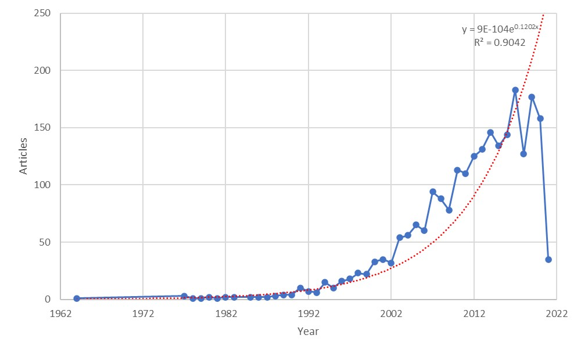

Fig. 1 Annual growth trend of begomovirus complex literature.
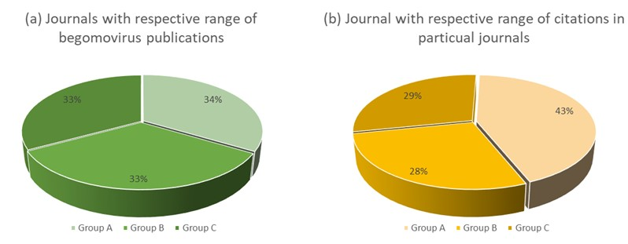

Fig. 2 According to Bradford law [4] distribution of journals in zones and distribution in publications (a) and citations (b) in each zone.
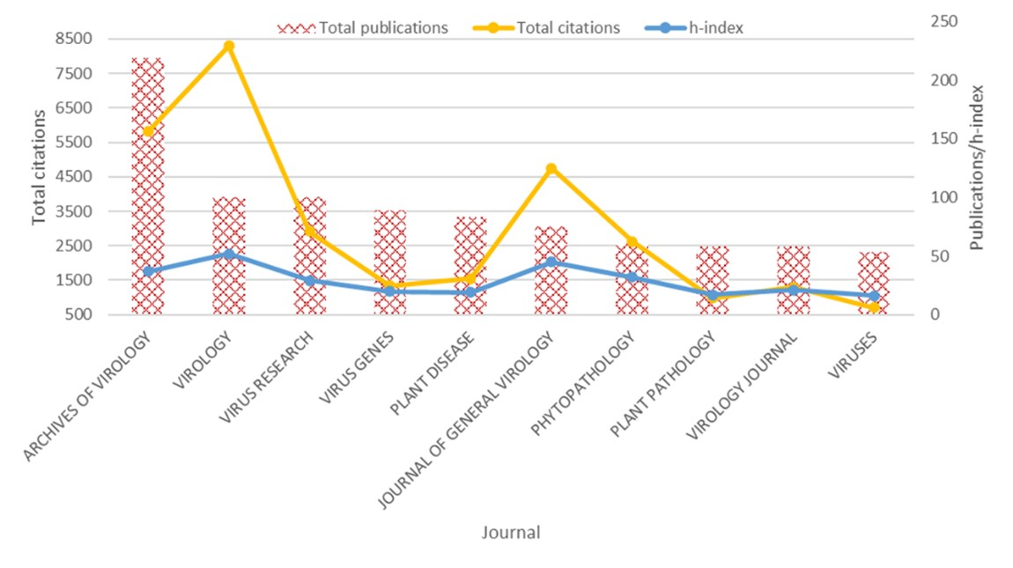

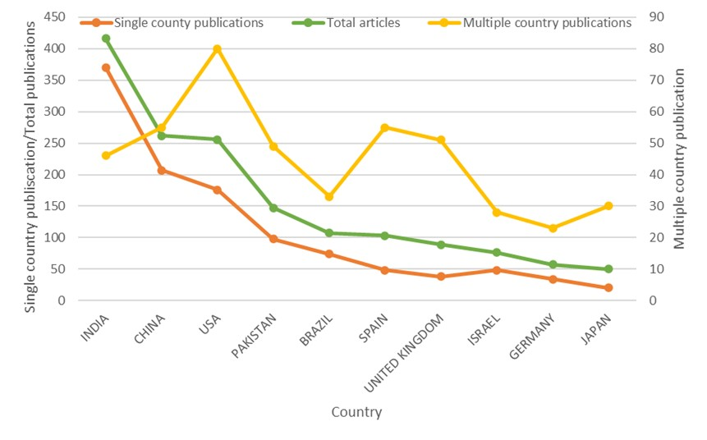
Fig. 3 Sources growth trend of top peer reviewed journals

Fig. 4 Single and multiple country publications trend.
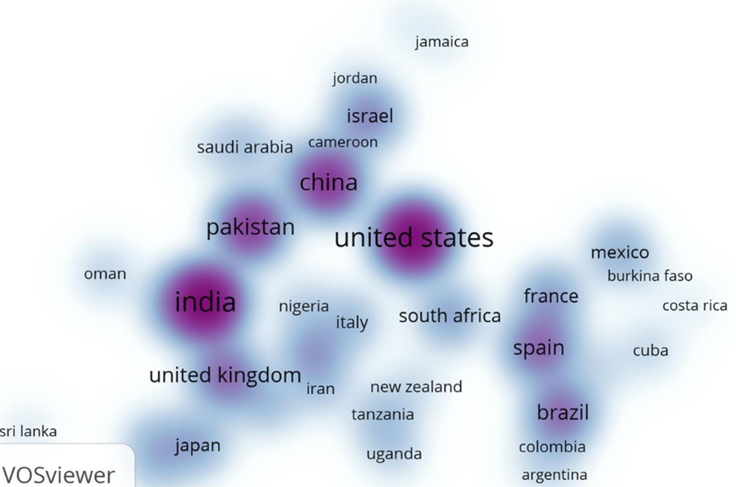

Fig. 5 Countries collaboration network
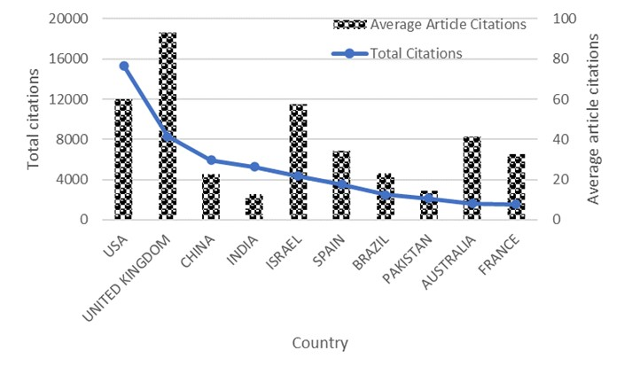

Fig. 6 Citation (total and average) among different countries

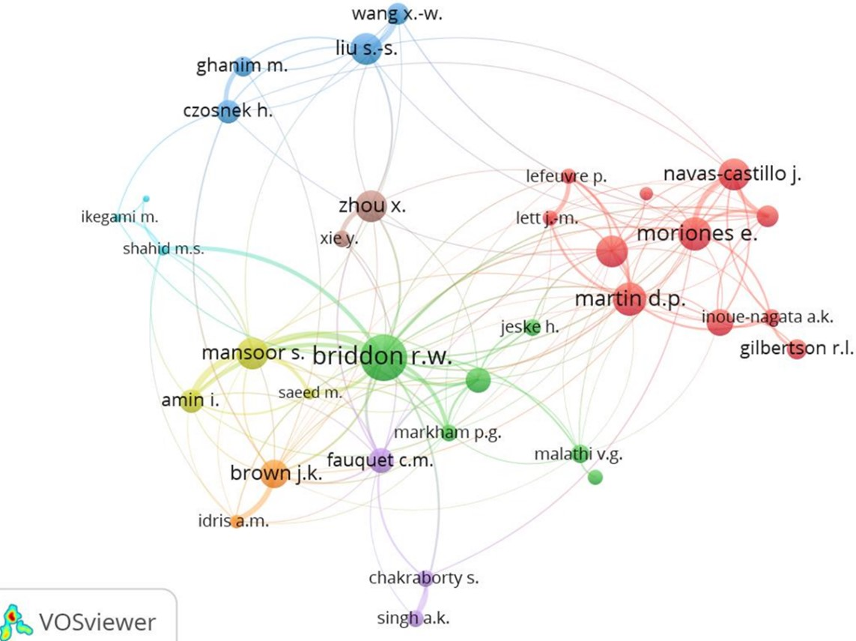

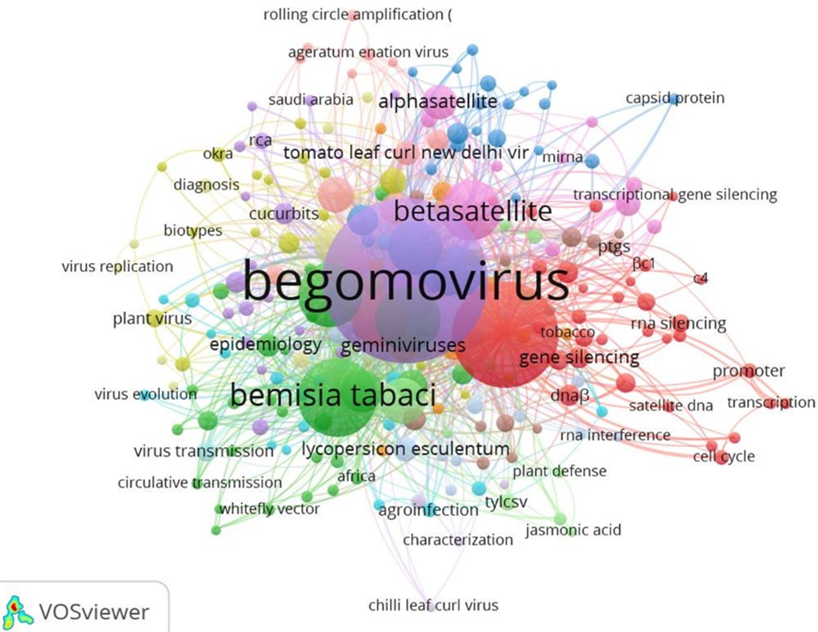
Fig. 7 Authors production and collaboration network

Fig. 8 Evolution of the frequency of different authors keywords

Table 1 Collaboration link strength as well as total citation score of highly effective countries.

Rank | Country | Articles | Cluster | Links | Total link strength | Citations | Norm. citations
1 | India | 523 | 1 | 19 | 105 | 7823 | 368.47
2 | US | 479 | 5 | 25 | 243 | 23595 | 746.79
3 | China | 281 | 5 | 15 | 74 | 7533 | 423.75
4 | Pakistan | 260 | 6 | 18 | 139 | 8178 | 311.30
5 | UK | 163 | 2 | 19 | 106 | 12223 | 228.25
6 | Brazil | 155 | 4 | 17 | 62 | 4131 | 230.00
7 | Spain | 154 | 4 | 16 | 90 | 5880 | 287.83
8 | Israel | 96 | 5 | 11 | 38 | 4917 | 140.05
9 | France | 89 | 3 | 16 | 46 | 3725 | 137.13
10 | Germany | 89 | 1 | 18 | 44 | 2535 | 80.74

Table 2 Collaboration link strength and total citations score of highly effective authors along with affiliations.

Based on total publications
Rank | Author | Documents |  | cluster | Links | Total link strength | Citations | Norm. citations
1 | Briddon R.W. | 145 | NIBGE (Pakistan) | 2 | 23 | 130 | 8197 | 253.51
2 | Mansoor S. | 113 | NIBGE (Pakistan) | 4 | 12 | 105 | 4203 | 134.24
3 | Brown J.K. | 75 | University of Arizona (USA) | 7 | 18 | 40 | 4810 | 109.83
4 | Zhou X. | 74 | Zhejiang University (China) | 8 | 8 | 30 | 3635 | 135.63
5 | Amin I. | 65 | NIBGE (Pakistan) | 4 | 9 | 63 | 2100 | 77.26
6 | Moriones E. | 61 | Universidade Federal De Viã§Osa (Spain) | 1 | 17 | 48 | 3669 | 148.67
7 | Navas-castillo J. | 60 | Universidade Federal De Viã§Osa (Spain) | 1 | 12 | 58 | 2801 | 136.10
8 | Jeske H. | 48 | University of Stuttgart (Germany) | 2 | 4 | 6 | 1257 | 41.70
9 | Czosnek H. | 47 | Hebrew University of Jerusalem (Israel) | 3 | 7 | 23 | 2898 | 72.57
10 | Liu S.S. | 47 | Zhejiang University (China) | 3 | 7 | 29 | 1797 | 132.46
Based on total citations
Rank | Author | Documents |  | cluster | Links | Total link strength | Citations | Norm. citations
1 | Briddon R.W. | 145 | NIBGE (Pakistan) | 2 | 23 | 130 | 8197 | 253.51
14 | Stanley J. | 38 | John Innes Centre, Norwich, UK | 2 | 10 | 21 | 4897 | 82.24
3 | Brown J.K. | 75 | University of Arizona (USA) | 7 | 18 | 40 | 4810 | 109.83
17 | Fauquet C.M. | 34 | Danforth Plant Science Centre, USA | 5 | 11 | 20 | 4606 | 85.98
2 | Mansoor S. | 113 | NIBGE (Pakistan) | 4 | 12 | 105 | 4203 | 134.24
6 | Moriones E. | 61 | Universidade Federal De Viã§Osa (Spain) | 1 | 17 | 48 | 3669 | 148.67
4 | Zhou X. | 74 | Zhejiang University (China) | 8 | 8 | 30 | 3635 | 135.63
30 | Markham P.G. | 27 | John Innes Centre, Norwich, UK | 2 | 12 | 23 | 3125 | 43.45
9 | Czosnek H. | 47 | Hebrew University of Jerusalem (Israel) | 3 | 7 | 23 | 2898 | 72.57
7 | Navas-castillo J. | 60 | Universidade Federal De Viã§Osa (Spain) | 1 | 12 | 58 | 2801 | 136.10

Table 3 According to Lotka Law, distribution of author's contribution to begomovirus research.
Documents written | Number of Authors | Proportion of Authors
1 | 3175 | 0.64
2 | 774 | 0.16
3 | 344 | 0.07
4 | 183 | 0.04
5 | 123 | 0.03
6 | 84 | 0.02
7 | 61 | 0.01
8 | 34 | 0.01
9 | 32 | 0.01
10 | 29 | 0.01

Table 4 Frequently cited articles related to begomovirus research based on average per year citations.
Rank | APYC | PY | Title | Journal | Reference
1 | 47.09 | 1999 | Possible Emergence of New Geminiviruses by Frequent Recombination | Virology | Padidam et al., 1999
2 | 28.27 | 2010 | De Novo Characterization of A Whitefly Transcriptome and Analysis of its Gene Expression During Development | BMC Genomics | Wang et al., 2020
3 | 28.25 | 2017 | Capulavirus and Grablovirus: Two New Genera in the Family Geminiviridae | Arch. Virol. | Varsani et al.,2017
4 | 20.00 | 2013 | The Tomato Yellow Leaf Curl Virus Resistance Genes Ty-1 and Ty-3 Are Allelic and Code For DFDGD-Class RNA-Dependent RNA Polymerases | Plos Genet. | Verlaan et al.,2013
5 | 17.45 | 2001 | Identification of DNA Components Required for Induction of Cotton Leaf Curl Disease | Virology | Briddon et al.,2001
6 | 17.44 | 2003 | Diversity of DNA Β, A Satellite Molecule Associated with Some Monopartite Begomoviruses | Virology | Briddon et al.,2003
7 | 17.64 | 2010 | The Transmission Efficiency of Tomato Yellow Leaf Curl Virus by the Whitefly Bemisia Tabaci Is Correlated with the Presence of a Specific Symbiotic Bacterium Species | J. Virol. | Gottlieb et al.,2010
8 | 16.45 | 2010 | The Spread of Tomato Yellow Leaf Curl Virus from The Middle East to the World | Plos Pathog. | Lefeuvre et al.,2010
9 | 15.86 | 2007 | Vector-Virus Mutualism Accelerates Population Increase of an Invasive Whitefly | Plos One | Jiu et al.,2007
10 | 15.29 | 2000 | A Unique Virus Complex Causes Ageratum Yellow Vein Disease | Proc. Natl. Acad. Sci. USA. | Saunders et al.,2000
11 | 14.86 | 2000 | Tomato Yellow Leaf Curl Virus, An Emerging Virus Complex Causing Epidemics Worldwide | Virus Res. | Moriones and Navas-Castillo 2000
12 | 15.88 | 2013 | A Plant Virus Manipulates the Behavior of its Whitefly Vector to Enhance Its Transmission Efficiency and Spread | Plos One | Moreno-Delafuente et al., 2013
13 | 15.30 | 2011 | Suppression of Methylation-Mediated Transcriptional Gene Silencing By β²C1-Sahh Protein Interaction During Geminivirus-Betasatellite Infection | Plos Pathog. | Yang et al., 2011

