MYCOLOGICAL STUDIES OF SOYBEAN FIELDS IN DIFFERENT GEOGRAPHICAL ZONES OF UZBEKISTAN
Matniyazova Kh.X^{1,2}., Sherimbetov A. A¹., Yuldashov U. Kh¹

¹Institute of Plant Genetics and Experimental Biology, Academy of Sciences, Tashkent, Uzbekistan
²Chirchik State Pedagogical Institute of Tashkent Region, Chirchik City, Uzbekistan
Email: jaloliddinshavkiev1992@gmail.com
ABSTRACT
Soybean is an unconventional crop in Uzbekistan, recently it has been introduced into local agriculture and there is a tendency of increasing soybean cultivation volume in the republic. Fungal phytopathogens cause serious diseases in soybean that lead to significant yield losses. Identification and understanding of their distribution pattern can help to prevent crop diseases and significant yield losses. The main objective of this study is the isolation and morphological identification of fungi associated with soybean plants and from soil layers of soybean cultivated fields in Uzbekistan.
As a result of a mycological investigation of 160 soybean plant segments sampled from field surveys, 95 saprotrophic and phytopathogenic fungal strains were isolated which have the following distribution according to species assignment: Fusarium culmorum -11% , Fusarium oxysporum-13%, Alternaria alternata-9%, Fusarium solani-14%, Aspergillus niger-10%, Alternaria sp-3%, Fusarium spp-8%, Mucor sp -3%, Penissulium sp -7%, Cercospora kikuchii-3%, Colletotrichum truncatum-3% Botrytis cinerea - 3%, Tirichoderma sp – 9%, F. Heterosporum -4% .
As a result of mycological investigation of soil samples total of 40 fungal isolates were recovered which have the following species assignment: Fusarium culmorum, Fusarium oxysporum, Alternaria alternata, Fusarium solani, Aspergillus niger, Alternaria sp, Fusarium spp, Trichoderma sp Penissulium sp Mucor sp.
The fungal isolates obtained in this study can be used to facilitate the development of the effective integrated management of soybean diseases in Uzbekistan
Keywords: Soybean, mycological investigation, fungi, pathogen, isolate, species

INTRODUCTION
Soybean is a major source of proteins and oil worldwide. Cultivated soybean (Glycine max L.) belongs to the legume family. It is the most widespread crop on our planet, cultivated in more than 60 countries with temperate, subtropical and tropical climates. In developed countries, legumes occupy 10-12% of the area of field crop rotations.
Soybean is an unconventional crop in Uzbekistan, and in 2005 it has been introduced into local agriculture. Adaptation of foreign soybean varieties to the agroclimatic conditions of Uzbekistan has been made and also local soybean varieties have been created for cultivation in the republic (Maphosa and Victoria, 2017; Cecilia et al., 2020). The government of Uzbekistan issued a special resolution "On measures to further increase the volume of soybean cultivation in the republic" and approved a “road map” aimed at expanding the cultivation of soybean in the republic. in 2018-2020 According to the decree, 18,500 hectares were allocated for soybean planting in Uzbekistan. The area under soybean production is increasing in response to the growing demand, a trend that is expected to continue in the coming years.
Soybean has a high nutritional value that provides proteins with essential amino acids, complex carbohydrates, minerals and vitamins (Jensen et al., 2012). Due to its high protein content, when included in other meals, it may help reduce malnutrition in children and lactating mothers, thereby improving nutrition in developing countries.
Soybeans have also been reported to have health-beneficial properties (Lemke et al., 2007). They contain biologically active peptides (BAPs), glycosides, isoflavones and phenolic compounds, phytosterols, saponins, alkaloids, sphingolipids and other phytochemicals with health-promoting activities (Yigezu et al., 2009; Horoszkiewicz-Janka et al., 2013).
In addition, soybeans can fix 44-103 kg of atmospheric nitrogen per hectare annually, playing an important role in improving soil fertility and reducing the need to apply large amounts of nitrogen fertilizers (Deneke, 2018).
Crop diversification in Uzbekistan and sustainable land management requires increased efforts to reduce mono-planting practices and the transition to crop rotation and intercropping. Numerous studies and field experiments show that crop rotation and intercropping involving soybean can increase soil fertility and increase farmers’ profitability
Soybeans are affected by fungal, bacterial and viral diseases. The most common from them are fungi. More than 100 species of fungi have been found on soybeans. The most common are Fusarium (Fusarium root rot), Alternaria, Phomopsis seed decay (Phomopsis spp.), Ascochyta, Cercospora purple seed stain (Cercospora kikuchii); Frogeye leaf spot on seed (Cercospora sojina); Anthracnose (Colletotrichum spp.); Downy mildew (Pernospora manshurica); and various other fungal pathogens.
A number of Fusarium species have been found associated with root rot of soybean. The species most frequently associated with root rot on soybean are F. solani and F. oxysporum. Other Fusarium species include F. acuminatum, F. chlamydosporum, F. compactum, F. culmorum, F. equiseti, F. graminearum, F. merismoides, F. proliferatum, F. pseudograminearum, F. semitectum, F. subglutinans, and F. verticilliodes. Fusarium species are widespread soilborne organisms capable of surviving for long periods of time as chlamydospores and as mycelium in plant residues and in soil. Fusarium root rot and wilt of soybean is an important disease that occurs in many soybean-producing countries (Sampaio et al., 2020).
Fusarium belongs to the xylem-invading and phloem-invading pathogens that cause vascular wilt diseases (Clare et al., 2010). Pathogens of the genus Fuzarium target the vascular system, which consists of xylem vessels, tracheary elements that transport water and minerals that are absorbed by the roots to the photosynthetic organs, and phloem elements that transports organic photosynthesis products. Vascular wilt pathogens are among the most destructive plant pathogens that can wipe out entire crops. Fusarium fungi can spread very well due to their high flexibility in crop rotation, often maintaining the same level of plant disease in different environmental conditions. The relative dominance and importance of the distribution of species of the Fusarium and other fungal pathogens affecting soybeans can vary widely depending on the location of the region, the climate and other factors (Scandiani et al., 2011).
Therefore, the main purpose of this study was
isolation and morphological identification of fungi from soybean plants and from soil layers of soybean fields in Uzbekistan.
MATERIALS AND METHODS
All collected plant samples were washed twice in distilled water, followed by surface sterilization by soaking for 1 min in 70% ethanol, 4 min in sodium hypochlorite (NaClO, 0.5%), then washed three times in sterile distilled water. After surface sterilization, samples were cut into 1 cm pieces using a sterile scalpel and transferred aseptically onto plates containing potato dextrose agar (PDA). Then fungal colonies were subsequently subcultured to isolate the monosporal fungal strains.
Nutrient media of the following compositions were used for growing fungal isolates: potato glucose agar (distilled water - 1000 ml, potato - 200 g, glucose - 100 g, agar - 20 g, pH-5.5); potato sucrose agar (potato extract - 1000 ml, sucrose - 40 g, agar - 20 g, pH-5.5); potato dextrose agar (distilled water - 1000 ml, potatoes - 200 g, dextrose - 20 g, agar - 20 g, pH-5.5), Chapek nutrient medium (KNO₃ - 2 g, K₂HPO₄ - 1.0 g, MgSO₄ - 0.5 g, KCl - 0.5 g, FeSO₄ - 0.001 g, sucrose - 20 g, agar-agar 20 g, distilled water - 1000 ml, pH-6). For this purpose, also liquid Chapek-Dox medium was used: NaNO₃ - 3.0 g, K2HPO4 - 1.0 g, KCl - 0.5 g, MgSO4 x 7H₂O - 0.5 g, FeSO4 x 7H2O - 0.01 g, ZnSO₄ - 0.01 g, CuSO₄ - 0.001 g, sucrose - 30.0 g, distilled water - 1000 ml, pH-6.
Carnation Leaf Agar (CLA) medium (KCl - 6 g, clove leaves 3–5 mm long, agar-agar - 20 g, distilled water - 1000 ml, pH-5.5) was used to produce macroconidia in the Fusarium species. Spezieller Nahrstoffarmer Agar (SNA) medium (KNO3 - 1 g, KH₂PO4 - 1 g, MgSO₄ x 7H₂O - 0.5 g, KCl - 0.5 g, glucose - 0.2 g, sucrose - 0.2 g, agar - 20 g, distilled water -1000 ml, pH-5.5.) was used to study the morphological structures of Fusarium species mycelium. Methylene blue, crystal violet (methyl violet 10B) and iodine-glycerol were used for the preparation of temporary wet mounts in order to observe and identify reproductive and vegetative structures of fungi under the microscope.
Transient preparations were prepared from the isolates and visualized under the binocular microscope. The shapes and sizes of macroconidia and microconidia were measured and x40, x100, x400 images of cells and mycelium were photographed.
Morphological identification of isolated fungi was conducted based on characteristics of the macroconidia, phialides, microconidia, chlamydospores and the colony color and growth rate (Thomma, 2003; Rhaiem et al., 2012; Mamta et al., 2013).
RESULTS
An expedition was carried out for the mycological examination of the fields planted with soybeans from representatives of the legume family (Leguminosae) in several fields of Tashkent, Samarkand, Navoi and Syrdarya regions of different geographical zones of Uzbekistan. During the expedition, radish samples were taken in special containers at a depth of 10, 20 and 30 cm from soybean fields (figures 1, 2).

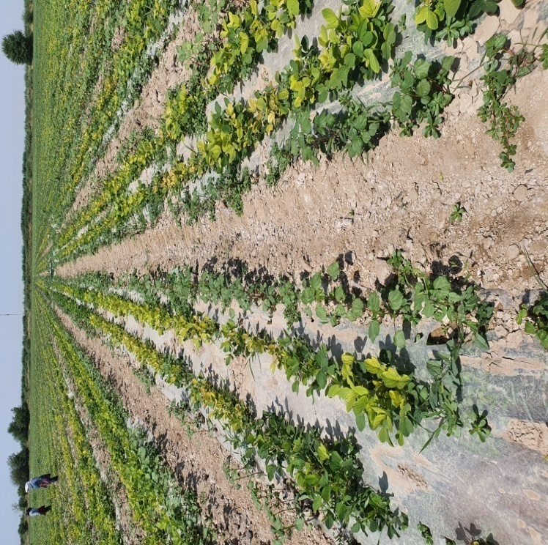 | 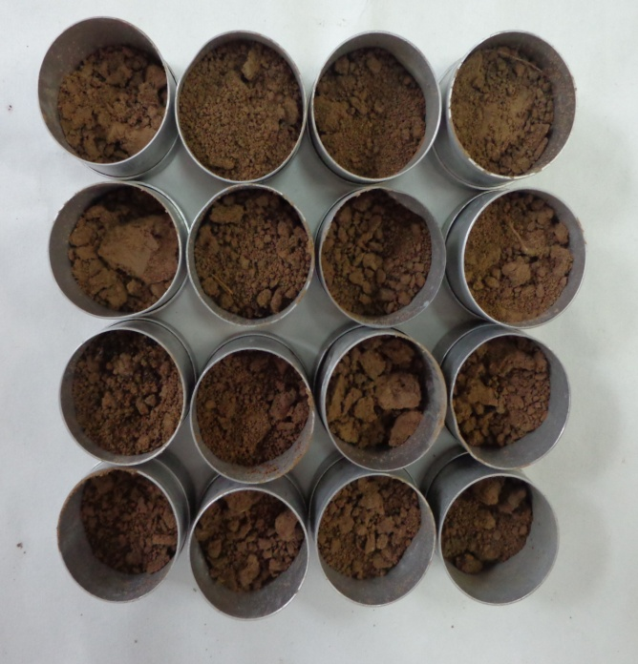
Figure 1. Infected soybean field of Syrdarya region | Figure 2. Soil samples taken for mycological analysis
Portion of 10 g from each collected soil sample were taken for mycological investigation. Then a 1: 100, 1: 1000, and 1: 10000 solutions were prepared from soil samples by mixing them with distilled and sterilized water in the sterilized 300 ml flasks. 1 ml of each solution at a ratio of 1: 10,000 was taken and inoculated in agar (WA). After inoculation, the fungi were cultured at +25 + 26 °C in an artificial climate chamber for 3-5 days. From day 3-5, fungal colonies were separated according to species composition. The isolates were grown in potato dextrose agar (PDA) nutrient medium in an artificial climate chamber for 15 days at +25 + 26°C (figures 3,4,5).

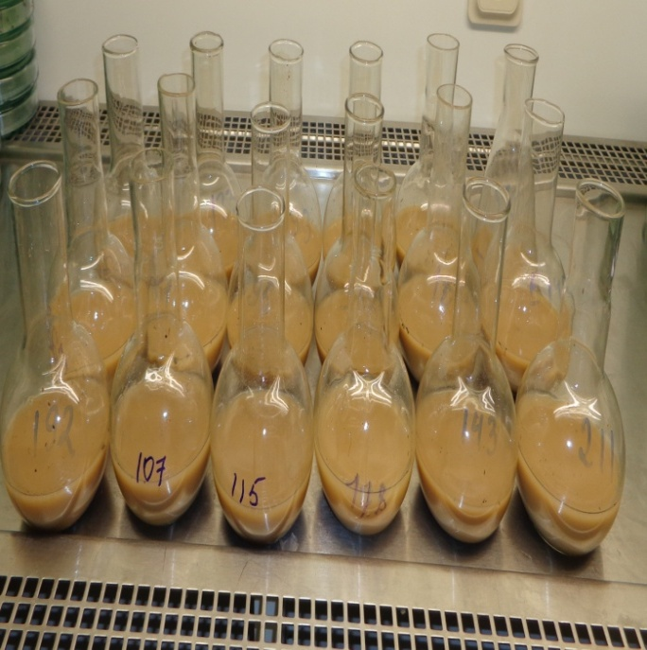 | 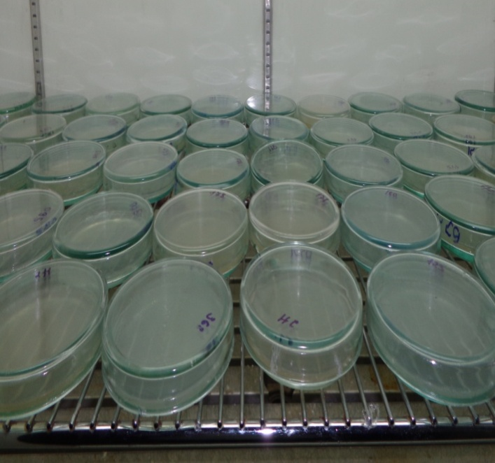
Figure 3. Preparation of soil samples for mycological investigation | Figure 4. Soil samples in an artificial climate chamber

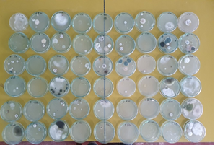 | 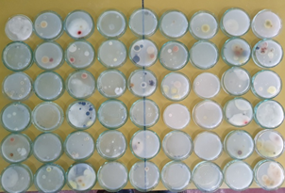
Figure 5. Soil samples after 72 h of incubation in PDA
Mycological investigation of the 1st field soil samples from Samarkand region revealed the presence of Fusarium oxysporum, F.solani, F. heterosporum fungi in the soil layers of 10, 20 and 30 cm (figures 6).
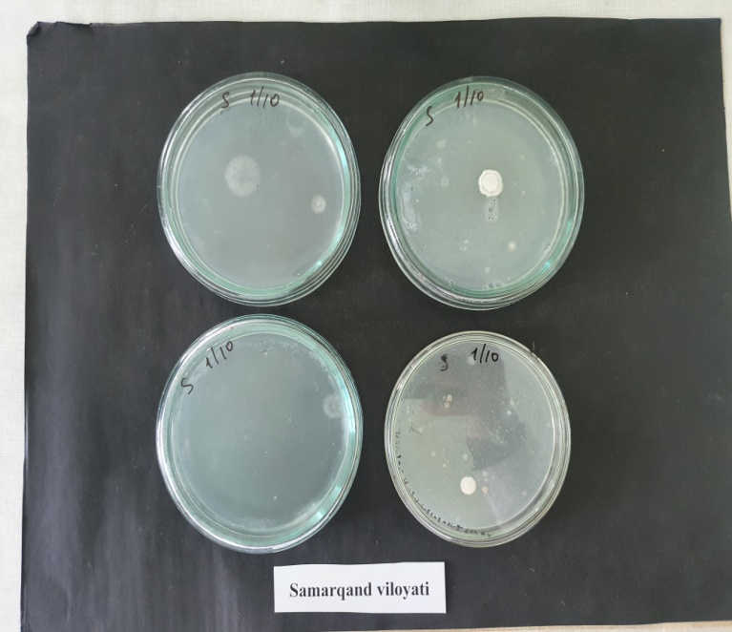 | 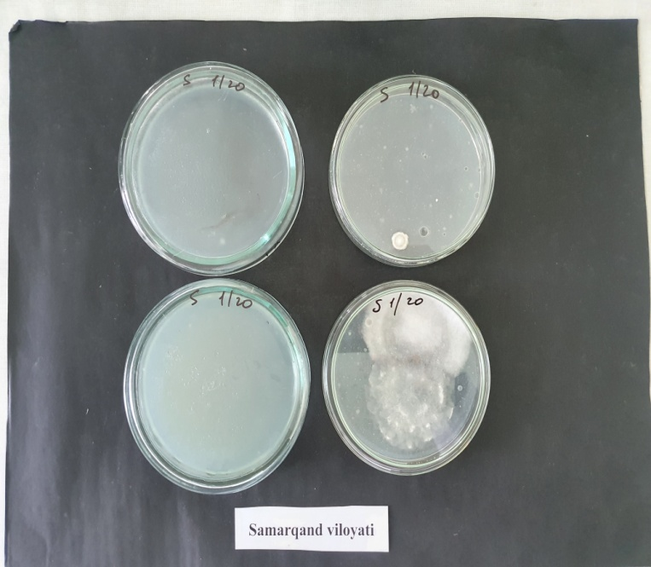 | 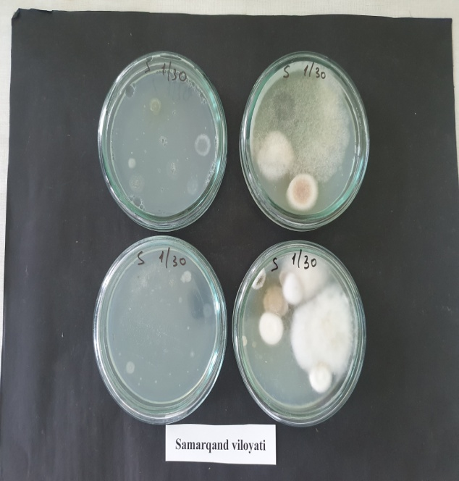
Figure 6. Mycological analysis of soil samples from Samarkand region

Mycological investigation of the 2nd field soil samples from the Navoi region showed the presence of Fusarium oxysporum, Fusarium solani, and F. culmorum in the soil layers of 10, 20 and 30 cm (figures 7).

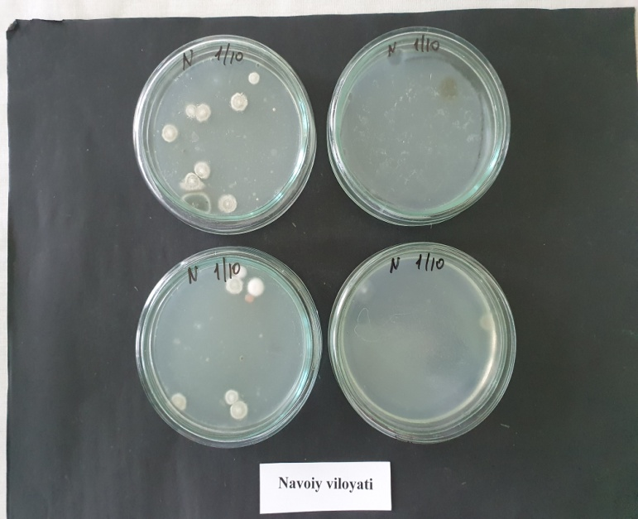 | 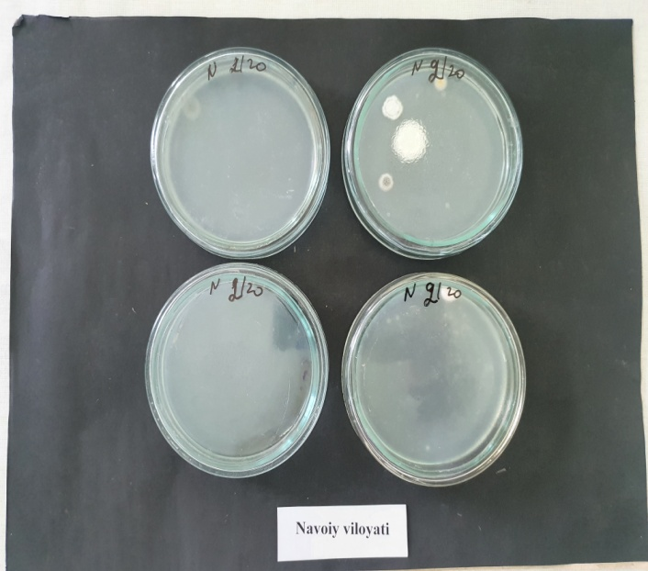 | 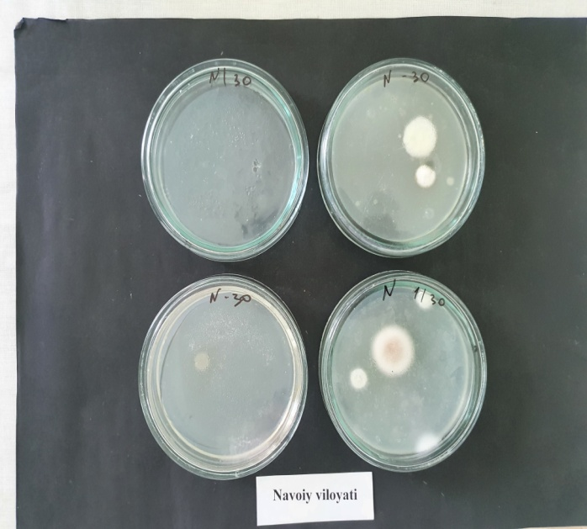
Figure 7. Mycological analysis of soil samples from the Navoi region.

When the 3rd field soil samples from the Tashkent region were mycologically investigated, Trichoderma sp, Penissulium sp and Aspergillus niger were found in the soil layers of 10, 20 and 30 cm depth (figure 8).
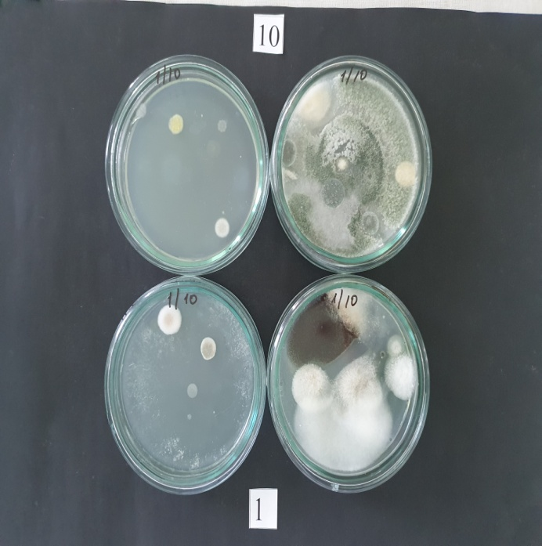 | 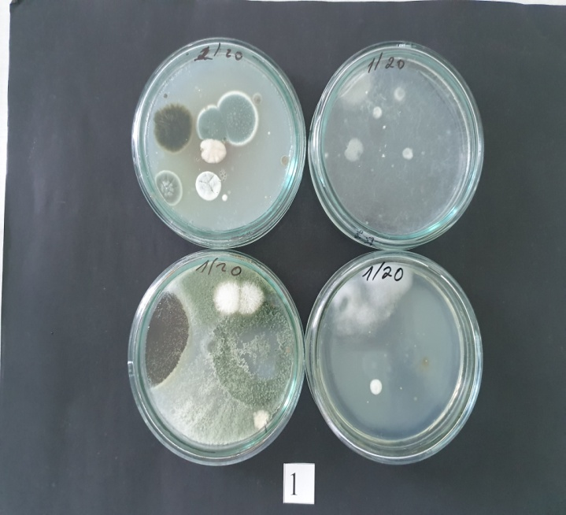 | 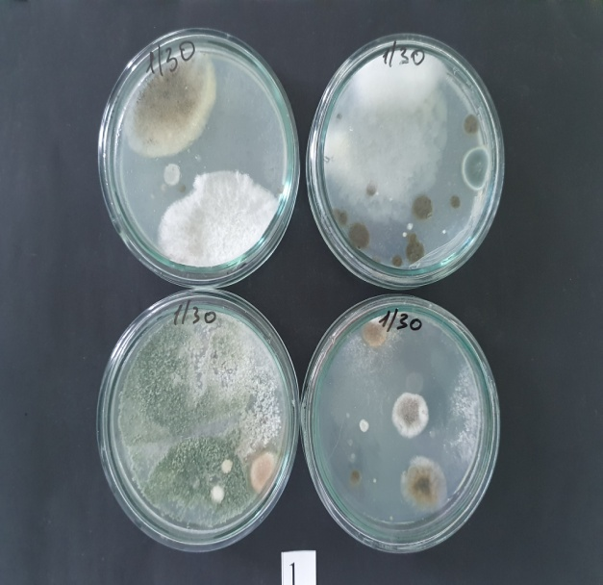
Figure 8. Mycological analysis of soil samples from Tashkent region

As a result of experiments, mainly Fusarium culmorum, Fusarium oxysporum, Alternaria alternata, Fusarium solani, Aspergillus niger, Alternaria sp, Fusarium spp, Trichoderma sp Penissulium sp Mucor sp fungal species were revealed (figures 9-11).
F.oxysporum - Large conidia are formed in aerial mycelia, sporodochia or pionnots and have a thin cell coat. The shape is filiform-arc-shaped, umbellate, most of the same width, the tip cells are short and regularly bent, well-formed pedicel, 3-5 septate.
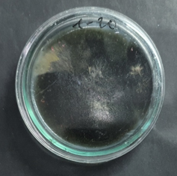 | 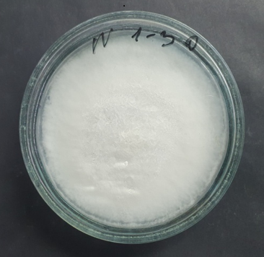 | 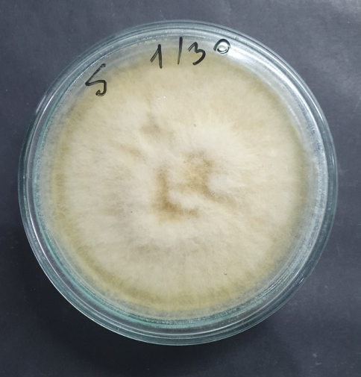
Figure 9 subcultured monosporal fungal strain from Tashkent region | Figure 10 subcultured monosporal fungal strain from Navoi region | Figure 11 subcultured monosporal fungal strain from Samarkand region
Aerial mycelium is fluffy, spider web-like, film-like, well-developed, semi-pink, light-purple, pale red, purple, dark purple, sometimes black, sometimes colorless. Chlamydospores are produced in large numbers and form a chain of one or two cells at the end of the mycelium.
The size of large three-barred conidia is 25-30x3.8-4 (-25-40x3.7-5) µm, five-barred conidia is 37-40x3.9-4.3 (30-50x3-5) µm (pictures 12,13).
The macroconidia of Fusarium oxysporum and Fusarium solani were studied under a binocular microscope by preparing a temporary preparation.

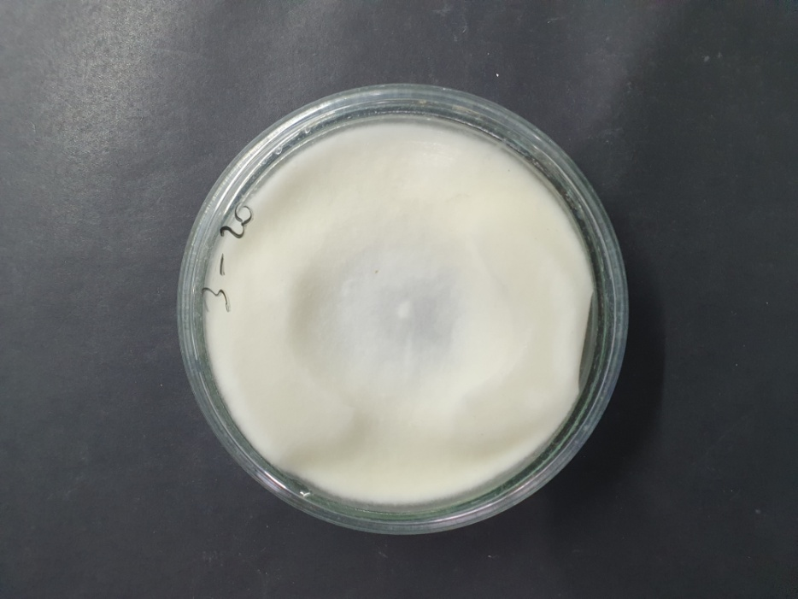 | 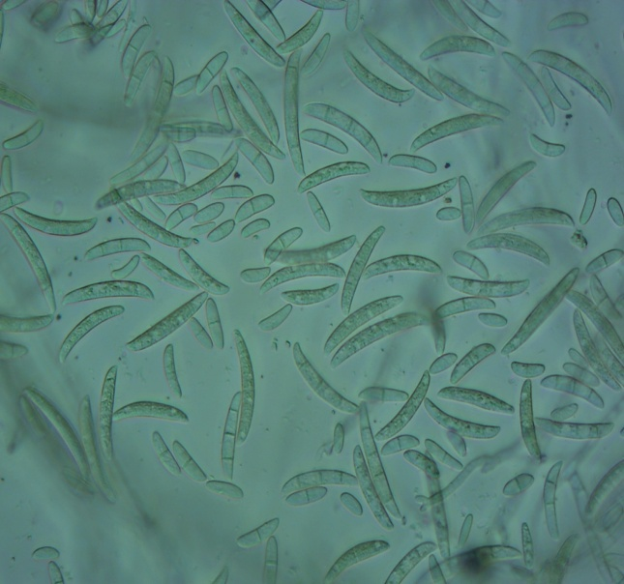
Figure 12. Fusarium oxysporum | Figure 13. Fusarium oxysporum conidia in KDA nutrient medium (х400 times magnified image)
Large conidia are formed in aerial mycelia, sporodochia or pionnots and have a thin cell coat. The shape is filiform-arc-shaped, umbellate, mostly of the same width, tip cells are short and regularly curved, with a well-formed peduncle at the base, 3-5 septa.
It produces numerous small conidia, oval, oblong, unicellular or unicellular, in conidial bands, aerial mycelia, heads and chains.
It should be emphasized that fundamental research should be conducted to study the morphological, systematic, biological, biochemical, physiological, and genetic features of the Fusarium fungus in extreme conditions in all regions of the Republic. In order to scientifically organize the fight against the disease, it is necessary to determine the species composition of fungi in the conditions of crop rotation and to reveal the laws of reducing the populations of pathogenic species.
In the conditions of crop rotation, it is necessary to scientifically base the norms and terms of agrotechnical activities carried out in the fields, and to implement biological control measures against the disease. It is necessary to identify the aggressive forms of the Fusarium fungus found in extreme conditions in all regions of the Republic, and to start selection work on the creation of disease-resistant soybean varieties in the infectious backgrounds created from them.
Colonies of Alternaria alternata species are fast-growing, gray, greener, dark gray, dark olive, or black in color. Conidia often form long and branched chains. Conidia are inverted tuft, ovoid or narrow ellipsoidal, gray-brown or olive-brown in color, 20-50x8-12 µm in size in culture, transverse septate, 1-2 longitudinal septate in 1 or several transverse segments. Secondary conidiophores are short, apical (usually up to 5-10 μm in length, rarely up to 35 μm), sometimes lateral. In KSA and V-4 media, the amount of aerial mycelium is moderate, colorless to light brown, with a gray tint when conidia are abundant. In the natural nutrient environment, the aerial mycelium is dense, colorless, yellowish, light-colored, less often light-gray. Sporulation usually begins between 5–10-day old colonies. The sporulation habit of isolates of this group of species is very variable. Chains of conidia are short or long, few or strongly branched. [Figures 14-15)
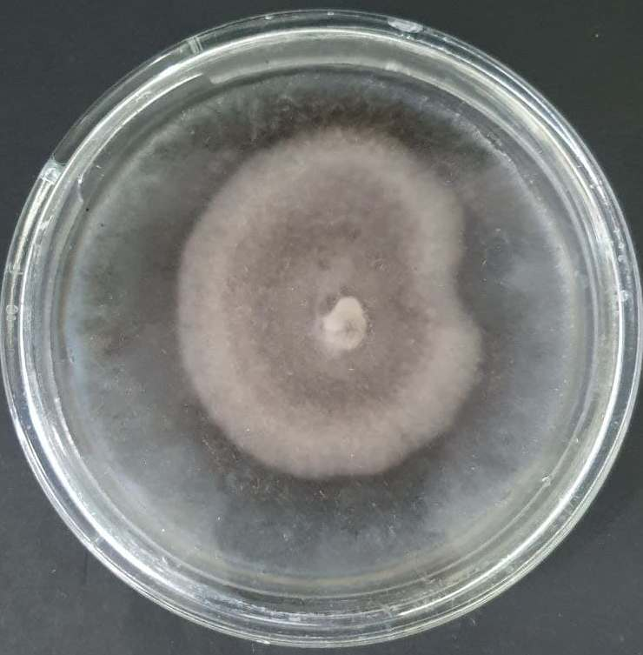 | 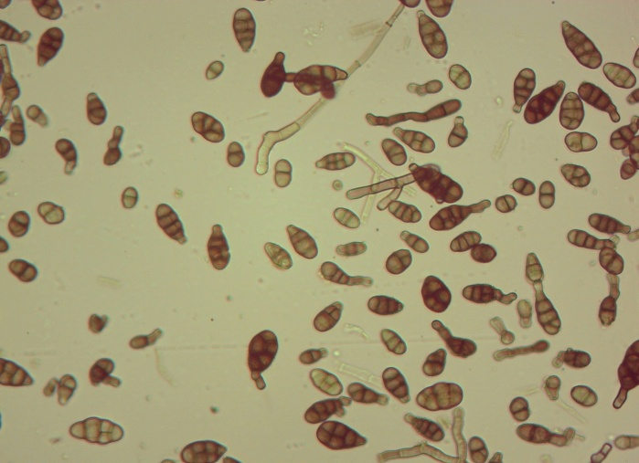
Figure 14. Alternaria alternata | Figure 15. Alternaria alternata conidia (х400 times magnified image)
In the irrigated fields of the districts of Tashkent, Syrdarya, Navoi and Samarkand regions of our republic, the fields planted with soybean plants representing the Leguminosae family were subjected to phytosanitary control. It was observed that there are disease symptoms in the plant organs, i.e., root rot, root neck rot, leaf spotting, stem wilting and various spots.
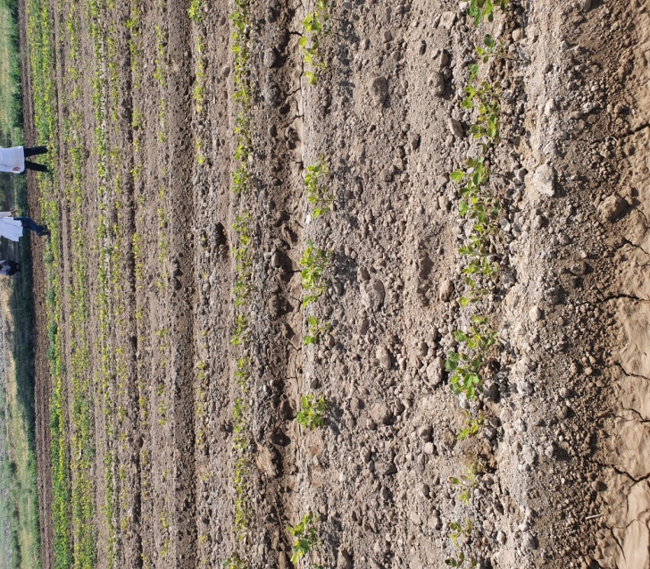 | 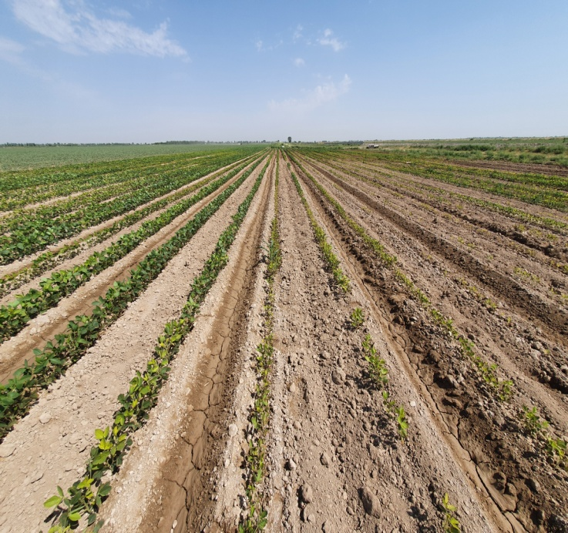
Figure 16. Investigated soybean field of Syrdarya region

As a result of the observations, samples were taken from various organs of these affected plants and herbariums were brought to the laboratory for mycological examination in order to isolate phytopathogenic mycomycetes. (Figure 17)

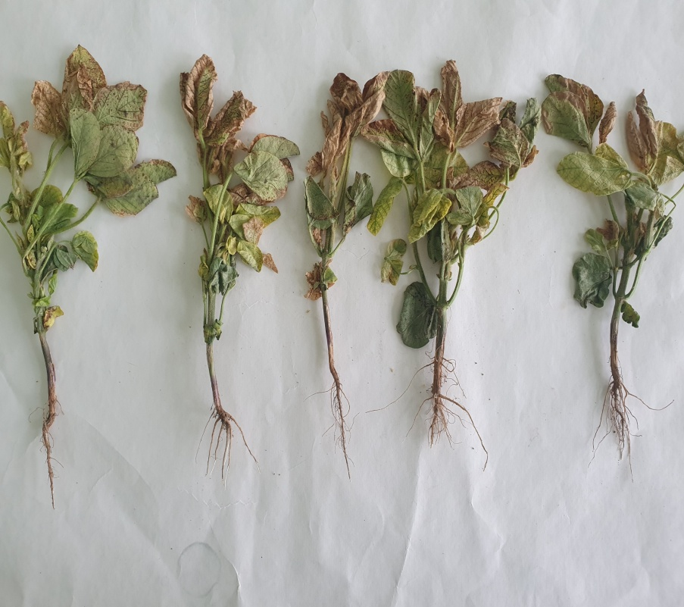 | 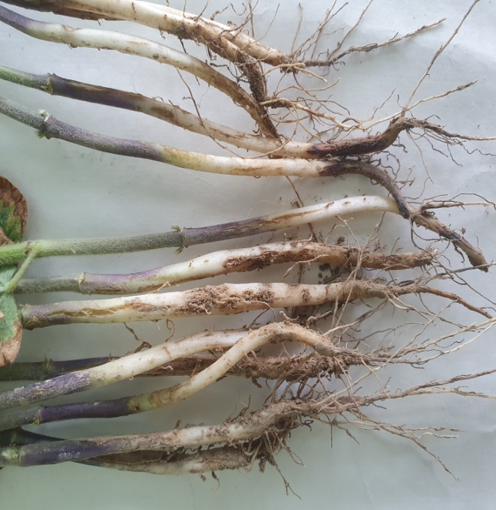
Figure 17. Soybean plants infected with fusarium wilt
To separate the isolated phytopathogenic fungi into separate species, as well as to determine their species composition, to determine the structure of their macro- and microconidia, they were planted in separate nutrient media and grown for 5 days (Fig. 18).
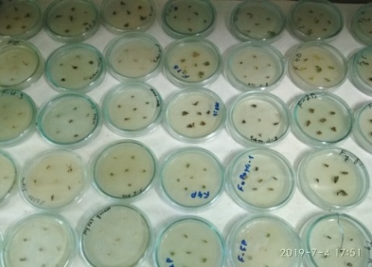 | 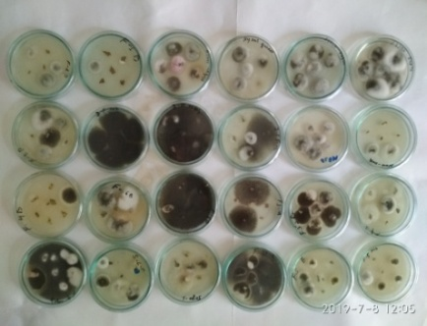 | 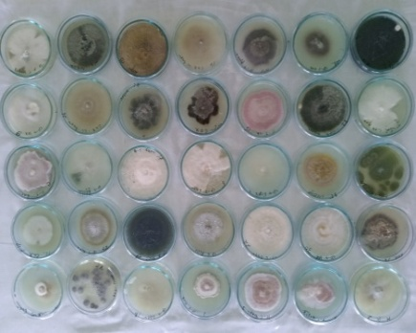
а) | б) | с)
Figure 18. а) samples of fungal colonies grown for 1 day. б) samples of fungal colonies grown for 5 days с) separated monosporal fungal colonies

As a result of mycological investigation of 160 plant segments sampled from field surveys (Fig.19), 95 fungal strains were isolated which have the following distribution according to species assignment: Fusarium culmorum -11% , Fusarium oxysporum-13%, Alternaria alternata-9%, Fusarium solani-14%, Aspergillus niger-10%, Alternaria sp-3%, Fusarium spp-8%, Mucor sp -3%, Penissulium sp -7%, Cercospora kikuchii-3%, Colletotrichum truncatum-3% Botrytis cinerea - 3%, Trichoderma sp – 9%, F. Heterosporum -4% (figure- 19). Isolated fungal strains belonged to 14 species from 10 genera.
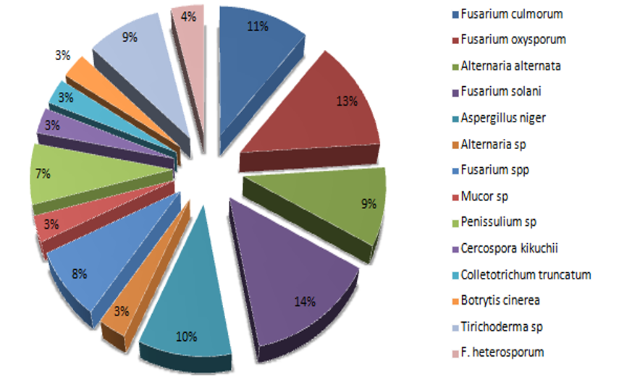
Figure 19. Distribution of fungal species isolated from soybean plant samples, %.
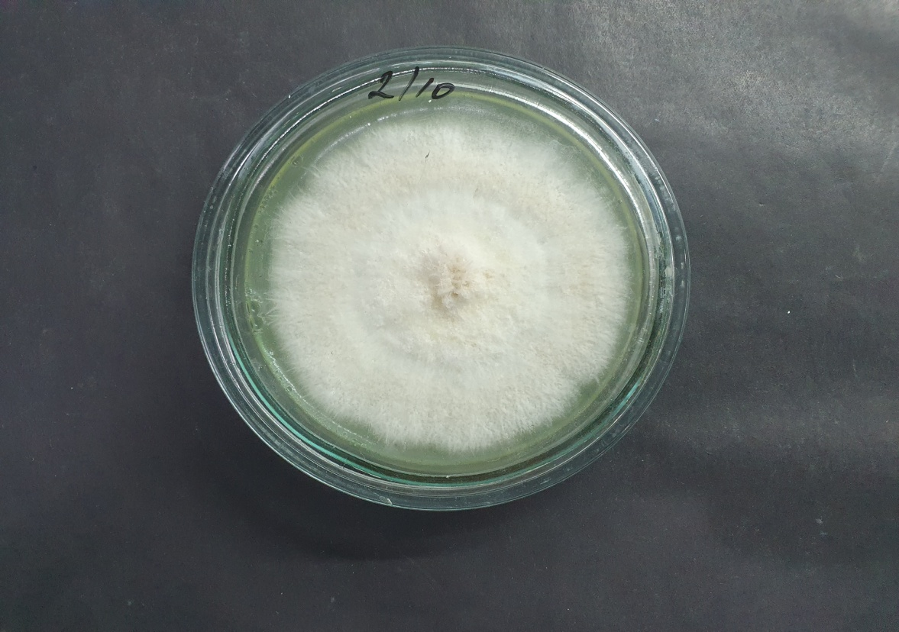 | 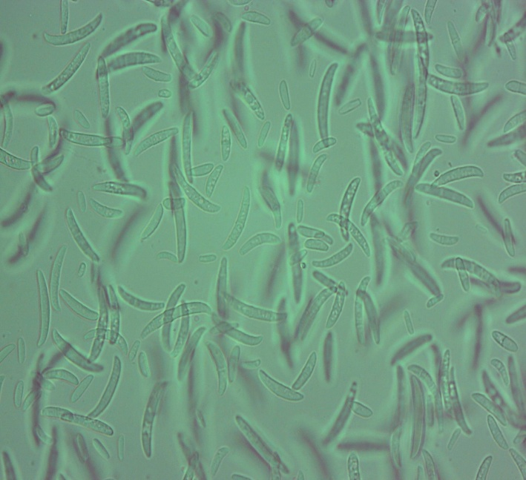
Fig. 20. F. solani fungus (in KDA nutrient medium) | F. solani conidia (in KDA nutrient medium) magnification x 400 times
Results of this study showed that the most common species of fungi isolated from soybean plants in Uzbekistan, were Fusarium solani, Fusarium oxysporum, Fusarium culmorum, Aspergillus niger followed by Trichoderma sp, Penissulium sp, Alternaria alternata sp, Cercospora kikuchii and others.
Fusarium species can spread efficiently along crop rotations, often infecting a wide range of plants under diverse environmental conditions. F. oxysporum, F. solani, F. culmorum and F. sambucinum and other species of Fusarium associated with the roots of leguminous crops usually appear as a pathogen complex rather than alone. Prevalence, dominance and importance of the individual pathogens in this complex vary widely depending on location, climate and agricultural practice.
Considering long wheat cultivation history in Uzbekistan, contamination of soils with members of Fusarium root rot pathogen complex from wheat crops can cause serious problems in the process of soybean plant introduction and acclimatization in the conditions of Uzbekistan.
In Uzbekistan, long-term monoculture of cotton and wheat crops has led to severe soil sickness and as a consequence, high concentrations of accumulated pathogenic Fusarium and other fungal species in the agricultural fields. Soil bio-fertility and productivity decline when these pathogens accumulate in the soil profile. Fusarium root rot can cause soybean yield losses of up to 80%, resulting in serious economic losses. Numerous species of the genus Fusarium can be involved, and it is usually not known which species is the major causative agent. This Fusarium root rot complex is a difficult-to-understand disease, especially when several factors are involved in disease development. It is therefore a challenge to design management options for growers.
In this regard complex and systematic strategies to control Fusarium should be used such as planting new resistant soybean cultivars, using bio-organic fertilizers, soil solarization, biofumigation and seed treatments. Soil solarization is an ecofriendly method of controlling soil-borne pathogens by placing plastic sheets on field soil during hot summer period (Metodika, 2009). Bio-organic fertilizers was shown to directly suppress Fusarium phytopathogenic strains and facilitate the growth of ecologically beneficial microbes, particularly by stimulating the growth and activities of indigenous, antagonistic microbes (Peresipkin, 1989). This result in the reestablishment of equilibrium in the soil microbial ecosystem and recovery from productivity losses due to sick soils.
Considering that not only soil, but also seeds can be a pathway of disease transmission, in order to prevent the introduction and distribution of Fusarium spp., farmers and seed producers need to use disease-free seed. Efforts must be directed towards avoiding seed contamination with pathogens and developing and introducing seed health testing methods to detect Fusarium and other important phytopathogenic fungi.
Therefore, along with the “road map” aimed at expanding cultivation of soybean in the Uzbekistan there is a need to develop also strategic “road map” aimed at large-scale soil health restoration and improving seed health in the republic.

DISCUSSION
More than 200 phytopathogenic microorganisms (primarily fungi) have been detected on soybean (Hartman et al., 2015), and it is considered that about 30 species can cause significant economic damage (Roy et al., 2000). Most of them colonize soybean seed and thus spread and distribute in other soybean-growing regions worldwide (Backman et al., 1985; Pioli et al., 1999, Vidić et al., 2006). This article describes the analysis of mycological studies carried out on fields sown with soybeans in different geographical zones of Uzbekistan. In some areas of the Tashkent, Samarkand, Navoi and Syrdarya regions of the Republic of Uzbekistan, a phytosanitary examination was carried out on soybean fields, samples of diseased plants and soil were collected. A mycological examination of the collected samples in the laboratory was carried out and pure cultures of phytopathogenic fungi species were isolated. The
morphological, systematic, biological characteristics of the isolated strains were determined.
According to Marin-Menguiano et al. (2019), in recent years, fungal diseases of crops have become increasingly serious as they have severely affected crop yield and quality, and they have become an important bottleneck for the development of sustainable agricultural.
Results of this study showed that the strains Fusarium solani, Fusarium oxysporum, Fusarium culmorum, Aspergillus niger, Alternaria alternata sp, Fusarium spp and Trichoderma sp were isolated, which were found in high percentages in members of the Leguminosae family. In soybean seedlings of these phytopathogenic micromycetes, moderate and severe darkening of the epicotyl or roots was observed. The findings of present research are consistent with study performed by Ruzmetov et al. (2021), in which, the frequency of F. solani, Alternaria alternate, Aspergillus niger, Ascohita rabiei, F. culmorum and F.oxysporum fungi isolated from legumes was found to be high. The most common fungi of soybean seed worldwide are species from following genera: Diaporthe, Fusarium and Alternaria as well as species: Cercospora kikuchii, Rhizoctonia solani Kühn, Sclerotinia sclerotiorum, Botrytis cinerea Persoon, Macrophomina phaseolina, and Peronospora manshurica (Rather et al., 2010: Tenuta et al., 2015).
Aspergillus niger is a filamentous fungus of ascomycetes that is ubiquitous in the environment. This fungus is being responsible for postharvest decay of grains worldwide and it was shown that increase of environmental temperature because of global warming, especially the increasing frequency and duration of heat-wave summer periods can result in an increased threat to food safety by stimulating growth of Aspergillus niger (Csernus et al., 2013; Sherimbetov et al., 2020).
The less frequent species identified in the present study were Penissulium sp -7%, Alternaria sp-3%, Mucor sp -3%, Cercospora kikuchii-3%, Colletotrichum truncatum-3% Botrytis cinerea - 3% and F. Heterosporum -4%. As a result of this experiment, it was determined that saprotrophic and phytopathogenic fungal strains belong to 10 genera and 14 species. According to the classification of Leslie and Summarell [(2006) there are 70 species of fungi in the Fusarium genus, while in the conditions of the Republic of Uzbekistan, it was determined that there are 17 species and 10 subspecies of this genus. Alternaria species (especially the sense lato type called A. alternate) have been found to cause diseases in leaves, stems and pods of soybean and chickpea in natural conditions (Khasanov et al., 2000; Khasanov et al., 2013). In our republic, 2 types of Alternaria species, strains of Alternaria alternate, Alternaria tenuissima species, which cause black sunken spot disease, were detected in the leaves of soybean, chickpea, mung bean and bean plants (Sherimbetov et al., 2020).
CONCLUSION
During mycological investigation of plant samples collected from soybean fields of the Republic of Uzbekistan, 95 fungal strains were isolated and assigned to 14 species from 10 genera. As a result of mycological investigation of soil samples total of 40 fungal isolates were recovered and assigned according to the species classification. The most common species of fungi isolated from soybean plants in Uzbekistan, were Fusarium solani, Fusarium oxysporum, Fusarium culmorum, Aspergillus niger followed by Trichoderma sp, Penissulium sp, Alternaria alternata sp, Cercospora kikuchii and others.
Pure cultures of fungal strains isolated in this study were deposited in the unique object collection of "Phytopathogenic and other microorganisms" of the Institute of Genetics and Experimental Biology of the Academy of Sciences of the Republic of Uzbekistan. The pathogenic fungal isolates obtained in this study can be used to develop the integrated diseases management of soybean crops in Uzbekistan.
REFERENCES
Backman PA, Weaver DB. & Morgan- Jones G (1985). Soybean stem canker: An emerging disease problem. Plant Disease. 69: 641 647.
Cecilia A. Moreno-Valdespino, Diego Luna-Vital, Rosa M. Camacho-Ruiz, Luis Mojica (2020). Bioactive proteins and phytochemicals from legumes: Mechanisms of action preventing obesity and type-2 diabetes. Food Research International. 130. https://doi.org/10.1016/j.foodres.2019.108905
Clare MM, Melis R, Dereta J, Laing M, Buruchara RA (2010). Identification of sources of resistance to Fusarium root rot among selected common bean lines in Uganda. Journal of Animal & Plant Sciences. 7: 876-891.
Csernus Olívia, Bata-Vidács Ildikó, Farkas J, Beczner Judit (2013). Effects of environmental conditions on growth of Aspergillus niger and Penicillium expansum. Acta Alimentaria. 42:640-648. Available: https://doi.org/10.1556/AAlim.42 .2013.4.17
Deneke S (2018). Review on Epidemiology and Management of Faba Bean (Vicia fabae) Chocolate Spot (Botrytis fabae), Root Rot (Fusarium solani) and Rust (Uromyces vicia fabae) in Ethiopia. Int. J. Sci. Res. Publ. 8:105–111.
Hartman GL, Rupe JC, Sikora EJ, Domier LL, Davies JA, Steffey KL (2015). Compendium of Soybean Diseases and Pests (5th Edition). The American Phytopathological Society. St. Paul. Minnesota.
Horoszkiewicz-Janka J, Jajor E, Korbas M (2013). Potential risk of infection of pathogenic fungi to legumes (Fabales) and possibilities of their control. Prog. Plant Protect. 53: 762–767. https://doi.org/doi:10.14199/ppp-2013-021
Jensen ES, Peoples MB, Boddey RM, Gresshoff PM, Hauggaard-Nielsen H, Alves BJR, Morrison MJ (2012). Legumes for mitigation of climate change and the provision of feedstock for biofuels and biorefineries. A review. Agronomy for Sustainable Development. 32: 329–364. https://doi.org/10.1007/s13593-011-0056-7
Khasanov BA, Rustamov AA, Gulmuradov RA, Mamanov T, Toxtamshev S, Abduraxmanov I (2013). Rot of roots, germinating seeds and seedlings of grain crops. Agro-ilm.Тoshkent. 1 (25): 42.
Khasanov BA, Zuparov MA, Gulmurodov RA (2000). Diseases of cotton.1. Seed and seedling diseases. Bulletin of agrarian science of Uzbekistan. 3: 104-112.
Lemke RL, Zhong Z, Campbell CA, Zentner R (2007). Can pulse crops play a role in mitigating greenhouse gases from north American agriculture. Agronomy Journal. 99(6): 1719–1725. https://doi.org/10.2134/agronj2006.0327s
Leslie JF, and Summerell BA (2006). The Fusarium Laboratory Manual. Ames, Iowa, USA. Blackwell Publishing. 1-388.
Mamta Sharma, Raju Ghosh, Suresh Pande. Occurrence of Alternaria alternata causing Alternaria blight in pigeon chickpea in India. Advances in Bioscience and Biotechnology. 4: 702-705. https://doi.org/10.4236/abb.2013.46092
Maphosa Y, Victoria AJ (2017). The Role of Legumes in Human Nutrition. In book: Functional Food - Improve Health through Adequate Food. 6: 103-121.
Marin-Menguiano M, Morenosanchez I, Barrales R R, Fernandezalvarez A, and Ibeas JI (2019). N-glycosylation of the protein disulfide isomerase Pdi1 ensures full Ustilago maydis virulence. PLoS Pathog. 15.
Metodika (2019). VIZR Izuchenie toksigennыx svoystv shtammov Fusarium Link. Rossiya. 24
Peresipkin VF (1989). Selskoxozyaystvennaya fitopatologiya. 48-70.
Persson L, Bødker L, Larsson-Wikström M (1997). Prevalence and pathogenicity of foot and root rot pathogens of pea in southern Scandinavia. Plant Dis. 81: 171–174.
Pioli RN, Grijalba P, Gosparini CO, Martinez C, Tozzini A, Hopp E, Morandi EN (1999) Morphological, pathogenic and molecular characterization of different isolates of Diaporthe phaseolorum var. meridionalis obtained in different areas of Santa Fe province, Argentina. Proc. World Soybean Res. Conf. VI, Chicago. IL, USA. 627-628.
Rhaiem M. Chérif TL. Peever P Dyer S (2012). Population structure and mating system of Ascochyta rabiei in Tunisia: evidence for the recent introduction of mating type 2. Journal of Plant pathology. 4(1): 99-108. https://doi.org/10.1111/j.1365-3059.2007.01779.x
Roy KW, Baird RE, Abney TS (2000). A review of soybean glycin emaX) seed, pod, and flower mycofloras in North America, with methods and a key for identification of selected fungi. Mycopathologia. 150: 15-27.
Ruzmetov DR, SHerimbetov AG, Davranov KD. and Adilov BS (2021). Isolation and identification of fungi associated with leguminous crops in uzbekistan and screening of their pathogenic. Plant Cell Biotechnology and Molecular Biology. 22(33&34): 245-256.
Sampaio AM, Araújo SS, Rubiales D, Vaz Patto MC (2020). Fusarium Wilt Management in Legume Crops. Agronomy. 10(8): 1073. https://doi.org/10.3390/agronomy10081073
Scandiani MM, Ruberti DS, Giorda LM, Pioli RN, Luque AG, Bottai H, Ivancovich JJ,Aoki T, O'Donnell K (2011). Comparison of inoculation methods forcharacterizing relative aggressiveness of two soybean sudden-death syndromepathogens, Fusarium virguliforme and F. tucumaniae. Tropical Plant Pathology. 36: 133-140.
Sherimbetov AG, Adilov BSh, Kadirova ZN, Makhmudov TX, Mambetnazarov AB, Ruzmetov DR (2020). Molecular verification of species identity of some isolates of the genus Fusarium deposited in the phytopathogen collection in Uzbekistan. Plant Cell Biotechnology and Molecular Biology. 21(71&72):94-98.
Sherimbetov AG, Namazov SE, Adilov BS, Sadiqov KR, Matyoqubov SK (2021). Investigation and identification of phytopathogenic and saprophytic Fusarium species in the agricultural fields soil layers of the republic of Uzbekistan. Plant Cell Biotechnology and Molecular Biology. 21(61&62): 101-108.
Tenuta, A., Bradley, C., Chilver, M., Giesler, L., Mathew, F., Mueller, D., Sisson, A., Smith, D. & Wise, K. (2015): Scoutingfor Common Soybean Seed Diseases. Crop Protection Network. Retrieved from http://www.soybeanresearchinfo.com
Thomma B (2003) Alternaria spp.: from general saprophyte to specific parasite Molecular Plant Pathology. 1(4):225-236. https://doi.org/10.1046/j.1364-3703.2003.00173.x
Vidić M, Jasnić S, Đorđević V (2006): Rasportranjenost Diaporthe/Phomopsis vrsta na semenu soje u Srbiji [Distribution of seed-borne Diaporthe/Phomopsis species in soybean in Serbia]. Pestic. Phytomed. 21: 39-48.
Rather AJ, Shannon G, Balardin R, Carregal L, Escobar R, Gupta GK, Ma Z, Morel W, Ploper D, Tenuta A (2010): Effect of diseases on soybean yield in the top eight producing countries in Plant Health Progress. 11(1). https://doi:10.1094/PHP-2010-0125-01-RS.
Yigezu YA, El-Shater T, Boughlala M, Bishaw Z, Niane AA, Maalouf F, Degu WT, Wery J, Boutfiras A, Aw-Hassan A (2019). Legume-based rotation have clear economic advantages over cereal monocropping in dry areas. Agron. Sustain. Dev. 39(6). 58 https://doi.org/10.1007/s13593-019-0602-2

Contribution of Authors:
Matniyazova Kh.X: Conduct trials and wrote manuscript
Sherimbetov A. A: Helped in manuscript write up and research trials
Yuldashov U. Kh: Prepared tables, figures and graphs

